

MoBPS

**Modular Breeding Program Simulator**



31. März 2022

University of Goettingen

Animal Breeding and Genetics Group

MoBPS v1.8.09

Torsten Pook, Martin Schlather, Henner Simianer

**Table of Contents**

1 General 6

2 Installation 7

3 Individual grouping 8

3.1 gen/database/cohorts 8

3.2 Sex of individuals 8

4 Creation of the starting population (creating.diploid()) 9

4.1 Importing/Generating of a genetic dataset 9

4.2 Importing a genetic map 10

4.3 Simulating/Generating the genetic architecture underlying each trait 10

4.3.1 Custom-made genetic architectures 10

4.3.2 Predefined genetic architectures 11

4.3.3 Correlated Traits 12

4.3.4 Non-gaussian distributed traits 12

4.3.5 Maternal / paternal effects 12

4.3.6 Traits as linear combination of other traits 12

4.3.7 Fixed effects 13

4.4 Position of Markers 13

4.5 Related founder individuals 13

4.6 Add genotyping arrays 14

5 Simulation of breeding processes (breeding.diploid()) 15

5.1 General setup 15

5.2 Control of heritability, breeding values, genotypes and phenotypes 16

5.3 Breeding value estimation 17

5.3.1 Direct approach with known heritability 19

5.3.2 Bayesian approaches (BGLR) 19

5.3.3 GBLUP (EMMREML) 19

5.3.4 GBLUP (sommer) 20

5.3.5 GBLUP (rrBLUP) 20

5.3.6 Marker-assisted selection 20

5.3.7 Parent/Grandparent mean 20

5.3.8 Own function 20

5.3.9 Calculating marker effects & GWAS 21

5.3.10 Calculation of reliabilities 21

5.4 Selection techniques & mating strategies 21

5.4.1 Multiple traits 22

5.4.2 Higher procreation of genetically favored individuals 22

5.4.3 Maximum number of offspring per individual & use of same mating pairing 23

5.4.4 Avoiding full-sibling / half-sibling matings 23

5.4.5 Selection thresholds 23

5.4.6 Plant breeding (no-sexes & selfing & DH-production & cloning) 23

5.4.7 Generate offspring for all sire combination 23

5.4.8 Targeted/Fixed mating/Manual selection of individuals 24

5.4.9 Gene-Editing 24

5.4.10 Optimum genetic contribution 24

5.5 Genetic architecture 24

5.6 Other 25

5.6.1 Culling / Death 25

5.6.2 Allele-frequency per generation 25

5.6.3 Set a random seed 26

5.6.4 save.recombination.history 26

6 Exemplary scripts 27

6.1 Basic breeding actions 27

6.2 Averaging results of the basic breeding scheme over multiple simulations 27

6.3 Generation of a founder population with real genomic data (vcf-file) 29

6.4 Generation of a founder population with real genomic data (ped/map-file) 29

6.5 Genotyping and Phenotyping of Subcohorts 30

6.6 Simulation of a base population with a hard sweep 31

6.7 Generation of traits based on genomic & phenotypic data 32

6.8 Generation of inbred lines 32

6.9 Generation of a trait with maternal component 33

6.10 Simulation of a MAGIC population in maize 33

6.11 Simulation of Introgression on blue eggshell QTL in chicken 34

6.12 Simulation of a conservation breeding program using cock rotation in chicken 37

6.13 Simulation of gene editing in a cow breeding program 38

6.14 Simulation of a simple GxE case 39

6.15 Use of the culling module 40

6.16 Simulation of an age structure 41

6.17 Import data from a ped-file 42

6.18 Generate QTL / and neural loci (e.g. not used in breeding value estimation) 42

7 Exporting information from the population-list (get.XXXX) 44

7.1 get.geno 44

7.2 get.haplo 44

7.3 get.bv / get.bve / get.pheno / get.reliability / get.selectionindex / get.npheno 45

7.4 get.qtl / get.qtl.effects / get.qtl.variance 45

7.5 get.recombi 46

7.6 get.pedigree (1/2/3) 47

7.7 get.cohorts 47

7.8 get.id 48

7.9 get.class 48

7.10 get.genotyped 48

7.11 get.genotyped.snp 48

7.12 get.time.point 49

7.13 get.creating.type 49

7.14 get.cullingtime 50

7.15 get.time.point 50

7.16 get.age.point 50

7.17 get.individual.loc 50

7.18 get.pheno.off 50

7.19 get.pheno.off.count 50

7.20 get.selectionbve 50

7.21 get.pca 51

7.22 get.admixture 51

7.23 get.dendrogram 52

7.24 get.dendrogram.heatmap 53

7.25 get.dendrogram.trait 53

7.26 get.phylogenetic.tree 54

7.27 get.distance 56

7.28 get.effect.freq 56

7.29 get.selectionindex 56

7.30 get.vcf 56

7.31 get.pedmap 56

7.32 get.map 57

7.33 get.database 57

8 Importing information to the population-list 59

8.1 insert.bve 59

8.2 set.class 59

9 Utility functions & advanced features 60

9.1 set.default 60

9.2 bv.development 60

9.3 bv.development.box 61

9.4 Relationship between individuals and inbreeding 62

9.4.1 Definition in MoBPS 62

9.4.2 kinship.exp 63

9.4.3 kinship.emp / kinship.emp.fast 63

9.4.4 kinship.development 64

9.5 analyze.population 64

9.6 new.base.generation 65

9.7 founder.simulation 65

9.8 pedigree.simulation 66

9.9 creating.trait 67

9.10 combine.traits 67

9.11 bv.standardization 67

9.12 creating.phenotypic.transform 67

9.13 clean.up 68

9.14 ensembl.map 68

9.15 compute.costs 68

9.16 compute.costs.cohorts 69

9.17 summary 70

9.18 pedmap.to.phasedbeaglevcf 70

10 Data structure of the population list 72

10.1 $info 72

10.2 $breeding 74

10.2.1 Storage per generation 74

10.2.2 Storage per individual 74

11 Memory and computation times 76

11.1.1 Efficient BLAS / LAPACK 76

11.1.2 Reducing the size of the population list 77

11.1.3 Reducing memory needs in the BVE 77

11.1.4 Inverting G using miraculix 78

11.1.5 Working with a high number of traits 78

11.1.6 On-the-fly calculation of haplotypes 78

12 List of input parameters in breeding.diploid() 79

13 List of input parameters in creating.diploid() 88

14 List of datasets included in the package 91

15 On the generation of traits 93

15.1 General 93

15.2 Genotype – by – environment 94

16 User-interface 95

16.1 MoBPSweb 95

16.2 Input modules 96

16.3 Output modules 97

16.4 Compare Projects 98

17 References 100

18 Citation 103

19 Acknowledgements 104

References 104

# General

MoBPS is an R-package to simulate complex and large-scale breeding programs with a focus on livestock and crop populations. Simulations are performed on an individual basis. MoBPS is a versatile tool, providing standard procedures applied in animal and plant breeding like GBLUP and OGC, but also allowing to use own selection schemes while still controlling the simulation of phenotypes, meiosis and costs of the simulated scheme.

In the following, the underlying grouping of individuals will be described in section 3. Next, the two key steps of the simulation procedure, namely the creation of a starting population (section 4) and the simulation of breeding processes (section 54.5) are described. As it is our goal to provide a lot of flexibility while performing the simulation, there is a need of many parameters – luckily only a few of those will be needed for most simulations. For a better overview of potential scenarios to use MoBPS a variety of relatively plant and animal breeding programs are provided in section 6.

Next, a variety of utility functions to export/import specific information directly or generate standardized plots like a PCA or derive inbreeding rates (section 0, 8, 9). Sections 10 & 11 provide technical detail on the storage structure and computing times. Sections 0, 13, 14 provide a glossary on all available input parameter in *creating.diploid()* and *breeding.diploid().* Section 15 provides technical detail on the underlying methods to simulate traits.

Lastly, a brief introduction on our graphical interface (available at [www.mobps.de](http://www.mobps.de)) is given in section 0. Note that this interface is still in active development and not part of the MoBPS paper. The use of the interface is still encouraged, but for major projects, we highly recommend close collaboration for further development or the direct use of the overall more flexible R-package itself.

For questions regarding the tool or how to set up your simulation, feel free to contact me directly ([Torsten.pook@uni-goettingen.de](mailto:Torsten.pook@uni-goettingen.de)). We are always happy for questions as it really helps improve the tool and its documentation. For quick reply, it would help to provide a small example of our problem.

# Installation

The current version of MoBPS requires R 3.0 or higher. To ensure fast computing times we would additionally recommend the use of the R-package RandomFieldsUtils and miraculix.

**Step 1 (only Windows)**

On some Windows System installation of Rtools is required. This is no R-package, but separate program that can be downloaded at <https://cran.r-project.org/bin/windows/Rtools/rtools40.html> .

**Step 2 (Optional)**

RandomFieldsUtils and miraculix are R-package to enhance the computational performances. Please do **not** install these packages via CRAN, but download them from github: <https://github.com/tpook92/MoBPS>. It is important to first install RandomFieldsUtils and then miraculix.

For Linux use RandomFieldsUtils 1.0.6 and miraculix 1.0.5.

For Windows use RandomFieldsUtils 0.6.6 and miraculix 1.0.0.1.

Code in the packages is highly dependent of the respective other package. So please do not use version of the package that are not compadable with each other, but just the combinations suggested here!

**Step 3**

Install the MoBPS R-package itself. You can install MoBPS via CRAN, however, we could highly encourage to use the version of available on GitHub (<https://github.com/tpook92/MoBPS>) as we are providing basically weekly update on the framework while the CRAN version will only be updated once every couple of months.

Either download the package directly from GitHub or use the R-package devtools to install from your R prompt:

devtools**::**install_github**(**"tpook92/MoBPS", subdir**=**"pkg"**)**

The usage of Mac OS has not been tested by us, but should also work.

**Step 4 (optional)**

In addition to the R-package itself, we are providing a package containing some commonly used genetic maps from Ensembl (Zerbino et al. 2018). You can install the maps package in the same way as MoBPS itself:

devtools**::**install_github**(**"tpook92/MoBPS", subdir**=**"pkg-maps"**)**

# Individual grouping

One of the key challenges, for any simulation program is to provide the user with the necessary flexibility to perform certain breeding actions on specific groups of individuals. The conceptual idea behind MoBPS is orientation along the gene-flow concept (Hill 1974) which is using the term of a cohort as a group of individuals with same characteristics like age, sex, and genetic origin. Note that internally all simulations are based on single individuals and gains are based on individual simulations and no expected gene flow.

## gen/database/cohorts

Whenever a group of individuals is generated, the user can assign a specific and unique name – these kinds of group will later be referred to with the keyword **cohort**. Whenever a new cohort is generated it will automatically be assigned to a generation – to selected all cohorts of a certain generation, one can select the group of individuals via the parameter **gen.** Lastly, groups of individuals can be selected via the parameter **database**. A database contains four input information:

1. Generation
2. Sex (1 – male, 2- female)
3. Number of the first individual to consider (default: first individual of that generation/sex)
4. Number of the last individual to consider (default: last individual of that generation/sex)

The number of the individuals is assigned based on the order of generation in each specific generation.

As an example, consider the following selected input:

gen = 4:5, database = matrix(c(3,1,21,50), ncol=4), cohorts=”Founder”))

This parameter input will lead to MoBPS using all individuals of generations 4 and 5, as well as the male individuals 21 to 50 from generation 3 and the individuals from the cohort “Founder”.

Basically all breeding actions later introduced (section 5) will rely on this to selected with groups to use for breeding value estimation (**bve.gen**, **bve.database**, **bve.cohorts**), which cohorts to phenotype (**phenotyping.gen**, **phenotyping.database**, **phenotyping.cohorts**) or to just export information from the simulated population (section 0).

## Sex of individuals

Although each individual on generation will be assigned to a sex, this is not binding for downstream operations. E.g., an individual stored as a female can be used as the father (or more generally as the first parent).

In particular, in plant breeding and aquaculture, the sex of an individual might even not be unique. Sex can still be used to store individuals with more structure (e.g. each sex for a different gene pool). You can also deactivate the use of two sexes at the beginning of you simulation and store all individuals as part of the first (and then only) sex in *creating.diploid().*

# Creation of the starting population (*creating.diploid()*)

The input for the simulation of a breeding process is a population list. This list is created via *creating.diploid()*.

We provide exemplary genetic maps for some common species, which can be selected via the parameter **template.chip**. Note that primary the number of chromosomes and their genetic length is imported at this step (especially not real markers with known allele frequencies, effects, or base pairs). The maps provided via **template.chip** are “cattle” (Ma et al. 2015), “pig” (Rohrer et al. 1994), “chicken” (Groenen et al. 2009), “sheep” (Prieur et al. 2017), and “maize” (Lee et al. 2002). Alternatively, a genomic map can be inserted via the parameter **map** with exemplary maps being provided in the package itself or via import from Ensembl (section 149.10 ).

## Importing/Generating of a genetic dataset

In case one has haplotype data for the founders/starting population this can be imported via the parameter **dataset** in form of a haplotype dataset:

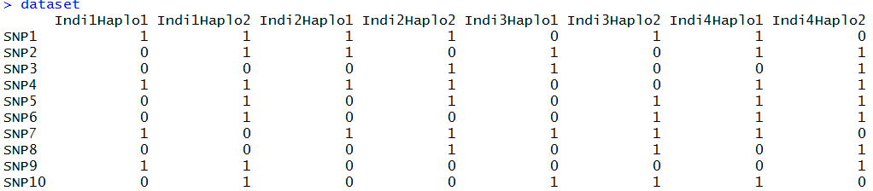

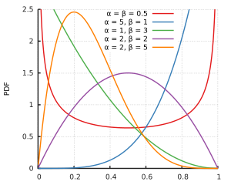Datasets can also be imported via entering the path of the vcf file in the parameter **vcf**. The R-package vcfR is needed for this. Otherwise, a dataset can be generated by setting the number of SNPs (**nsnp**) and individuals (**nindi**) – we offer four possible modes to simulate starting haplotypes (“all0”, “allhetero”, “random”, “homorandom") leading to haplotypes (000…/000…, 000…/111…,X_1 X_2 X_3… /X_4 X_5 X_6 … with X_i~B(**freq**) X_1 X_2 X_3 … /X_1 X_2 X_3… with X_i~B(**freq**)). On default “random” is used. The allele frequencies for each marker are entered via the parameter **freq** and are sampled from a beta distribution with **beta_shape1** and **beta_shape2** (default: 1,1; leading to a uniform distribution of allele frequencies.

Figure 1: https://en.wikipedia.org/wiki/Beta_distribution

To generate an LD and haplotype structure without using real data we recommend starting with one of the simple datasets and simulate some random/non-random mating generations using *breeding.diploid()* (cf. section 54.5). The function *founder.simulation()* provides an automated way to generate such LD structure for the founder / **dataset**-input. For more details see section 9.7.

If a vcf file is used for data import or a map is provided, the chromosome, marker name, and base pair position are automatically imported. Alternatively, those can be provided via **chr.nr**, **bp** and **snp.name**. By doing this, multiple chromosomes can be inputted jointly. If no input for **chr.nr** is provided all markers are assumed to be on the same chromosome (for more on the usage of a genetic map, we refer to section 4.2). To limit the number of markers imported from a vcf-file set the parameter **vcf.maxsnp** accordingly.

In case more markers are to be added to an existing population list set **add.chromosome** to TRUE and repeat the previous process with the population list as an additional input.

To specify the sex of each sample either assign each individual a probability to be female (**sex.quota**) or alternatively use a vector (**sex.s**) assigning each individual its sex (M=1, F=2).

You can activate a mode in which all individuals are automatically assign to the same sex by setting **one.sex.mode** to TRUE. This will also automatically adapt **breeding.size**, **sex.quota** etc.

## Importing a genetic map

The user can provide a genetic map of up to five columns via the parameter **map**. The first column contains the chromosome of the respective marker, the second column the name of the marker, the third column the position in Morgan, the fourth column the physical position in base pairs, and the last column the allele frequency in the population. All values not provided are automatically set to NA and values are used as input for **chr.nr**, **snp.name**, **bp**, **snp.position**, **freq**.

Alternatively, maps can be imported via *ensembl.map()*. For more on this, we refer to section 14.

## Simulating/Generating the genetic architecture underlying each trait

As the manual input of effects can be tiring, we provide some automated procedures to simulate some common effect structures (additive, dominant, qualitative, and quantitative epistasis) – if you do not need more, you can just skip to section 4.3.2). Technical details on the generation of correlated traits are given in section 15.

Note that this is the generation of an actual genetic value that is underlying each individual of the population. In reality, you cannot observe this, as traits will be caused by far more complex interactions, and effects are not known. This, on the other hand, enables opportunities to evaluate a model fit given a known structure (e.g. GWAS hits can be compared to actual effect markers instead of previously identified markers or similar). Traits can be named via the parameter **trait.name**. To obtain a given mean and genomic variance for a trait one can apply *bv.standardization()* on the resulting population list after generating the trait (section 9.10).

### Custom-made genetic architectures

To simulate a custom-made genetic architecture we allow for effects caused by one (**real.bv.add**), two (**real.bv.mult**) or more SNPs (**real.bv.dice**). These effects can either be added directly while using *creating.diploid()* or added later using *creating.trait()*. To delete previously existing effects set **replace.real.bv** to TRUE. For multiple traits use lists as inputs for all parameters in this section with each list element containing information for one trait.

Input structure for the first two is a matrix with each row coding a single effect:

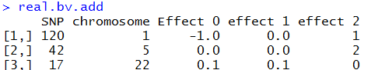

**real.bv.add** should be able to model any additive or dominance effects of single markers.



**real.bv.mult** should be able to model any epistatic interaction between two markers.

To simulate even more complex effect structures use the parameter **real.bv.dice** allowing the modelling of effects caused by more than two SNPs.

Input for **real.bv.dice** is a list containing a list of all locations and a list of all effects:

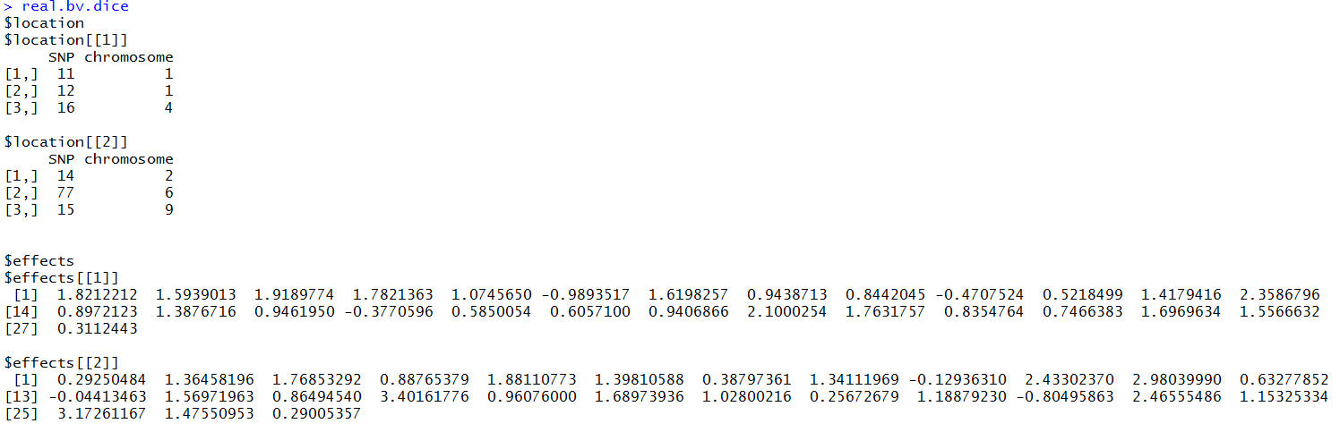

Each network of interacting markers is giving in the first list (location) and their effects are given in a second list (effects). Effects are sorted in the following order: 0…0, 0…01, … 2…2 – resulting in a vector with elements, where n is the number of markers involved in the effect.

Marker effects assign to positions that currently do not exist (e.g. SNP 100 on chromosome 1 in case chromosome 1 only contains 50 SNPs) are automatically removed from the stored effects unless **remove.invalid.qtl** is set to FALSE.

### Predefined genetic architectures

In the case of a predefined genetic architecture, all markers are assigned with the same probability to be drawn as effect markers. To exclude markers use a parameter **exclude.snps** containing a vector of all numeric positions of excluded markers. Numbering is consecutively starting with chromosome 1. Note that only markers, that are already included in the dataset, can be chosen as effect markers – so in case of more than one chromosome with no generation via **chr.nr** the effects should be added using *creating.trait()* (cf. section 9.99.3) or in the last run of *creating.diploid()*.

The number of additive (**n.additive**) and dominant (**n.dominant**) QTL as well as effects caused by qualitative (**n.qualitative**) and quantitative (**n.quantitative**) epistasis can be included directly. On default, each variance is set to 1 and effects are drawn from a Gaussian distribution. To assign the variance, one can input a vector containing the variance for each effect (**var.additive, var.dominant,…).** To generate additive or dominant QTLs which all have the same effect size use **n.equal.additive** and **n.equal.dominant**. The size of those effect can be chosen via **effect.size.equal.add** and **effect.size.equal.dom** with the default being 1. To make sure that all dominant effects are positive (e.g. to have positive effects of hybrid breeding) set the parameter dominant.only.positive to TRUE.

Qualitative epistasis is simulated by drawing 3 random effects for both involved markers, taking the absolute values from those, sorting them from low (0) to high (2), and multiplying those effects with each other. By this, we obtain the lowest effect for 00 and the highest for 22 with selection for the alternative allele to be beneficial in all cases.

Quantitative epistasis is simulated by drawing 9 random effects and assigning the absolute values of two of those to the corner 02 and 20. All other combinations are assigned the minus absolute values of the drawn random number.

To simulate more than one trait use vectors for **n.**XXX and lists for **var.**XXX instead.

### Correlated Traits

To generate correlated quantitative traits selected the traits that should be correlated via **shuffle.traits** and provide the needed correlation in **shuffle.cor**. Note that QTLs are then assigned to the same markers to get correlations independent of the underlying LD structure. To set a correlation for traits with no underlying QTL, use **new.breeding.correlation**. As the simulation is done via sampling from a Gaussian distribution and genetic traits do not fulfill all requirements of a dependent multivariate Gaussian distribution (which is here used to model dependency), the obtained resulting correlations can be different from the correlation set in **new.breeding.correlation** if non-QTL traits have correlations with QTL-traits. We are currently working on alternatives for this.

### Non-gaussian distributed traits

All underlying genomic values generated via methods given in section 4.3.2 are using Gaussian effect size. Especially for discrete distributions it is potentially beneficial to apply a transformation function on the generated phenotypes. This can be done by the use of the function creating.phenotypic.transform() – for more on that, we refer to section 15. E.g. to generate a binary trait use:

function(x){y = x>10; return(y)}

To transform all phenotypic observations higher than 10 to 1 and all below to 0. Thresholds to obtain certain probabilities of each phenotype must be manually derived according to the trait mean and variance set via bv.standardization() and the entered heritability.

### Maternal / paternal effects

In both *creating.diploid()* and *creating.trait()* one can indicate if a trait is caused by maternal or paternal effects via the parameter **is.maternal** and **is.paternal**. Setting this to TRUE will lead to the genotype of the respective parent to be used in the evaluation of QTL effects. For founder individuals, the genotype of the individual itself will be used.

### Traits as linear combination of other traits

The function *add.combi()* can be used add traits with underlying true genomic value equal to the combination of other traits. The trait to be considered can be selected via the parameter **trait** and the weightings can be chosen via **combi.weights**. The trait can be assigned with a name by the use of the **trait.name** parameter.

Note that phenotyping for such a trait is independent of phenotyping and heritablity for each of the other traits that is combined. Typically, only phenotyping of either the combined or the singular traits will be required. For an example on the use, we refer to section 6.9.

### Fixed effects

Fixed effects can be added via the *add.fixed.effects()* function. Fixed effects are provided via the **fixed.effects** parameter as a p x k matrix with p being the number of traits and k being the number of fixed effects. To remove already existing fixed effects set replace to TRUE – otherwise newly added fixed effects will be added to the list of effects. Whenever new individuals are generated the realization of fixed effects can subquently be chosen via **fixed.effects.p** in *breeding.diploid().* For more on this see Section XX.

## Position of Markers

For our simulations, the physical position in base pairs does not really matter as we are interested in a position in Morgan internally. We assume points of recombination to be distributed according to a Poisson distribution. On default, we assume markers to be equidistant with the total length of the chromosome in Morgan given by the parameter **chromosome.length** (default: 5). When performing a joint generation of multiple chromosomes with different sizes enter a vector instead. If non of the following options for the position of each marker are provided, markers are assumed to be equidistant. This will also minimize computation time and therefore should only be changed if needed.

Based on the physical positions entered in the parameter **bp** the position in Morgan can be derived by providing a conversion rate in **bpcm.conversion**. Note that tools like BEAGLE (Browning et al. 2018) assume 100.000.000 bp per Morgan. For chicken, we would recommend the use of 30.000.000 bp per Morgan.

Another way of entering the genetic position (in M) is via the parameter **snp.position** manually. Scaling can be performed internally by activating the parameter **position.scaling** and the **chromosome.length**. In addition, one should input a value for the number of base pairs before and after the last position (**length.before**, **length.behind**). Both should be chosen to be larger zero (default: 5) if scaling is performed.

For some applications, the recombination rate might not be the same for all individuals (e.g. male/female differences). To input an additional recombination map enter alternative positions in the parameter **add.architecture**. You can select which architecture is used for every parent in the actual simulation process via **gen.architecture.m** & **gen.architecture.f** in *breeding.diploid()*.

## Related founder individuals

On default, pairwise founder kinships are zero as no pedigree information for previous generations can be entered. To manually enter a kinship matrix for founders of the population list the function *add.founder.kinship()* can be used. The kinship matrix can be provided via the parameter **founder.kinship**. Alternatively, on can also directly derive a kinship matrix according to (VanRaden 2008) by setting **founder.kinship** to “vanRaden”. On default, the founder matrix is entered for generation 1. If a kinship matrix for another generation is supposed to be entered use the parameter **gen**.

## Add genotyping arrays

As different genotyping arrays are typically used for different individuals, it is possible to add specific genotyping arrays via *add.array()* with the parameter **marker.included** providing binary (TRUE/FALSE) information if the respective SNP is on the array. On default, one genotyping array that is containing all markers is already added by using *creating.diploid().* In each subsequent step to generate genotypes the used array can be selected. For more on this, we refer to section 5.2.

# Simulation of breeding processes (*breeding.diploid()*)

To perform the actual simulation of matings the function *breeding.diploid()* is used. Especially for that step, the sheer amount of different options can be deterring. In reality, only a few parameters will actually be relevant. In this section, we will first discuss absolutely necessary parameters, their default options and afterwards discuss possible deviations. For exemplary simulation, we refer to section 6. Note that you most likely can skip through some of the sections if you are not interested in changes in that dimension. There will be a lot of cases where there is the same parameter for the male and female part of the breeding program. We will limit ourselves here to the male parameter (parametername**.m**) – usage of the female version (parametername**.f**) will always be the same. The default setting for the female parameter is to be the same as the male parameter (NOT the default of the male parameter). An exception to this is when groups of individuals are selected to be used as parents and similar (e.g. **selection.f.cohorts**).

## General setup

The output of *breeding.diploid()* is an updated population list. All newly generated individuals are added as an additional generation – to add them to a previously existing generation set **add.gen** to the generation you want to add to.

The number of newly generated individuals can be chosen via **breeding.size**. Input for this is a numeric value and sex of each offspring is randomly determined via **breeding.sex** (probability of a male offspring). To remove randomness set **breeding.sex.random** to FALSE or input a vector containing the number of new male/female individuals in **breeding.size** instead.

To control which individuals are used in the mating procedure use the parameter **selection.size** (vector of size 2, containing the number of used male/female individuals). In case **selection.size** is not provided it will automatically be set to use all available individuals. By default, only the individuals of the last generation and class 0 (this is usually all and you will realize when this is not the case) are used. Classes can be used to model migration to store groups of different genetic origin but same sex and generation or to just remove individuals from the pool of individuals considered for selection. To control which individuals are used every cohort generated can be named via **name.cohort** in *breeding.diploid()* & *creating.diploid()*. The individuals used in the selection procedure can be chosen via **selection.m.gen**, **selection.m.database** and **selection.m.cohorts** (paternal side) and the same syntax for the maternal side. In the old version of the code, this is equivalent to the use **of best1.from.cohorts** and **best1.from.groups** that are still alternative input parameters for **selection.m.database** and **selection.m.cohorts**.

To combine individuals to a new cohort of individuals set **combine** to TRUE. This will generate a new cohort of all selected individuals - do not combine male and females individuals! To generate an exact copy (including genotyping/phenotyping information) of all selected male individuals set **copy.individual.m** to TRUE. An example of the use of **copy.individual.m** is provided in section 6.5. The use of **copy.individual** provides slightly more flexibility as it will just generate a copy of the paternal parent of a mating. As a side note: a hack to get the same functionality as **copy.individual.m** would be to set **selfing.mating** to TRUE, **selfing.sex** to 0, **max.offspring** to 1 and **breeding.size** to **selection.size**.

On default, the selection of individuals is done at random (For more on this we refer to 3.4).

To select the individuals of which class to consider in the selection procedure, use the parameter **class.m**, containing a vector of all usable classes. To control the class of the new individuals is assigned to, use the parameter **new.class** (default 0). Classes of all cohorts added are automatically added to the vector of considered classes (**class.m**) unless **add.class.cohorts** is set to FALSE.

To generate multiple offspring from the same dam/sire pair set **repeat.mating** to the desired number. In case offspring are generated via copying existing individuals use **repeat.mating.copy**. To use flexible litter size, you can provide a matrix (two columns: first: litter size, second: the probability of that litter size) instead of a numeric. The last value entered as the litter size will be saved and uses as the new default for all subsequent generations of offspring.

Both the time of the generation of new individuals (**time.point**) and the type of the mating (**creating.type**) can be stored. Both parameters are mostly used internally in the web-based application and are automatically tracked internally.

## Control of heritability, breeding values, genotypes and phenotypes

For each individual, an underlying true genetic value is calculated for each trait. Based on this, phenotypes can be generated. For which individuals to generate new phenotypes can be controlled via **phenotyping.gen**, **phenotyping.database** and **phenotyping.cohorts**. For a quick input of all individuals previously not phenotyped set **phenotyping** to “all”, “non_obs”, “non_obs_m” or “non_obs_f” for all or all previously not phenotyped individuals (potential of only one sex). To only generate phenotypes for a share of the selected gen/database/control use **share.phenotyped**. By default, for each individual at most one phenotype is generate. Set **multiple.observation** to TRUE to allow for more than one observation per individual. To generate multiple observations in a single run of *breeding.diploid()* set **n.observation** to that number. Observations are handled as repeated measurements with the **repeatability** controlling by how much the residual variance of the trait is reduced. In case more observations are generated, prior phenotypic observations are saved and explicitly not deleted. To model a correlation between the environmental variances for different traits set provide the desired correlation matrix via **new.residual.correlation** (this can also be done in *creating.diploid()*). For the simulation of correlated genetic values, we refer to section 4.3.3.

The environmental variance can be controlled by the using of setting are target **heritability** and providing a list of individuals to calculate the genetic variance from via **sigma.e.gen**, **sigma.e.database** and **sigma.e.cohort**. Note that on default the genetic variance is calculated without any correction for population structure set **variance.correction** to “parental.mean” or “generation.mean”. Alternatively, it is also provide to provide a target value for the environmental starndard deviation in **sigma.e**. A manual change of the genetic variance **sigma.g** is not recommended but in principle possible (this will only affect the breeding value estimation not the genomic values themselves – to change the overall genetic variance use *bv.standardization()*)*.* On default, it is estimated using all individuals used in the current breeding value estimation (set **forecast.sigma.g** to FALSE to deactivate).

For newly created individuals the phenotype is set to 0. Alternatively, one can it to the mean of the parents or create an observation by setting **new.bv.child** to “mean” or “obs” instead of “zero”. In case of generating individuals via **copy.individual** one can also use “addobs” to import existing observations but also potentially generate additional ones via **n.observation**. Estimated breeding values are also kept unless **copy.individual.keep.bve** is set to FALSE.

To select the share of individuals genotyped use the parameter **share.genotyped** or select it manually via **genotyped.s** (in concordance to **sex.s** in *creating.diploid()*). To add additional genotypic data after generation the parameter **genotyped.gen**, **genotyped.database**, **genotyped.cohorts** can be used to set the share of genotyped individual to **genotyped.share**. In case an individual is generated via **copy.individual** the genotyping state is kept and the share of previously not genotyped individuals that are now genotyped can be controlled via **added.genotyped**. In case multiple genotyping arrays were generated (section 4.64.5), the array used for genotyping can be selected via **genotyped.array** with the default being an array containing all SNPs.

To remove the status of an individual to be genotyped use **genotyped.remove.gen**, **genotyped.remove.database**, **genotyped.remove.cohorts**. This is mostly suggested in case genotyped in done by accident (as it is the default on generation). To only remove the genotyping state of a specific copy of an individual set **genotyped.remove.all.copy** to FALSE.

In some applications, the genetic value of the individual itself is not of importance and instead the performance of its offspring is of relevancy. To select for which individuals to import offspring phenotypes use **offpheno.parent.gen**, **offpheno.parent.database** and **offpheno.parent.cohorts**. Unless specified in **offpheno.offspring.gen**, **offpheno.offspring.database** and **offpheno.offspring.cohorts** all offspring are considered here.

For better comparison of and between breeding values it is possible to standardizing breeding values before the first generation by activating **standardize.bv**. By this the average breeding value is set to **standardize.bv.level** (default: 100) – for the calculation of this, the average of the individuals in generation **standardize.bv.gen** (default: 1) is used.

In case fixed effects are used in the simulation, one can choose the realisation of the fixed effects via the **fixed.effects.p**. In case multiple different realisations are possible it is also possible to provide a matrix as input with each row containing one realisation and probabilities of each realisation given in **fixed.effects.freq**.

Scaling in case of index selection with multiple traits is performed in the selection process itself.

## Breeding value estimation

To perform selection one can perform breeding value estimation. To activate this set **bve** to TRUE. In the simplest case, one has to input which groups to use in the breeding value estimation via the parameters **bve.gen**, **bve.database** and **bve.cohorts**.

As there are a lot of different ways to perform breeding value estimation, we implemented multiple variants:

1. GBLUP with assumed known heritability and direct solving of the mixed model without REML variance component estimation
2. Bayesian approaches implemented in BGLR (Pérez und de los Campos 2014)
3. GBLUP using EMMREML (Akdemir und Okeke 2015)
4. GBLUP using sommer (Covarrubias-Pazaran 2016)
5. GBLUP using rrBLUP (Endelman 2011)
6. Marker assisted selection
7. Parent/Grandparent mean
8. Own function

In any case estimated breeding values are entered for all individuals unless **bve.insert.gen**, **bve.insert.database** or **bve.insert.cohorts** directly classifies for which groups breeding values are to be entered. The accuracy of the breeding value estimation is automatically reported unless **report.accuracy** is set to FALSE. In case a breeding value estimation should only be performed for some of the traits the parameter **bve.ignore.traits** can be used to exclude selected traits.

On default, genomic information of all previously genotyped individuals is used. If different genotyping arrays are used, it is assumed that all individuals are imputed to the density of the individual with the highest number of genotyped markers. To include imputing errors use bve.**imputation.errorrate**. To only use markers availabe in all individuals set **bve.imputation** to FALSE. Alternatively, the markers used in the BVE can be selected via the **bve.array** parameter to select a set of markers used that was previously defined with *add.array().*

Fixed effects on default are estimated in rrBLUP, sommer and BGLR. In the direct estimation they are assumed to be known. To exclude them from the prediction model use the parameter **bve.exclude.fixed.effects**.

For the calculation of G we offer multiple methods with **relationship.matrix**=”vanRaden” being the default (VanRaden 2008). Alternatives include “kinship”, “CM”, “CE” (Martini et al. 2017) and the non-Z-standardized version of the vanRaden method (“non_stand”). In case “kinship” is selected the depth of the pedigree has to be provided via the parameter **depth.pedigree** (default: 7). Note that these individuals are just used to calculate the A matrix. Individuals used in the actual breeding value estimation still need to be selected via **bve.gen**, **bve.database** and **bve.cohorts**. Individuals with no observed phenotype start with a value of 0. Internally all phenotypes that are exactly 0 are handled as an NA – suppress this by setting **bve.0isNA** to FALSE (note that only methods 1./2./4. are able to handle NAs in the data). To active the use of the single-step relationship matrix set **singlestep.active** to TRUE – otherwise non-genotyped individuals are not considered in the breeding value estimation unless **remove.non.genotyped** is set to FALSE (Legarra et al. 2014).

On default, the phenotypes of the individuals themselves (“own”) will be used in the breeding value estimation. Alternatively, the average offspring phenotype (“off”) or an average between own and offspring phenotype (“mean”, “weighted”) can be used and providing it in the input parameter **bve.input.phenotype**. To calculate the mean offspring performance, provide the cohorts to calculate this for in **offpheno.parents.gen/database/cohorts**. This will automatically analyze all potential offspring – to save computing time, one can directly provide a list of the individuals to consider as offspring in **offpheno.offspring.gen/database/cohorts**.

In case a high number of individuals is used in the breeding value estimation, exact solving of the mixed model equations can be computationally challenging. Instead of the direct inversion, it is also possible to use a solver. MoBPS includes a preconditioned conjugate gradident (PCG)- solver (Fletcher und Reeves 1964) from the R-package cPCG (Zhuang 2019) that is using a Jacobi preconditioner (**bve.solve** = “pcg”). One can also enter a function to replace solve() / chol2inv(chol()) in the BVE in **bve.solve**.

To not perform statistical breeding value estimation but instead using the phenotypes as breeding value estimates set **phenotype.bv** to TRUE.

As the presence of true effect markers in the dataset might be a strong assumption one can set **remove.effect.position** to not use markers associated with any traits in the breeding value estimation.

To only included individuals with a certain class set **bve.class** to a vector containing all classes to consider.

In case individuals were generated via **copy.individual** (this is especially relevant for the web-based application) each individual is only used at most once. To consider the same individual multiple times set **bve.avoid.duplicates** to FALSE. Note that cloning will not lead to the same ID.

### Direct approach with known heritability

Main advantage of a direct estimation is a massive improvement in computation time as the usually necessary REML estimation takes most of the time. In practice, it might not be realistic but since genetic values are known it is possible. Especially for bigger populations heritability estimation should not be problematic and is not performed in each breeding value estimation in practice as well. Note that this is still an empirical measure that can change when using different individuals in the estimation process with no correction for population structure. To correct for generation or parental average use the parameter **variance.correction**. To instead estimate the additive genetic variance using a parental model activate **estimate.add.gen.var**. Or provide estimates for for the residual and genetic variance via **sigma.e** and **sigma.g**.

In case of missing phenotypes, estimates will be based on (VanRaden 2008) method 2. This will also be used in case of the use of single step. Alternatively, one can use rrBLUP based estimates by setting **bve.direct.est** to FALSE. Note that this second version is slower and requires the presence of individuals that are phenotyped and genotyped.

In case multiple observations are generated for some individuals, the residual variance in the mixed model will automatically be adapted accordingly. To deactivate this feature set **bve.per.sample.sigma.e** to FALSE.

### Bayesian approaches (BGLR)

For performing Bayesian methods we are using the R-package BGLR. To activate the usage of BGLR set **BGLR.bve** to TRUE. On default, a Reproducing-kernel-hilbert-space (“RKSH”) is used – alternatively one can use BayesA, BayesB, BayesC by setting **BGLR.model** to “BayesA”, “BayesB”, “BayesC”, “BRR”, or “BL”. Other parameter values will all be chosen according to the defaults of the BGLR package. If you want to test alternative parameter settings or use other methods implemented in BGLR either do the estimation manually (Chapter 5.3.8) or contact me to add it to the package.

To control the number of the burn-in and iterations use **BGLR.burnin** and **BGLR.iteration**. To deactivate the printing of results of the interim steps set **BGLR.print** to FALSE (equal to verbose=FALSE in BGLR). On default, BGLR will generate some internal files in its computations. To select a path of where to store them chose it via **BGLR.save**. Especially when parallelizing thousands of simulations BGLR can crash when the same path is used multiple times (So be warned when running 100+ simulations in parallel). Activating **BGLR.save.random** will hinder this.

### GBLUP (EMMREML)

Traditional GBLUP including variance component estimation using REML is performed by using the package EMMREML. To activate the usage set **emmreml.bve** to TRUE. EMMREML does not support missing phenotypes and therefore can only be used if phenotypes for all individuals in the BVE are available (if not use the direct approach, sommer or rrBLUP).

### GBLUP (sommer)

Traditional GBLUP including variance component estimation using REML is performed by using the package sommer. To activate the usage set **sommer.bve** to TRUE. Sommer does support missing phenotypes.

To activate the use of the multi-trait model implemented in sommer use **sommer.multi.bve** to TRUE. Note that this will take substantially longer than single trait models.

### GBLUP (rrBLUP)

Traditional GBLUP including variance component estimation using REML is performed by using the package rrBLUP. To activate the usage set **rrBLUP.bve** to TRUE. rrBLUP is about 2.5 times as fast as sommer for breeding value estimation.

### Marker-assisted selection

Marker-assisted selection can be activated by setting **mas.bve** to TRUE. The markers used and their effects can be provided via **mas.markers** and **mas.effects**. If **mas.effects** is not provided the marker effects will be estimated using a simple linear regression. In case **mas.markers** are not provided the **mas.number** (default = 5) markers with the highest single marker effects will be chosen as the markers to use.

### Parent/Grandparent mean

To use the mean performance of the parents / grandparents as the breeding value use **bve.parent.mean** / **bve.grandparent.mean**. On default breeding value estimates for the parents are used and if those are not available phenotypes. Alternatively on can select to use breeding values only (“bve”), phenotypes only (“pheno”), or genomic values (“bv”) via the parameter **bve.mean.between**.

### Own function

Instead of performing breeding value estimation inside of *breeding.diploid()* one can implement his own methodology by exporting all information needed to those computations and inserting own breeding values estimates via the function *insert.bve().*

According code could look like this:

# Simulate Phenotypes for generation 4 with heritability 0.4

population **<-** breeding.diploid**(**population, heritability **=** 0.4,

sigma.e.gen **=** 4,

phenotyping.gen **=** 4**)**

# Export genotypes and phenotypes for generation 4

genos **<-** get.geno**(**population, gen **=** 4**)**

phenos **<-** get.pheno**(**population, gen **=** 4**)**

# Here you perform your own method to assign breeding values to each individual

bve **<-** runif**(**ncol**(**genos**))** # This is probably not the best technique for this =)

# Import breeding values estimated for generation 4

bves **<-** cbind**(**colnames**(**genos**)**, bve**)**

population **<-** insert.bve**(**population, bves**=**bves**)**

For details on exporting functions, we refer to section 0. For details on importing function, we refer to section 8.

### Calculating marker effects & GWAS

For some applications (e.g. gene editing) it is necessary to identify causal markers. Although marker effects are known in a simulation, in practice one has to identify them. Options here are either a direct calculation of the effect size of each marker based on the computations performed in 5.3.1 (rrBLUP) or the performance of a GWAS-study without correction for population structure. Methods can be activated by setting **estimate.u** or **gwas.u** to TRUE.

In case of a GWAS study one can additionally select the groups used in the study by setting **gwas.gen**, **gwas.database** and **gwas.cohorts** (default is to use the same groups as for the breeding value estimation). As a value for y, one can use the phenotype (“pheno”), true breeding value (“bv”) or the estimated breeding value (“bve”). Additionally, it might be necessary to standardize the y value by the mean of the group by activating **gwas.group.standard**. Note that this is a basic implementation of GWAS with no correction for population structure or similar.

### Calculation of reliabilities

Reliabilities are not derived in any of the used R-packages. In the direct approach (Chapter 5.3.1), they can be derived by setting **calculate.reliability** to TRUE according to (VanRaden 2008).

## Selection techniques & mating strategies

Selection of the individuals for matings in the following generations is of key importance for any breeding program. Especially here, one is limited to the techniques that work in the species one wants to simulate. On default settings, the selection of the new founders is done at random. To use estimated breeding values as the selection criterion set **selection.m** to “function”. To ignore the best selected individuals set **ignore.best** to that value – note that this value will be internally subtracted from **selection.size**. E.g. to simulate mating between the top 100 female individuals with the third and fourth best male individual set **selection.size** = c(4,100) and **ignore.best**=c(2,0). To exclude specific individuals from the set of individuals to select from using **reduced.selection.panel.m**. The vector should contain all individuals to use (e.g. 1:10 when selecting from the first ten individuals).

To store details on which individuals were selected, which matings were performed and the currently estimated breeding values activate **store.breeding.totals**.

Selection can be performed based on the phenotype, genetic value or the breeding value estimates. To select what to use set **selection.criteria** to “pheno”, “bv”, “bve” or “offpheno” (default: “bve”). To select those individuals with the lowest breeding value set **selection.highest** to FALSE.

To export a list of all selected individuals set **export.selected** to TRUE. The first list contains the database position of all selected males and the second list the database position of all selected females.

### Multiple traits

When working with multiple traits, the selection of the best individuals is typically done by the use of a combination of those traits. All single values can either be added up directly (**multiple.bve**=”add”) or one can use a selection index just accounting for the ranking (**multiple.bve**=”ranking”). To reduce scaling problems for different traits one can use **multiple.bve.scale.m** to standardize the variance in each trait. Note that this scaling in the cohort mode is for all individuals together whereas in the old selection modes it is done per group (! – needs to be the same!!!). Additionally, each trait can be assigned a weighting via **multiple.bve.weights.m**.

To derive the ideal index based on phenotypic/genotypic variance, reliabilities and economic gains per unit according to (Miesenberger 1997) set **selection.m.miesenberger** to TRUE. Economic gains can be provided in **multiple.bve.weights.m**. On default, the gain has to be provided per standard deviation of the breeding value estimations. Alternatives can be provided in **multiple.bve.scale.m** (default: “bve_sd”) and are per unit (“unit”) and per phenotypic standard deviation (“pheno_sd”).

In case reliabilities are not derived (Chapter 5.3.10), they need to be estimated. On default, this is done by dividing the standard deviation of the breeding value estimation by the standard deviation of the phenotypes. Alternatives can be entered in **selection.miesenberger.reliability.est**, as the direct use of the heritability (“heritability”) or the actual calculation according to the correlation between breeding value estimates and true underlying genomic values (“derived”) which is of course not possible in practice but should be the most accurate.

### Higher procreation of genetically favored individuals

Genetically favored individuals tend to procreate more often. To model this set a ratio between the likelihood of the best individual to mate compared to the worst individual (in the group of selected individuals) in **best.selection.ratio.m**. This parameter describes the ratio of the frequency of use between the best selected individual and the worst selected individual. All other frequencies are then calculated linearly. E.g. in a group of selected individuals with breeding values 105, 103 and 100 with a ratio of 6 the relative frequencies are of 6,4,1 (this just is a linear function – comp for individual 2: (103 – 100)/ (105-100) * (6-1) +1). Criteria behind can be either “bv”, “bve” or “pheno” and can be entered in **best.selection.criteria.m**. To manually enter the probability of each individual in the group of selected individuals input a vector with frequencies for each individual in **best.selection.manual.ratio.m**. Individuals selected are sorted with the individual with the highest estimated breeding value beginning the first one. To instead use the order as provided in the database set **best.selection.manual.reorder** to FALSE.

This does not require breeding value estimation and can also be used to simulate slow natural selection processes over thousands of generations.

Higher procreation is also relevant for optimum genetic contribution theory and the use of **ogc** will automatically change these parameters accordingly (section 5.4.10).

### Maximum number of offspring per individual & use of same mating pairing

To control the maximum number of times each individual is used for reproduction set **max.offspring**. Either enter a numeric if that boundary is for both sexes or a vector with the first value coding the maximum for male and the second the one for female. Similarly, **max.litter** can be used to limit the number of newly generated litters that are stemming from a given individual.

To avoid the to generate multiple offspring from the same pairing of individuals, the maximum number of matings from a specific combination of sires/dams can be limited via the parameter **max.mating.pair**.

### Avoiding full-sibling / half-sibling matings

To not generate offspring from full siblings set **avoid.mating.fullsib** to TRUE. To avoid the use of full or half siblings for matings set **avoid.mating.halfsib** to TRUE.

### Selection thresholds

To set a certain threshold the estimated breeding value has to surpass use the parameter **threshold.selection**. On default, the estimated breeding value has to be high (**threshold.sign** = “>”). Alternatively use “<”, “=”, “<=”, “>=”. Note that this threshold is applied on the selection index in case multiple traits are considered.

### Plant breeding (no-sexes & selfing & DH-production & cloning)

For some applications, the sex of an individual is not relevant (or in particular for applications in plant breeding an individual does not even have a sex). Even though a sex is still stored internally, it might be neglectable for the application at hand. In this case, one can allow matings between individuals from the same sex by the usage of **same.sex.activ**. The probability to select a female individual as the parent can be set via **same.sex.sex** (default=0.5). To additionally allow for selfing set **same.sex.selfing** to TRUE. The probability for this mating is the same as any other mating combination.

To perform exclusively selfings, activate **selfing.mating** and selected the probability to use a female parent via **selfing.sex**.

To generate doubled haploid lines active **dh.mating** and selected the probability to use a female parent via **dh.sex**.

To generate an exact copy of an individual to **copy.individual** to TRUE. Instead of simulating the meiosis both chromosome sets of the selected first parent (usually the father) will be copied (to copy female individuals use **same.sex.activ** and set the probability to use females to 1 (**same.sex.sex**=1) or use the **copy.individual.m** / **copy.individual.f**.

### Generate offspring for all sire combination

To generate offspring from each possible parental combination set **breeding.all.combination** to TRUE. In case only individuals from one sex are selected sex is ignored when deriving potential matings. **breeding.size** still has to be set.

### Targeted/Fixed mating/Manual selection of individuals

If none of the previously described methods works for your simulation, you can also manually enter a list of all matings that should be performed. For this, use the parameter **fixed.breeding**. To perform targeted mating in the group of the best individuals use **fixed.breeding.best**. Here each row just contains the sex and position in the list of selected individuals. In both cases, an additional column can be added that is coding the likelihood of the offspring being female.

### Gene-Editing

With the increasing popularity of methods like CRISPR/Cas9 one might be interested in performing gene editing to increase the genetic gain. Gene editing can be activated by setting **gene.editing** to TRUE. The number of edits can be controlled via **nr.edits** and effect markers are picked via the usage of the predictions via rrBLUP/GWAS in section 5.3.9. We only count actually performed edits – if an allele is already beneficial, the next best marker is edited instead. Although such a procedure is not possible in practice, the first integrated way of editing is to edit all selected individuals – this technique is also performed in the approach PAGE (Jenko et al. 2015) and our counter version (Simianer et al. 2018).

As a more realistic scenario, we also allow for the editing of offspring via **gene.editing.offspring**. To only perform editing on male or female individuals set **gene.editing.offspring.sex** / **gene.editing.best.sex** to 1 (male) or 2 (female).

Note that traditionally modelled effects often neglected strongly deleterious mutations and we are here assuming that 100% of all edits to work, all possible offspring will survive the procedure and traits are as simple as designed (usually single marker QTL).

### Optimum genetic contribution

To use optimum genetic contribution theory (Meuwissen 1997) from the group of selected individuals set **ogc** to TRUE. This implementation used the R-package optiSel (Wellmann 2017, 2019), with parameter options according to the optiSel package.

To select the target of selection use the parameter **ogc.target** (default: “min.sKin”; minimizing average kinship). Constrains can be entered via **ogc.uniform/ub/lb/ub.sKin/lb.BV/ub.BV/eq.BV**. Furthermore, MoBPS is providing the option to set a maximum gain in kinship / minimum gain in genomic value via **ogc.ub.sKin.increase** and **ogc.lb.BV.increase**. Details on the optiSel framework can be accessed by entering browseVignettes('optiSel') in the R-console.

One can also provide on weightings via **best.selection.manual.ratio.m** (Chapter 5.4.2) and/or **fixed.breeding** (Chapter 5.4.8). We are also willing to implemented alternatives if they are needed/wanted.

## Genetic architecture

When simulating meiosis, we are accounting for recombination and mutation. We are assuming that recombination points are Poisson distributed with one expected point of recombination per 1 Morgan. To change this, set **recombination.rate** to the needed value. To not use, a fixed value but a step-function instead use **recom.f.indicator**. This will however only be useful in exceptional cases as the plain use of an accurate genetic map in *creating.diploid()* should be sufficient for basically all use cases. Additional genetic architectures can be added the same way as in *creating.diploid()* via **add.architecture**. To select the genetic architecture of recombination for set **gen.archicture.m** to the architecture that should be used for males.

Regarding mutation rates we are assuming that each marker has the same probability for a mutation – this can be changed via **mutation.rate** (default: 10-8). A mutation back to the reference is assigned the probability of **remutation.rate** (default: 10-8).

Duplications are implemented but the modelling is absolutely adhoc and probably needs refinement – talk to me if you plan to do something in that direction!

## Other

### Culling / Death

#### Culling module (Web-interface)

The new culling module is mainly intended for use in the web-interface. Here, parameters settings will take care of themselves and culling actions are automatically executed when a given time point is reached. To manually execute this in R use **culling.gen**, **culling.database** and **culling.cohort** to select for which groups to execute the module. The age of the individual can be provided in **culling.time**. The name of the culling reason can be provided in **culling.name**. Additional one can provide two breeding values (**culling.bv1**, **culling.bv2**) and two culling probabilities (**culling.share1**, **culling.share2**). For all other genomic values the probability of culling is then derived with linear extension.

An index of weighting between traits can be selected via **culling.index** (similar to **multiple.bve.weights.m** – Chapter 5.4.1). On default, no genomic influence is assumed and all individuals are culled with the same probability (**culling.share1**).

On default, the culling module is applied on all copies (generated via **copy.individual**) of the individuals selected. To deactivate this set **culling.all.copy** to FALSE. To not apply the culling module on all individuals of a selected group provide a vector in **culling.single** indicating in TRUE/FALSE if the module is to be applied on this specific individual.

For cohorts the stats on how many individuals have been killing due to each culling reason is also provided in population$info$culling.stats.

#### Old module

Especially for cost calculation it might be necessary to know the time of death for each individual. A group of individuals can be reduced to **reduce.group** with each row coding generation, sex, number of individuals to keep, class. To set the selection criteria use **reduce.group.selection** (default: “random”).

### Allele-frequency per generation

To store the frequency of each allele per generation activate **store.effect.freq**.

### Set a random seed

For repeatability it might be helpful to set a random seed in R. This can be done via the parameter **randomSeed** or directly performed in R using *set.seed().*

### save.recombination.history

To store the time of occurrence of each point of recombination activate **save.recombination.history**. This has to be done starting with the first generation and currently crashes after setting a new founder population (Currently nobody needs it! – but should be an easy fix!)

# Exemplary scripts

## Basic breeding actions

The following basic script is designed to give a brief overview on some basic breeding actions in MoBPS, according to the example given in our G3 Paper (Pook et al. 2020)

# Generation of a founder population

# with 100 individuals and 10,000 SNPs

# The genome contains 5 chromosomes with a length of 2 Morgan each

# Generation of one trait with 60 underlying QTL

# of which 50 are purely additive and 10 have a dominate effect

# The genomic variance of the trait simulated to be 1

# The generated cohort is named "Founder"

pop **<-** creating.diploid**(**nsnp**=**10000, nindi**=**100,

chr.nr**=**5, chromosome.length**=**2,

n.additive**=**50, n.dominant**=**10,

name.cohort**=**"Founder",

var.target **=** 1**)**

# Generate phenotypic observations for all individuals

# Residual variance is set to result in a heritablity of 0.5

pop **<-** breeding.diploid**(**pop, heritability**=**0.5,

phenotyping**=**"all"**)**

# Perform a breeding value estimation using all individuals

# of generation 1 (which are all).

pop **<-** breeding.diploid**(**pop, bve**=TRUE**,

bve.gen **=** 1**)**

# Generate 100 offspring

# Use the top 20 male and top 20 female based on their BVE

# All male individuals from the "Founder" cohort are used

# as potential sires.

# All female individuals from the "Founder cohort are used

# as potential dams.

# The resulting cohort in named "Offspring".

pop1 **<-** breeding.diploid**(**pop, breeding.size**=**100,

selection.size**=**c**(**20,20**)**,

selection.criteria **=** "bve",

selection.m.cohorts**=**"Founder_M",

selection.f.cohorts**=**"Founder_F",

name.cohort**=**"Offspring"**)**

# Same procedure, just with a higher selection intensity

# on the male side.

pop2 **<-** breeding.diploid**(**pop, breeding.size**=**100,

selection.size**=**c**(**5,20**)**,

selection.m**=**"function",

selection.m.cohorts**=**"Founder_M",

selection.f.cohorts**=**"Founder_F",

name.cohort**=**"Offspring"**)**

## Averaging results of the basic breeding scheme over multiple simulations

Usually running a simulation just once will not produce reliable results. Running the simulation presented in section 6.1 100 times could for example look like this. Subsequent plots are generated using 10.000 simulations as done in the first MoBPS paper (Pook et al. 2020).

library**(**MoBPS**)**

gain1 **<-** gain2 **<-** inbreeding1 **<-** inbreeding2 **<-** numeric**(**100**)**

**for(**index **in** 1**:**100**){**

pop **<-** creating.diploid**(**nsnp**=**10000, nindi**=**100,

chr.nr**=**5, chromosome.length**=**2,

n.additive**=**50, n.dominant**=**10,

name.cohort**=**"Founder",

var.target **=** 1**)**

pop **<-** breeding.diploid**(**pop, heritability**=**0.5,

phenotyping**=**"all"**)**

pop **<-** breeding.diploid**(**pop, bve**=TRUE**,

bve.gen **=** 1**)**

pop1 **<-** breeding.diploid**(**pop, breeding.size**=**100,

selection.size**=**c**(**20,20**)**,

selection.criteria **=** "bve",

selection.m.cohorts**=**"Founder_M",

selection.f.cohorts**=**"Founder_F",

name.cohort**=**"Offspring"**)**

pop2 **<-** breeding.diploid**(**pop, breeding.size**=**100,

selection.size**=**c**(**5,20**)**,

selection.m**=**"function",

selection.m.cohorts**=**"Founder_M",

selection.f.cohorts**=**"Founder_F",

name.cohort**=**"Offspring"**)**

# store the resulting genomic gains per run

gain1**[**index**]** **<-** mean**(**get.bv**(**pop1, gen**=**2**)** **-** mean**(**get.bv**(**pop, gen**=**1**)))**

gain2**[**index**]** **<-** mean**(**get.bv**(**pop2, gen**=**2**)** **-** mean**(**get.bv**(**pop, gen**=**1**)))**

temp1 **<-** kinship.emp**(**population**=**pop1, gen**=**2**)**

temp2 **<-** kinship.emp**(**population**=**pop2, gen**=**2**)**

# Calculate the average of all off-diagonal values (avg. kinship)

inbreeding1**[**index**]** **<-** mean**(**temp1**-**diag**(**diag**(**temp1**)))** **\*** 100**/**99

inbreeding2**[**index**]** **<-** mean**(**temp2**-**diag**(**diag**(**temp2**)))** **\*** 100**/**99

**}**

The results could then be plotted like in Figure 1 of the MoBPS G3 Paper:

par**(**mfrow**=**c**(**2,2**))**

par**(**mar**=**c**(**4.5,1.5,0.5,2**))**

hist**(**gain1, xlim**=**c**(**0.2,1.65**)**, main**=**"", axes **=** **FALSE**, xlab**=**"", breaks **=** 50**)**

abline**(**v**=**mean**(**gain1**)**, col**=**"red", lwd**=**2**)**

axis**(**side**=**4**)**

axis**(**side**=**1, at**=**seq**(**0.4,1.6, by**=**.3**))**

title**(**ylab**=**"Scenario 1", line**=**0, cex.lab**=**1.5**)**

hist**(**inbreeding1, xlim**=**c**(**0.004,0.019**)**, main**=**"", axes **=** **FALSE**, xlab**=**"", breaks **=** 25**)**

abline**(**v**=**mean**(**inbreeding1**)**, col**=**"red", lwd**=**2**)**

axis**(**side**=**4, ylab**=**"Scenario 1"**)**

axis**(**side**=**1, at**=**seq**(**0.005,0.018, by**=**.003**))**

hist**(**gain2, xlim**=**c**(**0.2,1.65**)**, axes**=FALSE**, main**=**"", xlab**=**"", breaks **=** 50**)**

abline**(**v**=**mean**(**gain2**)**, col**=**"red", lwd**=**2**)**

axis**(**side**=**4**)**

axis**(**side**=**1, at**=**seq**(**0.4,1.6, by**=**.3**))**

title**(**ylab**=**"Scenario 2", line**=**0, cex.lab**=**1.5**)**

title**(**xlab**=**"Genomic gain", cex.lab**=**1.5**)**

hist**(**inbreeding2, xlim**=**c**(**0.004,0.019**)**, axes**=FALSE**, main**=**"", xlab**=**"", breaks **=** 40**)**

abline**(**v**=**mean**(**inbreeding2**)**, col**=**"red", lwd**=**2**)**

axis**(**side**=**4**)**

axis**(**side**=**1,at**=**seq**(**0.005,0.018, by**=**.003**))**

title**(**xlab**=**"Gain in avg. kinship", cex.lab**=**1.5**)**

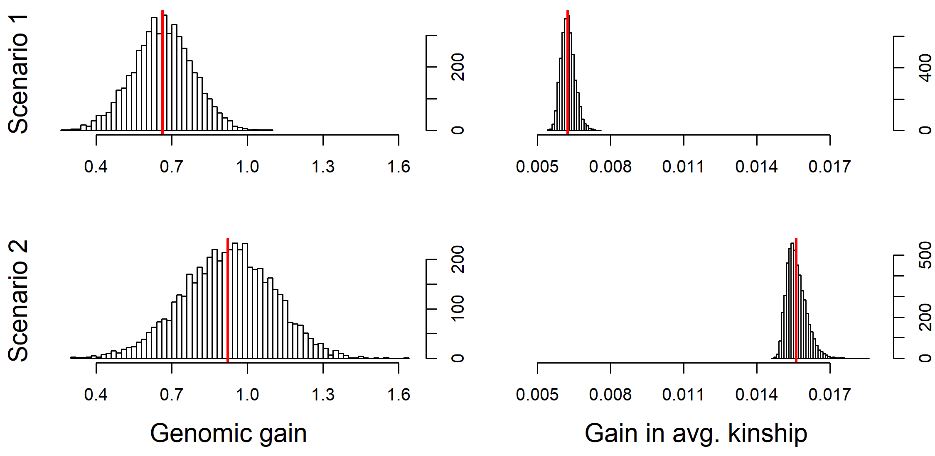

## Generation of a founder population with real genomic data (vcf-file)

# Generation of an exemplary VCF-file to load it

# File should contain: 500 SNPs, 30 Individuals

# SNPs are placed on two chromosome

population **<-** creating.diploid**(**nsnp **=** 500, nindi **=** 30,

chr.nr **=** c**(**rep**(**1,250**)**, rep**(**2, 250**))**,

bp **=** c**(**1**:**250**\***1000000, 1**:**250**\***50000**))**

get.vcf**(**population, path**=**"import_test", gen**=**1**)**

# Convert provided base-pair position into positions in Morgan

# 1 Morgan = 100.000.000 bp is a common conversion rate

# This can differ between species (e.g. chicken: ~30.000.000 bp)

# or be dependent between telomere / centromere

population **<-** creating.diploid**(**vcf**=**"import_test.vcf", bpcm.conversion **=** 1000000**)**

summary**(**population**)**

# Assume markers to be equidistant and generate a genome of fixed size:

population **<-** creating.diploid**(**vcf**=**"import_test.vcf", chromosome.length **=** c**(**2,1**))**

summary**(**population**)**

## Generation of a founder population with real genomic data (ped/map-file)

# Generation of an exemplary Ped/map-files to load it

# File should contain: 500 SNPs, 30 Individuals

# SNPs are placed on two chromosome

population **<-** creating.diploid**(**nsnp **=** 500, nindi **=** 30,

chr.nr **=** c**(**rep**(**1,250**)**, rep**(**2, 250**))**,

bp **=** c**(**1**:**250**\***1000000, 1**:**250**\***50000**))**

get.pedmap**(**population, path**=**"import_test", gen**=**1**)**

#

map **<-** as.matrix**(**read.table**(**"import_test.map"**))**

ped **<-** as.matrix**(**read.table**(**"import_test.ped"**))**

# Order in MoBPS map-files is not the same as in regular PedMap

# This will be fixed soon!

map**[**,3**:**4**]** **<-** map**[**,4**:**3**]**

# Convert PED-file into haplotype dataset (one haplotype per colum)

nsnp **<-** **(**ncol**(**ped**)-**6**)/**2

haplo1 **<-** ped**[**,1**:**nsnp**\***2**+**6**-**1**]**

haplo2 **<-** ped**[**,1**:**nsnp**\***2**+**6**]**

haplo **<-** t**(**rbind**(**haplo1, haplo2**)[**c**(**0,nrow**(**haplo1**))** **+** sort**(**rep**(**1**:**nrow**(**haplo1**)**,2**))**,**])**

population **<-** creating.diploid**(**dataset **=** haplo, map **=** map, bpcm.conversion **=** 1000000**)**

summary**(**population**)**

# Assume markers to be equidistant and generate a genome of fixed size:

population **<-** creating.diploid**(**dataset **=** haplo, map **=** map, chromosome.length **=** c**(**2,1**))**

summary**(**population**)**

## Genotyping and Phenotyping of Subcohorts

Here we show you to generate genotype and/or phenotype data of selected individuals of a cohort. The procedure we recommend using here is to generate a new cohort of individuals that is containing copies of those individuals that are intended to be genotyped and/or phenotyped. In any breeding value estimation of copies selected to be used in a breeding value estimation are accessed the genotype information is used as long as at least one copy is genotyped. Phenotype information of the copy that is phenotyped the most often is used. When using the copy function existing phenotypic information is also copies but later generated phenotypic information is not automatically added.

# Generate a starting population with 5000 SNPs and 500 male individuals

# 3 Traits with 500 purely additive QTL each

# No genotypes / phenotypes are generate

population **<-** creating.diploid**(**nsnp**=**5000, nindi **=** 500,

n.additive **=** c**(**500,500,500**)**,

share.genotyped **=** 0,

sex.quota **=** 0,

name.cohort**=**"Founder"**)**

# Generate a copy of those individuals that are supposed to be

# genotyped and/or phenotyped

population **<-** breeding.diploid**(**population, selection.size **=** c**(**250,0**)**,

copy.individual.m **=** **TRUE**,

selection.m.cohorts **=** "Founder",

name.cohort **=** "PartlyPhenotyped"**)**

population **<-** breeding.diploid**(**population, selection.size **=** c**(**100,0**)**,

copy.individual.m **=** **TRUE**,

selection.m.cohorts **=** "PartlyPhenotyped",

name.cohort **=** "Phenotyped+Genotyped"**)**

# Generate phenotypes for trait 1 & 2. Each trait is assumed to have a heritabilty of 0.5

population **<-** breeding.diploid**(**population, phenotyping.cohorts **=** "PartlyPhenotyped",

n.observation **=** c**(**1,1,0**)**, heritability **=** c**(**0.5,0.5,0.5**)**,

sigma.e.cohorts **=** "Founder"**)**

# Generate genotypes / phenotypes for all traits

population **<-** breeding.diploid**(**population, phenotyping.cohorts **=** "Phenotyped+Genotyped",

genotyped.cohorts **=** "Phenotyped+Genotyped"**)**

# MoBPS default BVE: GBLUP (all non-genotyped individuals are ignored)

# BVE only for the individuals in "Phenotyped+Genotyped"-cohort

# Genotype / Phenotype information from all copies entered in bve.gen/database/cohorts is collected

population **<-** breeding.diploid**(**population, bve**=TRUE**,

bve.cohorts **=** c**(**"Founder", "PartlyPhenotyped",

"Phenotyped+Genotyped"**))**

# BVE with pedigree BLUP

# All 500 individuals are used with 250/250/100 providing phenotype information

population **<-** breeding.diploid**(**population, bve**=TRUE**,

bve.cohorts **=** c**(**"Founder", "PartlyPhenotyped",

"Phenotyped+Genotyped"**)**,

relationship.matrix **=** "kinship"**)**

# BVE with single-step GBLUP

# Usually slightly higher prediction accuracy than pedigree BLUP

population **<-** breeding.diploid**(**population, bve**=TRUE**, singlestep.active **=** **TRUE**,

bve.cohorts **=** c**(**"Founder", "PartlyPhenotyped",

"Phenotyped+Genotyped"**))**

## Simulation of a base population with a hard sweep

We here show how to perform an exemplary simulation to generate a base population and a hard sweep.

# Generate a starting population with 5000 SNPs and 200 individuals

# and a single chromosome of length 2 Morgan.

population **<-** creating.diploid**(**nsnp **=** 5000, nindi **=** 200, chromosome.length **=** 2**)**

# LD build up via 100 generations of random mating

# Each generation contains 200 individuals

**for(**index **in** 1**:**100**){**

population **<-** breeding.diploid**(**population, breeding.size **=** 200,

selection.size **=** c**(**100,100**))**

**}**

# Derive allele frequency and check LD for the last generation:

genotype.check **<-** get.geno**(**population, gen **=** length**(**population**$**breeding**))**

p_i **<-** rowMeans**(**genotype.check**)/**2

ld.decay**(**population, genotype.dataset **=** genotype.check, step **=** 10, max **=** 500**)**

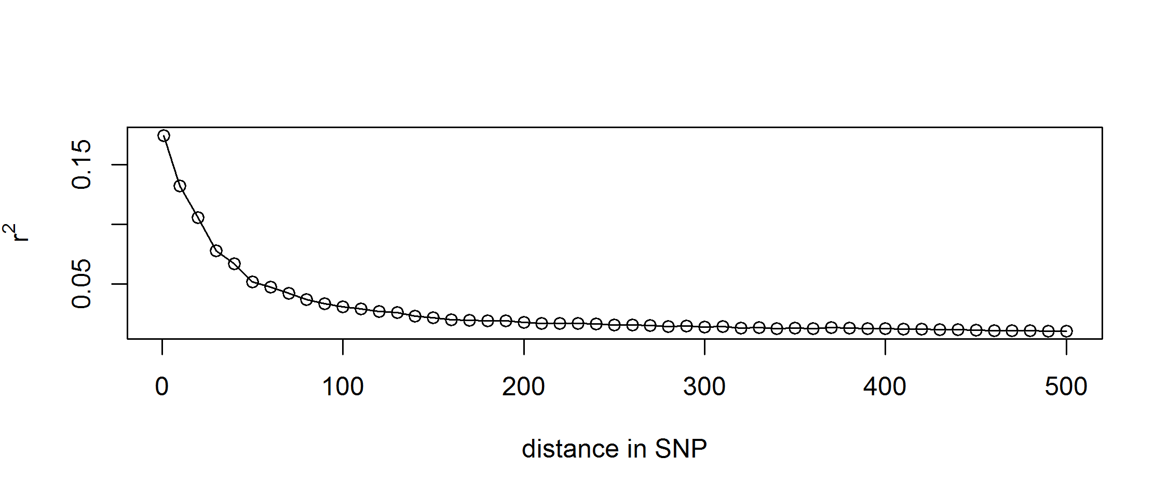

# Simulate a favorable mutation in a previously fixed marker

fixated_markers **<-** which**(**p_i**==**0**)** # Which markers are fixated

qtl_posi **<-** sample**(**fixated_markers, 1**)** # Selected a fixated marker in A

trait **<-** cbind**(**qtl_posi, 1, 0, 1, 2**)** # SNP, Chromosome, Effect AA, Effect AB, Effect BB

population **<-** creating.trait**(**population, real.bv.add **=** trait**)**

# Generate a mutation in the first male individual

population **<-** mutation.intro**(**population, 101, 1, 1, qtl_posi**)**

# Simulate generations with selection pressure

# Individuals with the favorable SNP are picked 5 times as often

**for(**index **in** 1**:**25**){**

population **<-** breeding.diploid**(**population, breeding.size **=** 200,

selection.size **=** c**(**100,100**)**,

best.selection.ratio.m **=** 5,

best.selection.ratio.f **=** 5**)**

**}**

analyze.population**(**population, gen **=** 98**:**115, chromosome **=** 1, snp **=** qtl_posi**)**

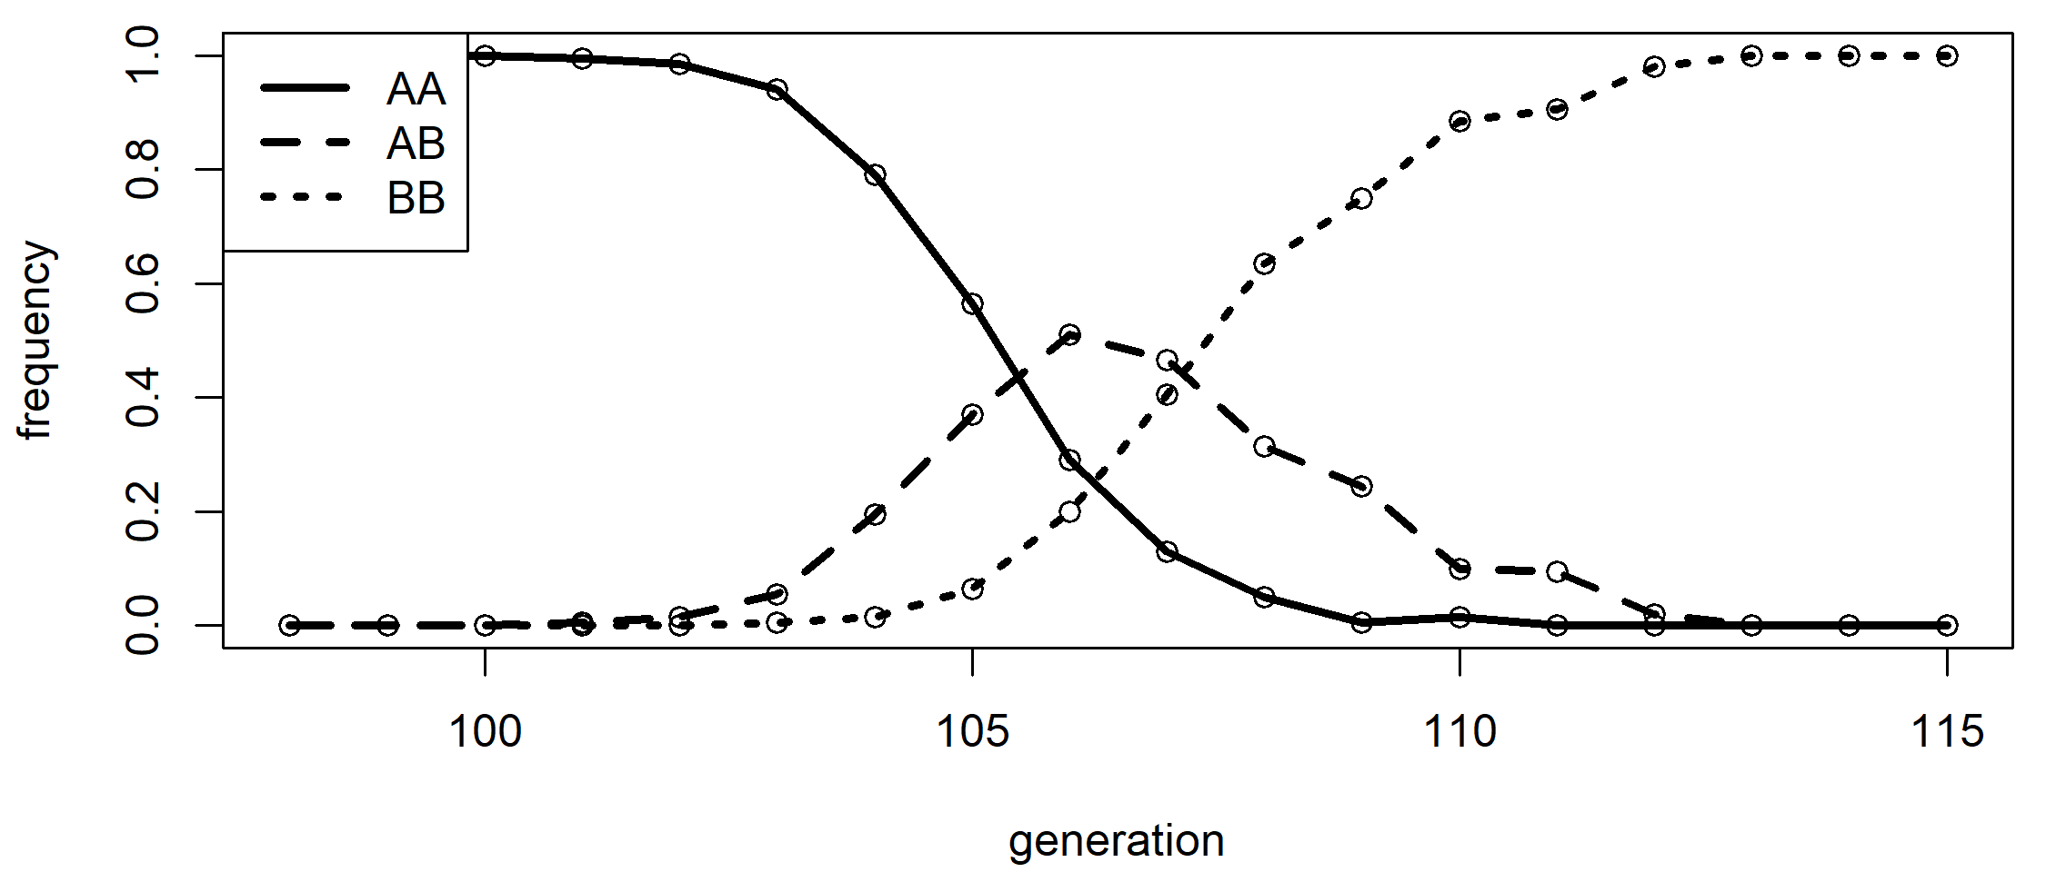

## Generation of traits based on genomic & phenotypic data

Genotyping and phenotypic data can be used to generate a realistic trait architecture for a real-world population. For this the function effect.estimate.add provide an rrBLUP estimator to assign linear effects all markers.

# Load in some data (Ideally real-world but here from an simulated MoBPS population

data**(**ex_pop**)**

pheno **<-** get.pheno**(**ex_pop, gen**=**1**:**5**)**

geno **<-** get.geno**(**ex_pop, gen**=**1**:**5**)**

haplo **<-** get.haplo**(**ex_pop, gen**=**1**:**5**)**

map **<-** get.map**(**ex_pop, use.snp.nr**=TRUE)**

# Estimate marker effects

real.bv.add **<-** effect.estimate.add**(**geno, pheno, map**)**

# Generate new population (or in this case exactly the same) with estimated marker effects

population **<-** creating.diploid**(**dataset **=** haplo, map **=** map, real.bv.add **=** real.bv.add**)**

# First run of breeding.diploid to calculate true genomic values

population **<-** breeding.diploid**(**population**)**

# Check how good the approximation works here:

cor**(**get.bv**(**population, gen**=**1**)[**1,**]**, get.pheno**(**ex_pop, gen**=**1**:**5**)[**1,**])**

cor**(**get.bv**(**population, gen**=**1**)[**1,**]**, get.bv**(**ex_pop, gen**=**1**:**5**)[**1,**])**

## Generation of inbred lines

# Generation of an inbred founder population

# All plants are saves as sex 0 (male)

dhfounder_population **<-** creating.diploid**(**nindi **=** 200, nsnp **=** 500, dataset **=** "homorandom",

sex.quota **=** 0**)**

# Generation of a heterozygous founder population

population **<-** creating.diploid**(**nindi **=** 50, nsnp **=** 500, sex.quota **=** 0**)**

# Generation of inbreds via DH technology

dh_population **<-** breeding.diploid**(**population, breeding.size **=** c**(**200,0**)**, dh.mating **=** **TRUE)**

# Generation of inbreds via five generation of selfing

selfing_population **<-** population

**for(**index **in** 1**:**5**){**

selfing_population **<-** breeding.diploid**(**selfing_population, breeding.size **=** c**(**200,0**)**,

selfing.mating **=** **TRUE)**

**}**

table**(**get.geno**(**dhfounder_population, gen**=**1**))**

table**(**get.geno**(**dh_population, gen**=**2**))**

**for(**gen **in** 1**:**6**){**

print**(**table**(**get.geno**(**selfing_population, gen**=**gen**)))**

**}**

# Share of heterozygous markers in the selfing population reduces by ~50% per cycle

## Generation of a trait with maternal component

For some traits part of the trait expression depends on the genotype of a parent (e.g. mother supplying messenger RNA or proteins to the egg). The following example shows how to generate such a trait with the direct and maternal effect being separated into sub-traits. All following analysis would then be executed just based on the combined trait:

# 1. Trait is direct effect

# 2. Trait is maternal effect

population **<-** creating.diploid**(**nsnp **=** 1000, nindi**=**10,

n.additive **=** c**(**100,100**)**,

var.target **=** c**(**100,20**)**,

shuffle.traits **=** 1**:**2,

shuffle.cor **=** matrix**(**c**(**1,0.5, 0.5, 1**)**, nrow**=**2**)**,

is.maternal **=** c**(FALSE**, **TRUE)**,

trait.name **=** c**(**"direct_effect", "maternal_effect"**))**

# 3. Trait is the sum of both previous traits

population **<-** add.combi**(**population, trait **=** 3, combi.weights **=** c**(**1,1**)**, trait.name **=** "combined_trait"**)**

# Generate some offspring

population **<-** breeding.diploid**(**population, breeding.size **=** 100**)**

# Looking at trait 2 and mother id

bvs **<-** get.bv**(**population, gen**=**2**)**

pedi **<-** get.pedigree**(**population, gen**=**2**)**

cbind**(**pedi**[**,3**]**, bvs**[**2,**])**

## Simulation of a MAGIC population in maize

We here show how to perform an exemplary simulation of a MAGIC population in maize with a mating scheme given in (Zheng et al. 2015) – cf. adjacent Figure.

Since default settings in MoBPS are to always use the last generation anyway the needed code is quite short even without cohort mode. For the sake of completeness, we provide a cohort version for the script as well.

In term of computation time this simulation with a 15.3M genome, 31k SNPs and a total of 780 individuals took 1.6 seconds on one core of my local maschine.

Non-cohort-modus:

# Generation of 20 fully-homozygous founders lines

# All plants are stored as male individuals (sex=0)

population **<-** creating.diploid**(**nindi **=** 20, sex.quota **=** 0, template.chip **=** "maize",

dataset **=** "homorandom"**)**

# Simulate matings between all founders.

# Each plan is involved in exactly 19 matings.

population **<-** breeding.diploid**(**population, breeding.size **=** c**(**190,0**)**,

breeding.all.combination **=** **TRUE**,

selection.size **=** c**(**20,0**)**, max.offspring **=** 19**)**

# Simulate matings between plants of the last generation.

# Each plant is involved in exactly 2 matings.

population **<-** breeding.diploid**(**population, breeding.size **=** c**(**190,0**)**,

selection.size **=** c**(**190,0**)**, same.sex.activ **=** **TRUE**,

same.sex.sex **=** 0, max.offspring **=** 2**)**

population **<-** breeding.diploid**(**population, breeding.size **=** c**(**190,0**)**,

selection.size **=** c**(**190,0**)**, same.sex.activ **=** **TRUE**,

same.sex.sex **=** 0, max.offspring **=** 2**)**

population **<-** breeding.diploid**(**population, breeding.size **=** c**(**190,0**)**,

selection.size **=** c**(**190,0**)**, same.sex.activ **=** **TRUE**,

same.sex.sex **=** 0, max.offspring **=** 2**)**

Cohort-modus:

# Generation of 20 fully-homozygous founders lines

# All plants are stored as male individuals (sex=0)

population **<-** creating.diploid**(**nindi **=** 20, sex.quota **=** 0, template.chip **=** "maize",

dataset **=** "homorandom", name.cohort **=** "F0"**)**

# Simulate matings between all founders.

# Each plan is involved in exactly 19 matings.

population **<-** breeding.diploid**(**population, breeding.size **=** c**(**190,0**)**,

breeding.all.combination **=** **TRUE**,

selection.size **=** c**(**20,0**)**,

selection.m.cohort **=** "F0", name.cohort **=** "F1"**)**

# Simulate matings between plants of the last generation.

# Each plant is involved in exactly 2 matings.

population **<-** breeding.diploid**(**population, breeding.size **=** c**(**190,0**)**,

selection.size **=** c**(**190,0**)**, same.sex.activ **=** **TRUE**,

same.sex.sex **=** 0, max.offspring **=** c**(**2,0**)**,

selection.m.cohort **=** "F1", name.cohort **=** "F2"**)**

population **<-** breeding.diploid**(**population, breeding.size **=** c**(**190,0**)**,

selection.size **=** c**(**190,0**)**, same.sex.activ **=** **TRUE**,

same.sex.sex **=** 0, max.offspring **=** c**(**2,0**)**,

selection.m.cohort **=** "F2", name.cohort **=** "F3"**)**

population **<-** breeding.diploid**(**population, breeding.size **=** c**(**190,0**)**,

selection.size **=** c**(**190,0**)**, same.sex.activ **=** **TRUE**,

same.sex.sex **=** 0, max.offspring **=** c**(**2,0**)**,

selection.m.cohort **=** "F3", name.cohort **=** "F4"**)**

## Simulation of Introgression on blue eggshell QTL in chicken

We here show how to perform an exemplary simulation of a breeding scheme to perform introgression of a single QTL. In terms of computing time this simulation with a 5M genome, 5k SNPs and a total of 520 individuals took 1.2 seconds on one core of my local machine without the usage of miraculix.

# Generate an input SNP-dataset

# 10 White-Layer (0) (20 haplotypes, 5'000 SNPs)

# 10 Wild population (1) (20 haplotypes, 5'000 SNPs)

dataset1 **<-** matrix**(**0, nrow **=** 5000, ncol **=** 20**)**

dataset2 **<-** matrix**(**1, nrow **=** 5000, ncol **=** 20**)**

# Generation of a trait

# Colums code: SNP, chromosome, effect 00, effect 01, effect 11

# Blue Eggshell QTL is positioned on SNP 2000, chromosome 1

major_qtl **<-** c**(**2000, 1, 0, 10000, 20000**)**

# In all other positions the white layer genome is assumed to be favorable

# All marker effects combiened are smaller than the blue eggshell QTL

rest **<-** cbind**(**1**:**5000, 1, 1, 0.5, 0**)**

trait **<-** rbind**(**major_qtl, rest**)**

# Generation of the base-population

# First 10 individuals are female (sex=2)

# Next 10 individuals are male (sex=1)

population **<-** creating.diploid**(**dataset **=** cbind**(**dataset1, dataset2**)**,

real.bv.add **=** trait, name.cohort **=** "Founders",

sex.s **=** c**(**rep**(**2,10**)**, rep**(**1,10**)))**

# Simulate random mating:

population **<-** breeding.diploid**(**population, breeding.size **=** c**(**100,100**)**,

selection.size **=** c**(**10,10**)**,

selection.m.cohorts **=** "Founders_M",

selection.f.cohorts **=** "Founders_F",

name.cohort **=** "F1"**)**

# Simuation of matings with selection:

# Top 50 cocks are mated to the 10 founder hens

# Selection of the cocks based on their genomic value ("bv")

# Target: Increase share of white layer while preserving blue egg shell QTL

population **<-** breeding.diploid**(**population, breeding.size **=** c**(**100,100**)**,

selection.size **=** c**(**50,10**)**,

selection.m.cohorts **=** "F1_M",

selection.f.cohorts **=** "Founders_F",

name.cohort **=** "BC1", selection.m **=** "function",

selection.criteria **=** "bv"**)**

population **<-** breeding.diploid**(**population, breeding.size **=** c**(**100,100**)**,

selection.size **=** c**(**50,10**)**,

selection.m.cohorts **=** "BC1_M",

selection.f.cohorts **=** "Founders_F",

name.cohort **=** "BC2", selection.m **=** "function",

selection.criteria **=** "bv"**)**

population **<-** breeding.diploid**(**population, breeding.size **=** c**(**100,100**)**,

selection.size **=** c**(**50,10**)**,

selection.m.cohorts **=** "BC2_M",

selection.f.cohorts **=** "Founders_F",

name.cohort **=** "BC3", selection.m **=** "function",

selection.criteria **=** "bv"**)**

# Mating of cocks and hens that are heterozygous in blue egg shell QTL

# 25% of resulting offspring should be homozygous in blue egg shell QTL

population **<-** breeding.diploid**(**population, breeding.size **=** c**(**100,100**)**,

selection.size **=** c**(**50,50**)**,

selection.m.cohorts **=** "BC3_M",

selection.f.cohorts **=** "BC3_F",

name.cohort **=** "IC",

selection.criteria **=** "bv"**)**

# Check genomic share of wild race in the final generation

genoIC **<-** get.geno**(**population, cohorts **=** "IC_F"**)**

plot**(**rowSums**(**genoIC**)/**200, xlab **=** "genome", ylab **=** "frequency of wild allele", type **=** "l"**)**

abline**(**v **=** 2000, lwd **=** 2, col **=** "red"**)**

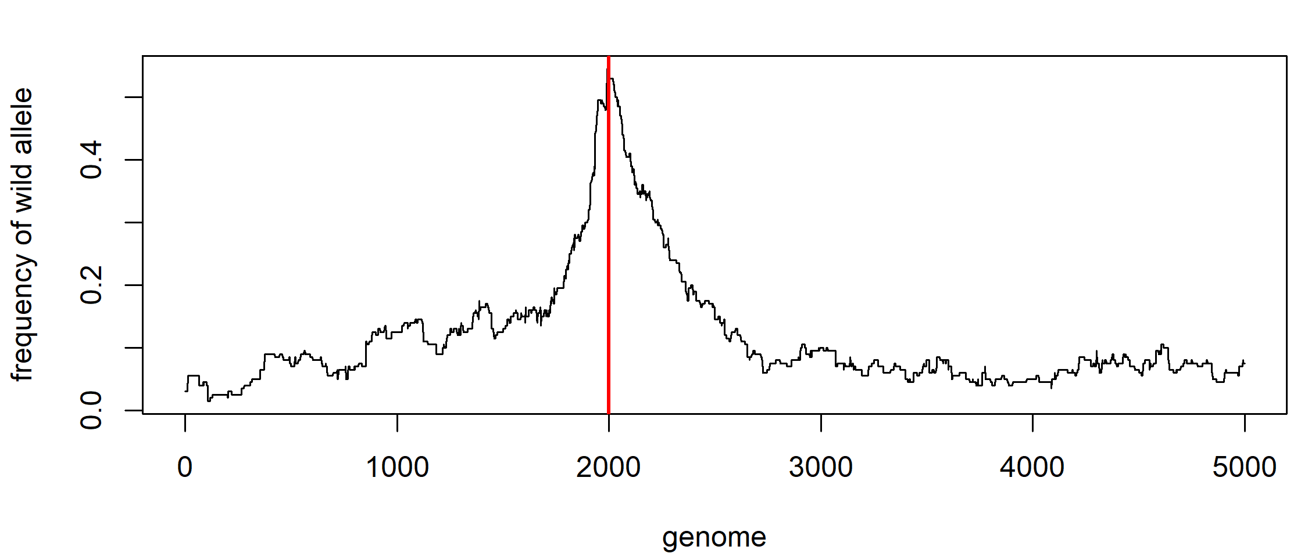

As expected, the frequency of genetic material stemming from the wild type is higher in the region of the QTL.

## Simulation of a conservation breeding program using cock rotation in chicken

We here show how to perform an exemplary simulation of a conservation breeding scheme in chicken and compare a random mating environment with the use of a cock rotation mating scheme (Pook et al. 2017). In term of computing time these two simulations with a 5M genome, 5k SNPs and a total of 1092 individuals each took 5.7 seconds on one core of my local maschine without the usage of miraculix.

# Generate initial boxes with 5 hens (sex=2) and 1 cock (sex=1) each

population **<-** **NULL**

**for(**index **in** 1**:**7**){**

population **<-** creating.diploid**(**population **=** population, nindi **=** 6,

nsnp **=** 5000, sex.s **=** c**(**1, 2, 2, 2, 2, 2**)**,

name.cohort **=** paste0**(**"Box_", index, "gen_0"**))**

**}**

# Simulate 25 generations of matings.

# Hens are rotated by one box per generation.

# best1.from.cohort is the cohort used as sires

# best2.from.cohort is the cohort used as dams

**for(**gen **in** 1**:**25**){**

**for(**index **in** 1**:**7**){**

population **<-** breeding.diploid**(**population, breeding.size **=** c**(**1,5**)**,

selection.size **=** c**(**1,5**)**,

selection.m.cohorts **=** paste0**(**"Box_",

**if(**index**==**1**){**7**}** **else** **{**index**-**1**}**,"gen_", gen**-**1,"_M"**)**,

selection.f.cohorts **=** paste0**(**"Box_", index,"gen_", gen**-**1,"_F"**)**,

name.cohort **=** paste0**(**"Box_", index, "gen_", gen**)**,

add.gen**=**gen**+**1

**)**

**}**

**}**

# Generate a population of same size without cock rotation

pop1 **<-** creating.diploid**(**nindi **=** 42, nsnp **=** 5000,

sex.s **=** c**(**rep**(**1,7**)**, rep**(**2,35**)))**

# Simulate 25 generations of random mating

**for(**gen **in** 1**:**25**){**

pop1 **<-** breeding.diploid**(**pop1, breeding.size **=** c**(**7,35**)**,

selection.size **=** c**(**7,35**))**

**}**

kin **<-** kinship.development**(**population, gen **=** 1**:**26, ibd.obs **=** 1000, hbd.obs **=** 100**)**

kin1 **<-** kinship.development**(**pop1, gen **=** 1**:**26, ibd.obs **=** 1000, hbd.obs **=** 100**)**

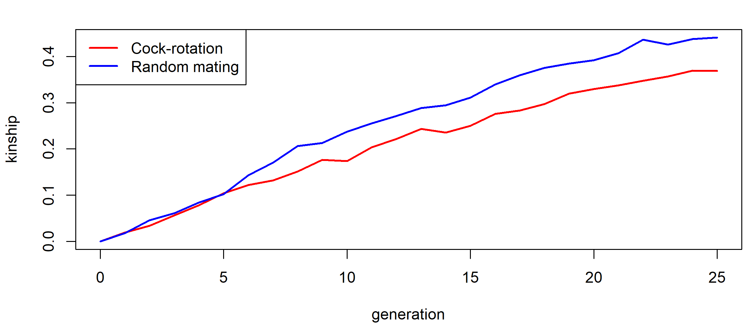

## Simulation of gene editing in a cow breeding program

The following script can be used to simulate a breeding program that is utilizing genome editing. Design is chosen according to (Jenko et al. 2015; Simianer et al. 2018). Note that individual numbers are much smaller than in the two references to ensure low computation times. Simulation of 20 generations with 50’000 cows per generation would take 26.3 hours using 24 cores on the gwdg-hpc (Intel E5-2650 (2X12 core 2.2GHz)). This small example with a 5 Morgan chromosome, 5k SNPs and 4300 individuals took 7.4 seconds.

# Generation of a base population:

# 1'000 Founder individuals

# 5'000 SNPs

# 100 additive single marker QTL

population **<-** creating.diploid**(**nindi **=** 1000, nsnp **=** 5000,

n.additive **=** 100, name.cohort **=** "Founders"**)**

# Simulation of a random mating generation

# 100 bulls (sex=1), 1'000 cows (sex=2) are generated

population **<-** breeding.diploid**(**population, breeding.size **=** c**(**100,1000**)**,

selection.size **=** c**(**500,500**)**,

selection.m.cohorts **=** "Founders_M",

selection.f.cohorts **=** "Founders_F",

name.cohort **=** "Random"**)**

# Generate 200 offspring of both from the top 5 bulls / 200 cows

# Heritability of the trait is set to 0.5

# only phenotypes previously unobserved cows are generated

population **<-** breeding.diploid**(**population, breeding.size **=** 200,

selection.size **=** c**(**5,200**)**, bve **=** **TRUE**,

heritability **=** 0.5,

phenotyping **=** "non_obs_f",

selection.criteria **=** "bve",

name.cohort **=** "Top",

selection.m.cohorts **=** "Random_M",

selection.f.cohorts **=** "Random_F"**)**

# Generate additional cows using all cows of the previous generation

# Cows are added to the same generation as the previous simulation

population **<-** breeding.diploid**(**population, breeding.size **=** c**(**0,900**)**,

selection.size **=** c**(**5,1000**)**,

selection.criteria **=** "bve",

name.cohort **=** "Sec_F",

selection.m.cohorts **=** "Random_M",

selection.f.cohorts **=** "Random_F",

add.gen **=** 3**)**

# Same cycle as before with additional genome editing

# Edits are chosen based on highest effects in rrBLUP

population **<-** breeding.diploid**(**population, breeding.size **=** c**(**100,100**)**,

selection.size **=** c**(**5,200**)**, bve **=** **TRUE**,

phenotyping **=** "non_obs_f",

selection.criteria **=** "bve",

name.cohort **=** "Top_Edit",

selection.m.cohorts **=** "Top_M",

selection.f.cohorts **=** c**(**"Top_F","Sec_F"**)**,

nr.edits **=** 20, estimate.u **=** **TRUE)**

population **<-** breeding.diploid**(**population, breeding.size **=** c**(**0,900**)**,

selection.size **=** c**(**5,1000**)**,

selection.criteria **=** "bve",

name.cohort **=** "Sec_Edit",

selection.m.cohorts **=** "Top_M",

selection.f.cohorts **=** c**(**"Top_F","Sec_F"**)**,

add.gen **=** 4**)**

bv.development.box**(**population, cohorts **=** c**(**"Founders_F", "Random_F", "Sec_F",

"Top_F", "Sec_Edit", "Top_Edit_F"**)**, display **=** "bv"**)**

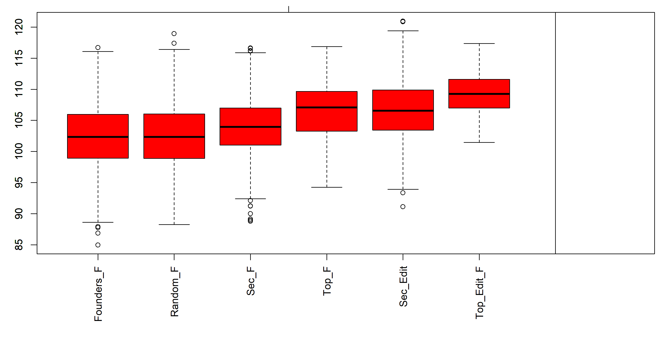

## Simulation of a simple GxE case

# Generation of a baseline population

# Generation of a trait with slightly different genetic architecture in two environments

set.seed**(**1**)**

population **<-** creating.diploid**(**nsnp**=**5000, nindi**=**100, n.additive **=** c**(**100,100**)**,

shuffle.cor **=** matrix**(**c**(**1,0.9,0.9,1**)**, ncol**=**2**))**

# Linking of the two traits (environments)

population **<-** combine.traits**(**population, combine.traits **=** 1**:**2**)**

# Collection of phenotypic data

# 50 lines are phenotypes in either of the two environments

population **<-** breeding.diploid**(**population, phenotyping.database **=** cbind**(**1,1**)**,

heritability **=** 0.3, n.observation **=** c**(**1,0**))**

population **<-** breeding.diploid**(**population, phenotyping.database **=** cbind**(**1,2**)**,

heritability **=** 0.3, n.observation **=** c**(**0,1**))**

# Breeding value estimation on the entire set

population **<-** breeding.diploid**(**population, bve**=TRUE**, bve.gen **=** 1**)**

# Details on the accuracy of the BVE on the individuals sets

#(for comparability later)

analyze.bv**(**population, database**=**cbind**(**1,1**))**

analyze.bv**(**population, database**=**cbind**(**1,2**))**

# Breeding value estimation when only using one of the two sets

population **<-** breeding.diploid**(**population, bve**=TRUE**, bve.database **=** cbind**(**1,1**))**

population **<-** breeding.diploid**(**population, bve**=TRUE**, bve.database **=** cbind**(**1,2**))**

Accuracy joined BVE:

Set1: 0.5172634 0.4899090

Set2: 0.6329011 0.7166195

Individual BVEs:

0.5126079 0.4889113

0.6319154 0.7123234

Only minor in this case but better than nothing =)

## Use of the culling module

library**(**MoBPS**)**

set.seed**(**1**)**

# Generate a founder population

population **<-** creating.diploid**(**nsnp**=**1000, nindi **=** 100, n.additive **=** 100**)**

# Make sure the simulated trait has a set mean and variance

population **<-** bv.standardization**(**population, gen**=**1, mean.target **=** 100, var.target **=** 10**)**

# Generate offspring

population **<-** breeding.diploid**(**population, breeding.size **=** 500, selection.size **=** c**(**50,50**))**

### Plain application of culling with a set probability

# Apply culling with a probability of 0.3 to all individuals

pop1 **<-** breeding.diploid**(**population, culling.gen**=**2, culling.share1 **=** 0.3**)**

# Death animals put into class (-1)

# This means that these individuals on default will not be used for reproduction anymore

# These individuals can still be used in a breeding value estimation

table**(**get.class**(**pop1, gen**=**2**))**

#-1 0

#170 330

### Apply culling with a probability depending on the genomic value

pop2 **<-** breeding.diploid**(**population, culling.gen**=**2, culling.bv1 **=** 100, culling.share1 **=** 0.5, culling.bv2 **=** 105, culling.share2 **=** 0.1,

culling.index **=** 1**)**

class **<-** get.class**(**pop2, gen**=**2**)**

bv **<-** get.bv**(**pop2, gen**=**2**)[**1,**]**

par**(**mfrow**=**c**(**2,1**))**

hist**(**bv**[**class**==**0**]**, xlim**=**c**(**90,110**)**, main**=**"Genomic value distribution of alive individuals", xlab**=**"genomic value"**)**

hist**(**bv**[**class**==(-**1**)]**, xlim**=**c**(**90,110**)**, main**=**"Genomic value distrition of death individuals", xlab**=**"genomic value"**)**

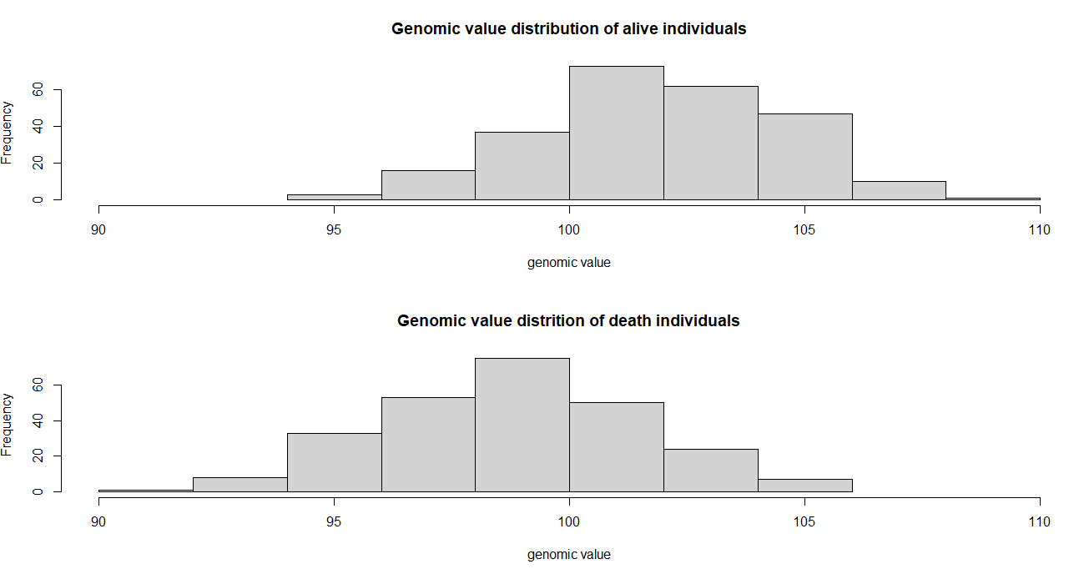

## Simulation of an age structure

library**(**MoBPS**)**

set.seed**(**1**)**

# Generation of an initial breeding population

population **<-** creating.diploid**(**nsnp **=** 1000, nindi **=** 200, name**=**"Breeding_Population_1"**)**

**for(**index **in** 1**:**20**){**

# Generation of new offspring

population **<-** breeding.diploid**(**population, breeding.size **=** 100, name**=**paste0**(**"Offspring_",index**)**,

selection.m.cohorts **=** paste0**(**"Breeding_Population_", index, "_M"**)**,

selection.f.cohorts **=** paste0**(**"Breeding_Population_", index, "_F"**)**,

time.point **=** index**)**

# Calculate how many animals are alive

alive_m **<-** sum**(**get.class**(**population, cohorts **=** paste0**(**"Breeding_Population_", index, "_M"**))==**0**)** **+** 50

alive_f **<-** sum**(**get.class**(**population, cohorts **=** paste0**(**"Breeding_Population_", index, "_F"**))==**0**)** **+** 50

# individuals from the offspring and breeding population are merged into a joint breeding population for the next cycle

population **<-** breeding.diploid**(**population, combine **=** **TRUE**,

selection.m.cohorts **=** c**(**paste0**(**"Breeding_Population_", index, "_M"**)**,

paste0**(**"Offspring_", index, "_M"**))**,

name.cohort **=** paste0**(**"Breeding_Population_", index**+**1, "_M"**))**

population **<-** breeding.diploid**(**population, combine **=** **TRUE**,

selection.f.cohorts **=** c**(**paste0**(**"Breeding_Population_", index, "_F"**)**,

paste0**(**"Offspring_", index, "_F"**))**,

name.cohort **=** paste0**(**"Breeding_Population_", index**+**1, "_F"**))**

# All individuals are culled with a probability of 0.3

### IF different culling probabilites per age are wanted culling could be applied on the Offspring cohorts

### if one copy of an individuals is culled, all other copies are culled as well

### culling.share1 can also be a vector to assign each individual will a different culling probability

population **<-** breeding.diploid**(**population, culling.cohorts **=** paste0**(**"Breeding_Population_", index**+**1, c**(**"_M", "_F"**))**,

culling.share1 **=** 0.3**)**

**}**

# Extract the Age distribution in the final breeding population

age **<-** 21 **-** get.age.point**(**population, cohorts**=**paste0**(**"Breeding_Population_", 21, c**(**"_M", "_F"**))** **)**

table**(**age**)**

# age

#1 2 3 4 5 6 7 8 9 10 11 16 17 21

#100 73 54 32 23 18 17 9 6 7 6 1 1 1

hist**(**age, main**=**"Distribution of the age of individuals in the breeding population", nclass**=**50**)**

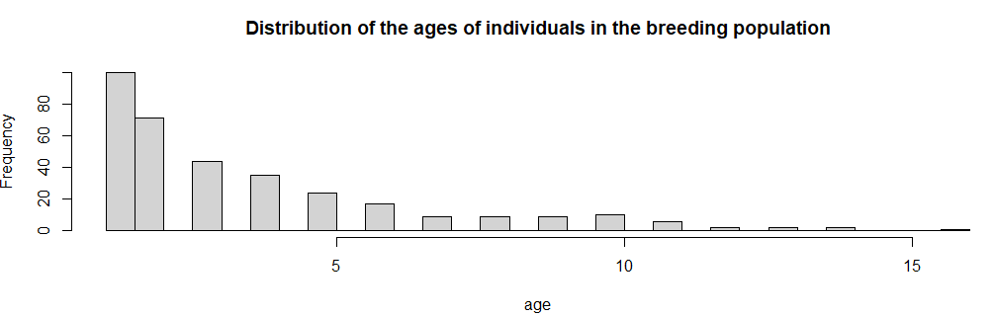

## Import data from a ped-file

library**(**MoBPS**)**

# Create an exemplary ped-file:

population **<-** creating.diploid**(**nsnp**=**1000, nindi**=**100**)**

get.pedmap**(**population, path**=**"temp", gen**=**1**)**

# Transform PED -> Haplotypes per column

ped_file **<-** utils**::**read.table**(**"temp.ped"**)**

haplo12 **<-** t**(**ped_file**[**,**-(**1**:**6**)])**

haplo **<-** matrix**(**0, ncol **=** ncol**(**haplo12**)\***2, nrow**=**nrow**(**haplo12**)/**2**)**

**for(**index1 **in** 1**:**ncol**(**haplo12**)){**

haplo**[**,index1**\***2**+**c**(-**1,0**)]** **<-** matrix**(**haplo12**[**,index1**]**, ncol**=**2, byrow**=TRUE)**

**}**

# markers in exclude snps are not picked as QTL / no genotyping is performed

population **=** creating.diploid**(**dataset **=** haplo**)**

## Generate QTL / and neural loci (e.g. not used in breeding value estimation)

library**(**MoBPS**)**

# The goal here is to generate 1000 markers of which:

# 100 are QTLs not placed on an array

# 500 markers that are placed on an array

# 400 markers that are not on the array (neural)

# Pick array markers:

array_marker **<-** sort**(**sample**(**1**:**1000, 500**))**

array_mobps **<-** rep**(FALSE**, 1000**)**

array_mobps**[**array_marker**]** **<-** **TRUE**

# markers in exclude snps are not picked as QTL / no genotyping is performed

population **=** creating.diploid**(**nsnp**=**1000, nindi**=**100, n.additive **=** 100,

exclude.snps **=** array_marker, share.genotyped **=** 0**)**

# Add an additional genotyping array

# Default array (1) will always contain all markers

# Hence this is the second array (2)

# You can later selected with array to use for genotyping with genotyped.array

population **<-** add.array**(**population, marker.included **=** array_mobps**)**

# Extract QTL position and neural loci position

qtls **<-** sort**(**get.qtl**(**population**))**

neural_loci **<-** **(**1**:**1000**)[-**c**(**qtls, array_marker**)]**

# Perform a breeding value estimation based on the SNP subset

population **<-** breeding.diploid**(**population **=** population, genotyped.array **=** 2,

genotyped.gen **=** 1, genotyped.share **=** 0.5**)**

population **<-** breeding.diploid**(**population, phenotyping.gen **=** 1, heritability **=** 0.5**)**

population **<-** breeding.diploid**(**population, bve**=TRUE**, bve.gen **=** 1,

singlestep.active **=** **TRUE)**

# if less than all markers are used in the BVE you will always get a print of the form:

# 500 markers survived filtering for BVE.

# To check which markers are genotyped for which individuals

get.genotyped.snp**(**population, gen**=**1**)**

# Exporting information from the population-list (get.XXXX)

Most of the data stored in a population list is highly compressed since saving haplotypes of all individuals of the dataset for all generations would often exceed most local machines or even servers. For some applications (especially if one wants to perform his own fancy simulations without contacting the author and asking him to extend the package) it might be useful to understand the data structure behind it. For that, we refer to section 10. In most cases, using our predefined export functions should be enough:

To select for which individuals the required information is exported groups of individuals can be selected via **gen**, **database,** and **cohorts**. For details on the structure, we refer to section 3. On default, names of individuals will be chosen according to the MoBPS identifier name coding “Sex Number _ Generation”. To instead use the underlying ID assigned upon generation set the parameter **use.id** to TRUE. Note that the other of individuals will be done according to position in the database (starting with the lowest generation), even when the input in **gen/database/cohorts** might suggest a different ordering!

## get.geno

This function will export genotypes. To additionally output the base pair of the minor/major allele set the parameter **export.alleles** to TRUE. Each column contains one genotype with column names indicating sex, individual number and generation.

To replace all non-genotyped entries with NAs set **non.genotyped.as.missing** to TRUE.

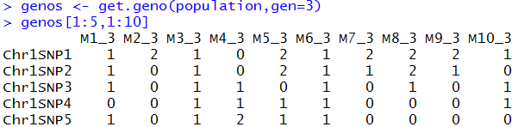

## get.haplo

This function will export haplotypes. To additionally output the base pair of the minor/major allele set the parameter **export.alleles** to TRUE. Each column contains one haplotype with column names indicating sex, individual number, chromosome set (currently only diploid individuals) and generation. To replace all non-genotyped entries with NAs set **non.genotyped.as.missing** to TRUE.

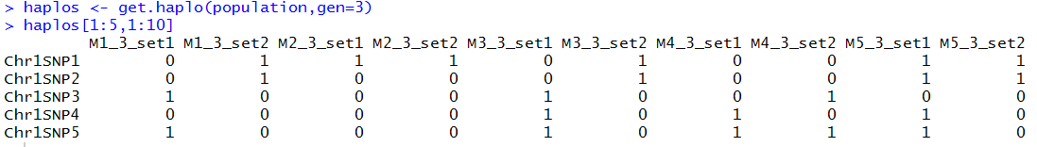

## get.bv / get.bve / get.pheno / get.reliability / get.selectionindex / get.npheno

These functions will export the true underlying breeding value (“bv”), the estimated breeding value (“bve”), the phenotype (“pheno”), the reliability for each breeding value estimation/trait (“reliability”), the selection index used in the last selection procedure (“selectionindex”) and the number of times each trait has been phenotyped for the selected groups of individuals (**gen**/**database**/**cohort**).

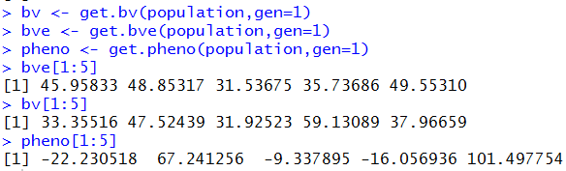

## get.qtl / get.qtl.effects / get.qtl.variance

These function will provide information on the underlying simulated QTLs. With *get.qtl()* providing information on the positions (based on order in the genotype dataset) have effects. *get.qtl.effects()* additionally provide explicit information on the size of the effects. *get.qtl.variance()* will compute the additive genetic variance of all single marker QTLs (**n.additive** / **n.dominant / n.equal.additive / n.equal.dominant** / input of **real.bv.add**).

data**(**ex_pop**)**

get.qtl**(**ex_pop**)**

[1] 62 97 23 15 64 38 81 41 7 99

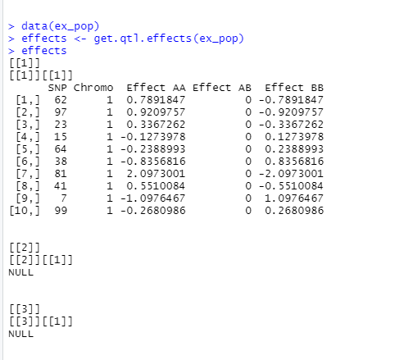

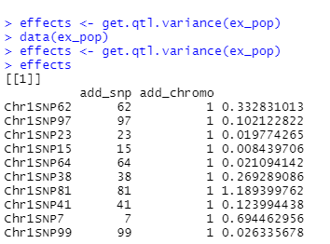

## get.recombi

This function will export all points of recombination and the genetic origin of each segment. The structure here is a list of 4 elements with elements 1 (paternal) and 2 (maternal) containing recombination points and elements 3 (paternal) and 4 (maternal) containing the genetic origin.

Each row is coding the genetic origin between two points (generation, sex, individual number, chromosome set). In the example provided this would mean that the segment between 0.000 and 0.218 of the paternal chromosome originates from the second chromosome set of the 532nd female individual of the first generation.

Note that in addition to all recombination points the start and end points of chromosomes are also exported.

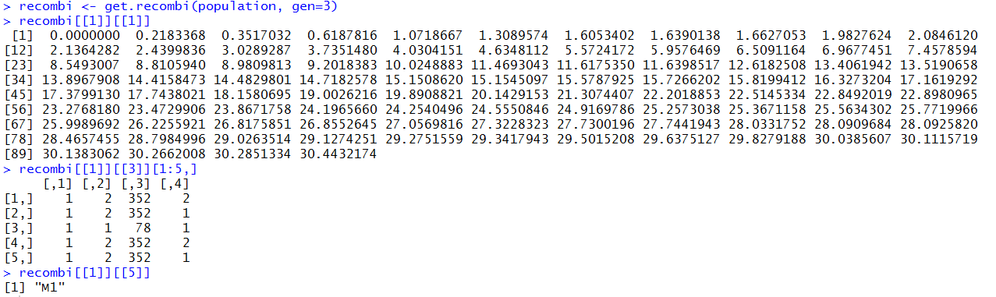

## get.pedigree (1/2/3)

This function will export the pedigree. Individuals are coded by sex, individual number and generation.

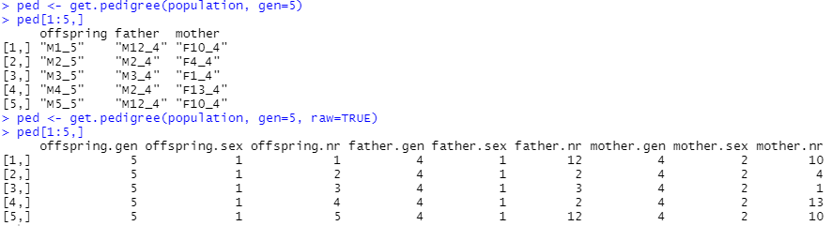

Instead of a character string with “M”/”F” indicting sex, one can also directly export a table with 9 columns indicating Sex (1/2), Generation(1,2,3,…) and individual number (1,2,3,…) in a numeric format by setting **raw** to TRUE.

To export grandparents use *get.pedigree2()*, to get both *get.pedigree3()*. In *get.pedigree2()* one can additionally export the share of the genome inherited by which grandparent by setting the parameter **shares** to TRUE.

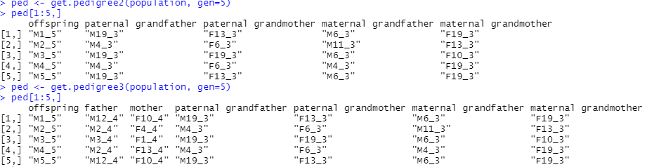

## get.cohorts

This function extracts all existing cohorts from the population list. Set **extended** to TRUE to also extract further information on the cohorts:

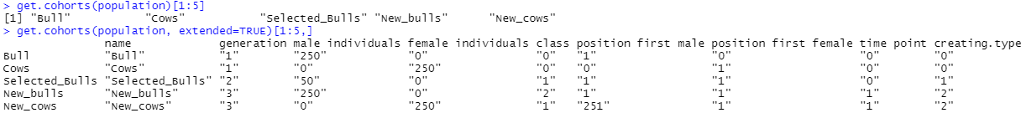

## get.id

This function extracts the individual ids for individuals from the selected gen/database/cohorts.

## get.class

This function extracts the class of each individual:

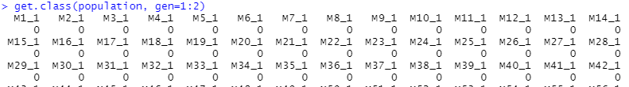

…

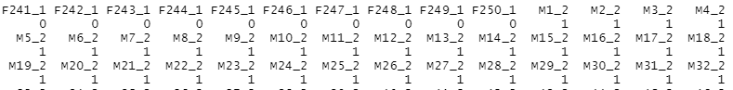

## get.genotyped

This function extracts if an individual is genotyped or not (mostly relevant for cost calculation and/or use in Single Step GBLUP (Legarra et al. 2014).

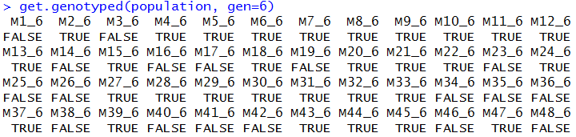

## get.genotyped.snp

This function extracts for which SNPs the selected groups of individuals (**gen**/**database**/**cohorts**) are genotyped.

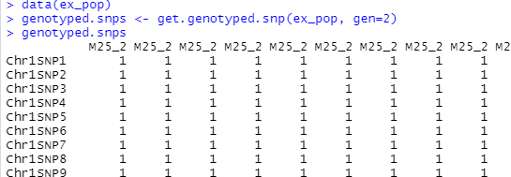

## get.time.point

This function to extract the time point of generation – this is mostly applicable when using the web-based application since there, the first possible time point of generation is automatically calculated.



…

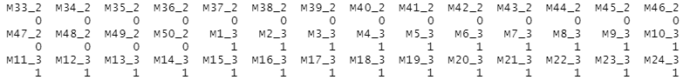

## get.creating.type

This function extracts the creating type of each individual – this is mostly applicable when using the web-based application of the package. Here following coding is used:

0 – Founder

1 – Selection

2 – Reproduction

3 – Recombination

4 – Selfing

5 – DH-Production

6 – Cloning

7 – Combine

8 – Aging

9 – Split

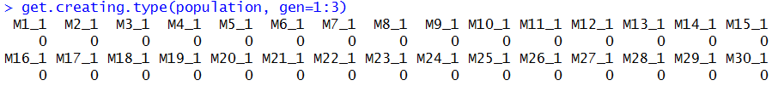

…



## get.cullingtime

This function extracts the time of culling of each individual – this is mostly applicable when using the web-based application of the package.

## get.time.point

This function extracts the time the selected gen/database/cohorts were generated.

## get.age.point

This function extracts the time THIS copy of the individual selected in gen/database/cohorts were generated. Usually the same as get.time.point unless copy.individual was used.

## get.individual.loc

Function to derive the position in the stored population-list.

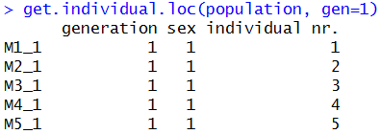

## get.pheno.off

Function to extract the average phenotype of the offspring of individuals selected in gen/database/cohorts.

## get.pheno.off.count

Function to extract the number of observations used to derive the average phenotype of offspring in *get.pheno.off().*

## get.selectionbve

Function to extract the breeding value used for selection in the last breeding value estimation for selected gen/database/cohorts. Mostly used in case of multi-trait models

## get.pca

This function will generate a PCA for the individuals in selected groups (**gen**/**database**/**cohorts**). On default the first two (1:2) principle components will be plotted. Other components can be selected via **components**. On default, individuals are colored via their group (**coloring** = “group”). Alternatively, coloring can be done according to the individual sex (“sex”), class (“class”), original class at the point of generation (“genclass”) or just the same color for all (“plain”). Alternatively, it is also possible to provide a vector with the length of the number of individuals in coloring, which will then use these individually chosen colors for each respective individual.

data**(**"ex_pop"**)**

get.pca**(**ex_pop, gen**=**1**:**2**)**

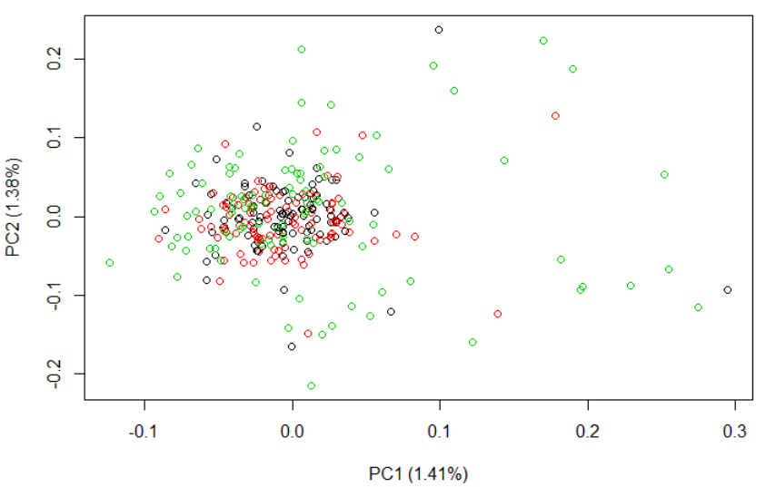

## get.admixture

This function will generate an admixture plot for the individuals in selected groups (**gen/database/cohorts**). For this, the R-package alstructure is used. The number of dimensions to include is automatically estimated based on the alstructure algorithm, but can also be manually set via the parameter **d**. To sort individuals based on their contributions to the respective dimensions set **sort** to TRUE. To exclude individuals with low contributions from the sorting, use **sort.cutoff**.

data**(**ex_pop**)**

get.admixture**(**ex_pop, gen**=**4**:**6, d**=**3, sort**=TRUE)**

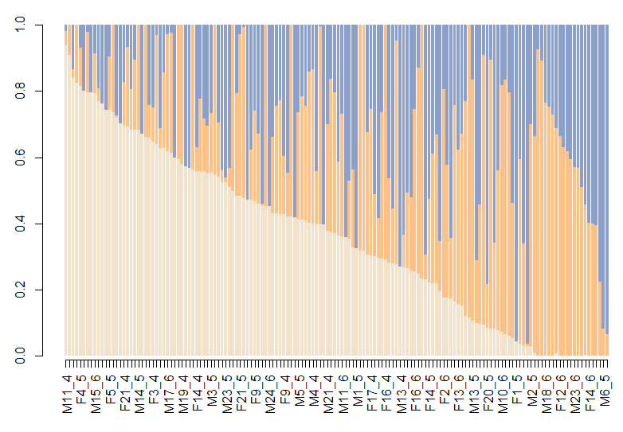

## get.dendrogram

This function will generate a dendrogram plot for the individuals in selected groups (**gen/database/cohorts**). For this, the R-package NAM is used. The used genetic distance can be selected via the parameter method (default: “Nei”, alt: “Rogers”, “Prevosti”, “Modified Rogers”).

data**(**ex_pop**)**

get.dendrogram**(**ex_pop, gen**=**2**)**

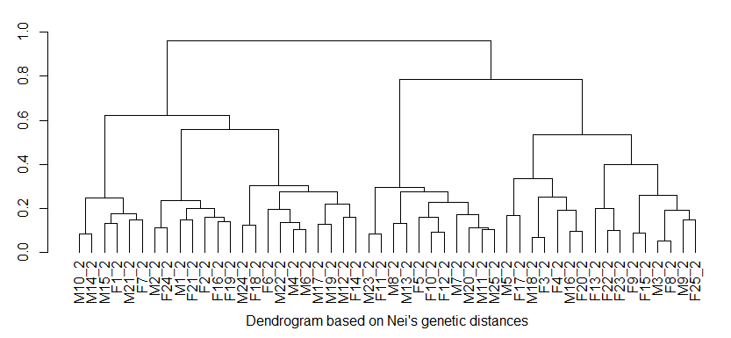

## get.dendrogram.heatmap

This function will generate a dendrogram plot for the individuals in selected groups (**gen/database/cohorts**) including a heatmap for the different traits selected via the parameter **traits** and **type** (default: “pheno”, alt: “bv”, “bve”). For this, the R-package NAM is used. The used genetic distance can be selected via the parameter method (default: “Nei”, alt: “Rogers”, “Prevosti”, “Modified Rogers”).

population **<-** creating.diploid**(**nsnp**=**1000, nindi**=**40, n.additive **=** c**(**100,100,100**)**,

shuffle.cor **=** matrix**(**c**(**1,0.8,0.2,0.8,1,0.2,0.2,0.2,1**)**, ncol**=**3**)**, shuffle.traits **=** 1**:**3**)**

population **<-** breeding.diploid**(**population, phenotyping **=** "all", heritability **=** 0.5**)**

get.dendrogram.heatmap**(**population, gen**=**1, type**=**"pheno"**)**

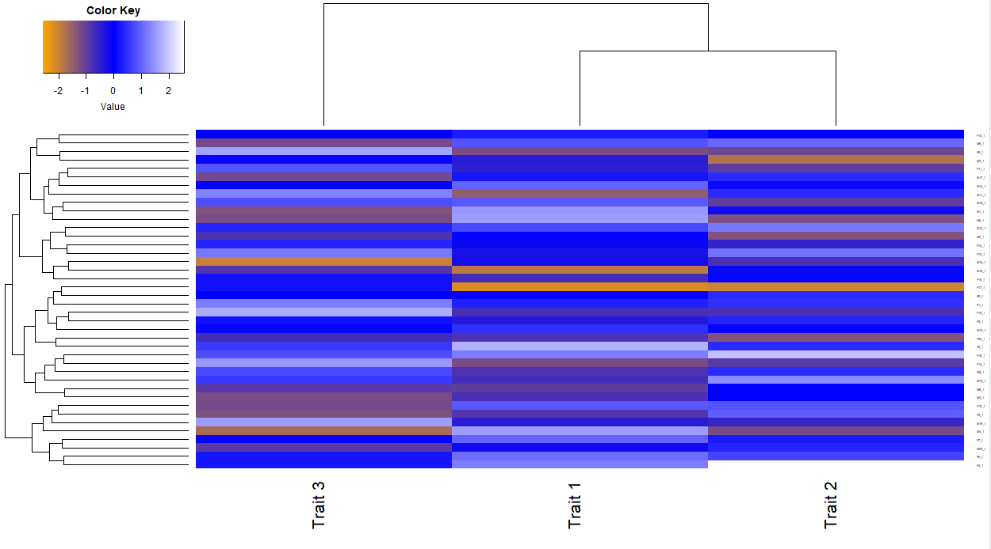

## get.dendrogram.trait

This function will generate a dendrogram plot for distribution of trait values in selected groups (**gen/database/cohorts**) for the different traits selected via the parameter **traits** and **type** (default: “pheno”, alt: “bv”, “bve”). For this, the R-package NAM is used. The used genetic distance can be selected via the parameter method (default: “Nei”, alt: “Rogers”, “Prevosti”, “Modified Rogers”).

population **<-** creating.diploid**(**nsnp**=**1000, nindi**=**100, n.additive **=** c**(**100,100,100**)**,

shuffle.cor **=** matrix**(**c**(**1,0.8,0.2,0.8,1,0.2,0.2,0.2,1**)**, ncol**=**3**)**, shuffle.traits **=** 1**:**3**)**

population **<-** breeding.diploid**(**population, phenotyping **=** "all", heritability **=** 0.5**)**

get.dendrogram.trait**(**population, gen**=**1, type**=**"pheno"**)**

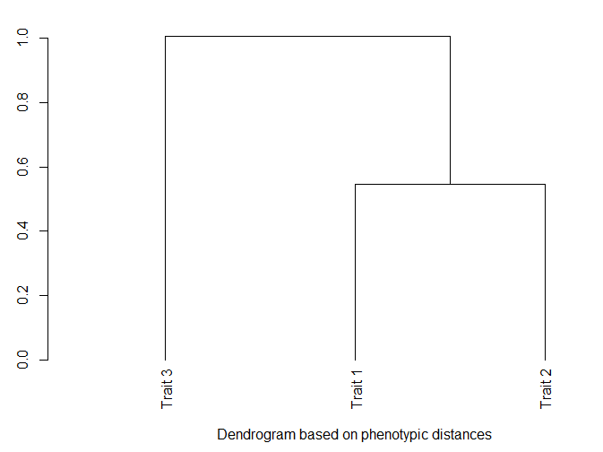

## get.phylogenetic.tree

This function will generate a phylogenetic tree for selected groups (**gen/database/cohorts**). For this, the R-packages NAM and phylogram are used. The distance measure used can be selected via the parameter **method** (default: “Nei”, alt: “Rogers”, “Prevosti”, “Modified Rogers”). A circular layout tree can be build by setting the parameter **circular** to TRUE. Ward distance is used in the clustering.

data**(**ex_pop**)**

get.phylogenetic.tree**(**ex_pop, gen**=**1, circular**=FALSE)**

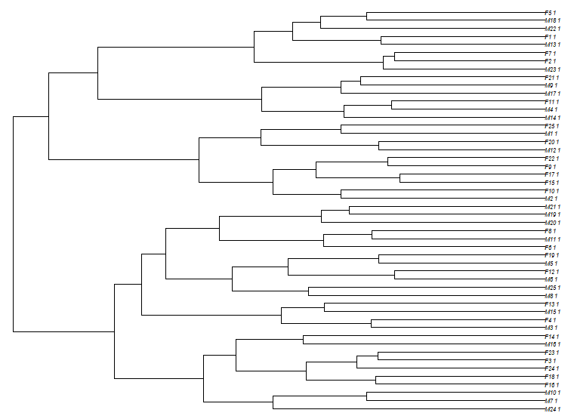

get.phylogenetic.tree**(**ex_pop, gen**=**1, circular**=TRUE)**

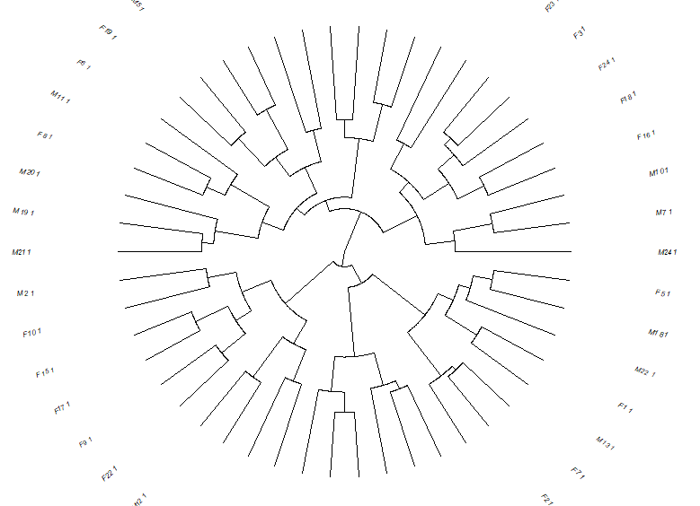

## get.distance

This function allows to compute the genetic distance between two populations given via **gen1/database1/cohort1** and **gen2/database2/cohort2**. For more than two populations provide each database as a list element in **gen/database/cohorts.list**. The distance measure used can be selected via the parameter **type** (default: “nei”, alt: “cavalla”, “reynold”, “nei_minimum”, “nei_distance”). To selected which marker are used, the parameter **marker** can be used (default: “alt”) or statistics can be provided **per.marker**.

## get.effect.freq

To extract the allele frequency at all QTLs to a selected group of individuals (gen/database/cohorts) use this function. To sort markers along the genome set sort to TRUE.

## get.selectionindex

Function to extract the last selection index used to form a breeding value for selected gen/database/cohorts. In particular relevant in case index weights are scaled by reliability factors as in (Miesenberger 1997).

## get.vcf

Function to export genomic data in a vcf-file. The groups to include in the file can be selected via **gen**/**database**/**cohorts** and the path to write to is selected in **path**. To replace all non-genotyped entries with “./.” set **non.genotyped.as.missing** to TRUE.

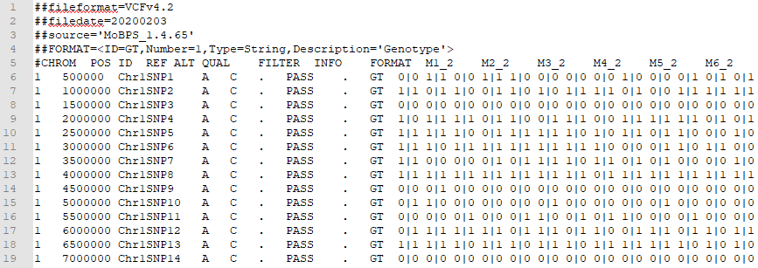

## get.pedmap

Function to export genomic data in a ped and a map-file (PLINK format (Purcell et al. 2007)). The first of the two columns of each marker is representing the first haplotype of the individual. The groups to include in the file can be selected via **gen**/**database**/**cohorts** and the path to write to is selected in **path**. To replace all non-genotyped entries with N set **non.genotyped.as.missing** to TRUE.

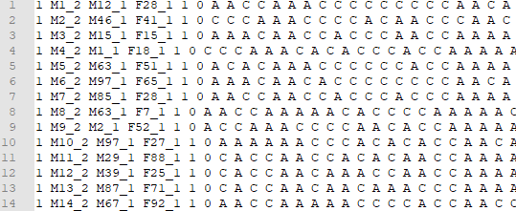

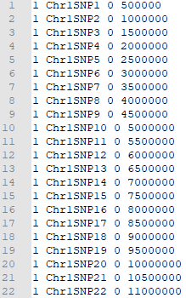

## get.map

Function to export a matrix with map-information (1st column: Chromosome, 2nd column: SNP-name, 3rd column: BP-position, 4th column: Morgan-position.

## get.database

Function to merge **gen**, **database,** and **cohorts** –info into a joint database. On default, the resulting database will have as low number of rows as possible and by that put multiple cohorts into a joint row. To avoid this set **avoid.merging** to TRUE.

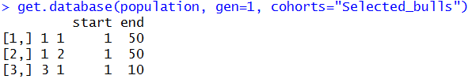

Instead of providing **gen/database/cohort** it is also possible to provide individual IDs in the **id** parameter. Available animals will subsequently be screened on where selected IDs are located. On default, the first version of an individual will be given – to display all copies set **id.all.copy** to TRUE, to display the last copy set **id.last** to TRUE. This is only relevant if **copy.individual** is used as this allows the generation of multiple version of an individual with the same ID.

# Importing information to the population-list

## insert.bve

To manually insert breeding values (type=”bve”), true genetic values (type=”bv”) or phenotypes (type=”pheno”) use the function insert.bve. Output is a modified population list. In case new phenotypes are observed this is counted as **count** observations. This will only increase the number of phenotypes generated for a trait unless **count.only.increase** is set to FALSE. In case bve are changed it is assumed that genotyping was necessary unless **count** is set to 0. This is only relevant for economic calculations.

New observations are entered in the parameter **bves** with the first column coding the individual and the others containing values for the traits:

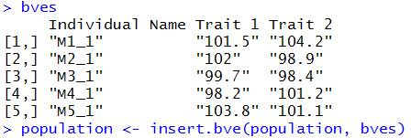

The structure of individual names is the same in all export functions (sex [“M”/”F”], individual number [1,2,…], and generation [1,2,…]). It is recommended to just use the names as they are exported via *get.geno()* etc..

## set.class

This function can be used to manually change the class of selected **gen**/**database**/**cohorts** to the class **new.class** in an already existing population list.



# Utility functions & advanced features

In this section a set of utility function is described that should help you get a better overview of your population list. This list is constantly growing and we are always happy for suggestions on additional function to add to our package.

## set.default

This function can be used to automatically initialize selected parameters in *breeding.diploid()*. The parameter to initialize is selected via **parameter.name** and the value is given in **parameter.value**. To remove a specific initialization use **parameter.remove** or remove all previously set parameters via setting **reset.all** to TRUE.

## bv.development

This function will generate a plot showing the development of breeding values and phenotypes over generations. 95% confidence bands are included in a dotted line:

Which groups to display is selected via the parameters **gen**, **database** & **cohorts**. In case the user interface was used to generate the population list set **json** to TRUE to automatically display all selected cohorts. Confidence bands are drawn for “bv” (1), “bve” (2) & “pheno”(3) – to change the quantile use the parameter **quantile** (default: 0.95), to exclude selected the for with to draw a confidence band via the parameter **confidence** (default: c(1,2,3)). Groups with only zeros are ignored on default – if you want lines to be included for all selected cohorts set **ignore.zero** to FALSE.

To display the time point, the creating type, the sex, and cohort name set **display.time.point**, **display.creating.type**, **display.cohort.name**, **display.sex** to TRUE. In case the generating interface between groups is highly heterozygous it might be useful to use **equal.spacing** between displayed cohorts. To not display the line displaying a long-term trend of the breeding values set **display.line** to FALSE.

population **<-** json.simulation**(**total **=** ex_json**)**

bv.development**(**population, json**=TRUE**, bvrow**=**1, confidence **=** 1, development **=** 1,

display.creating.type **=** **TRUE**, display.sex **=** **TRUE**,

display.cohort.name **=** **TRUE)**

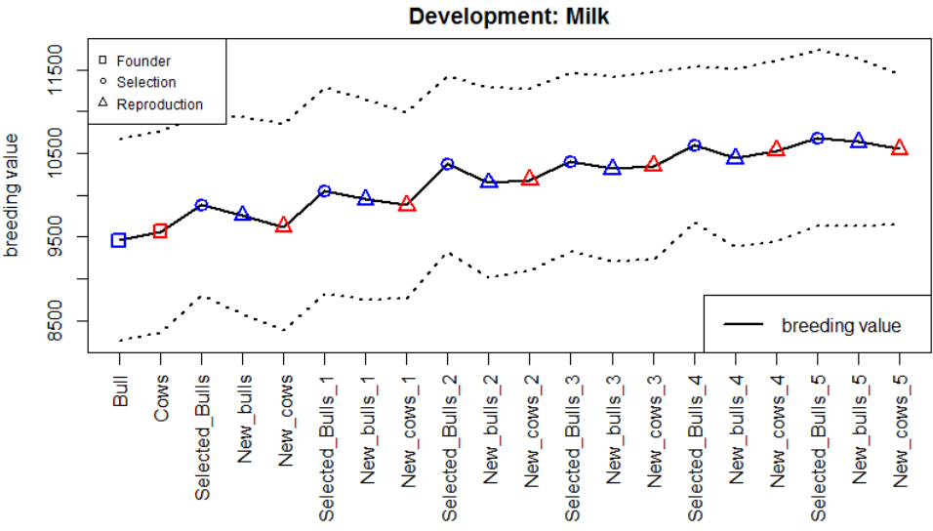

## bv.development.box

This function will generate a plot displaying the development of breeding values with a boxplot for each selected **gen**, **database**, **cohorts**. In case the user-interface was used to generate the population set **json** to TRUE to automatically display all selected cohorts. To only display a subset of trait set **bvrow** to those traits. To display phenotypes or breeding value estimations for the individuals instead of breeding values, set **display** to “pheno” / “bve”.

In case the user interface was used to generate the population, one can display which cohorts where generated by which other cohort (via selection or reproduction) by setting **display.selection** and **display.reproduction** to TRUE.

population **<-** json.simulation**(**total **=** ex_json**)**

bv.development.box**(**population, json **= TRUE**, bvrow **=** 1**)**

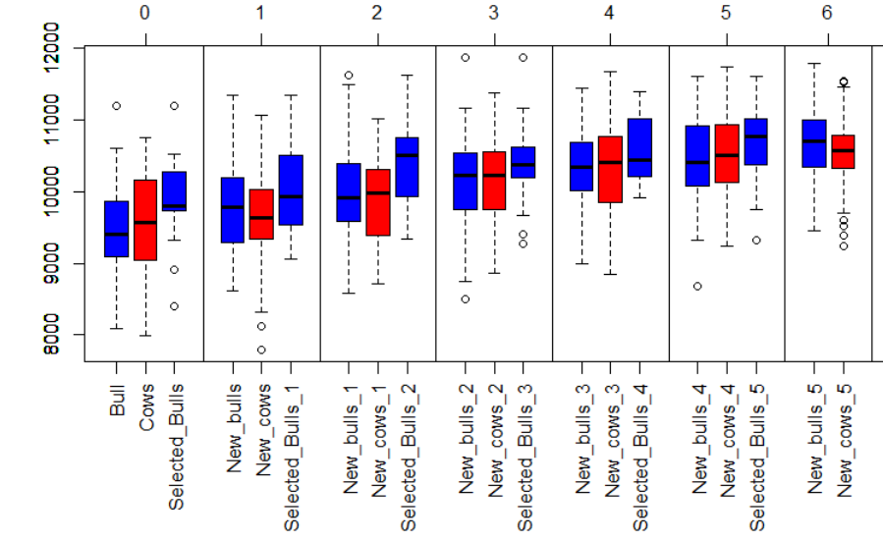

## Relationship between individuals and inbreeding

### Definition in MoBPS

The definition of kinship in MoBPS is in accordance with (Malécot 1948). This formally means the probability of a randomly chosen allele (or position in the genome) from two individuals to be in IBD. For both individuals which of the two chromosome pairs is chosen is also done at random. This at first might sound unnecessarily technical – thus let’s consider a small example with a genome with 5 alleles. Instead of alleles for each marker, we will be using numbers to indicate from which founder a specific segment is stemming:

|  |  |  |  |  |  |
| --- | --- | --- | --- | --- | --- |
| Individual 1 chromosome pair 1 | 1 | 1 | 1 | 1 | 1 |
| Individual 1 chromosome pair 2 | 1 | 2 | 2 | 2 | 2 |
| Individual 2 chromosome pair 1 | 1 | 3 | 3 | 3 | 3 |
| Individual 2 chromosome pair 2 | 1 | 4 | 4 | 4 | 4 |

When looking at locus 1, independent of which of the chromosome pairs of both individuals is chosen, this will always result in a case of IBD. In locus 2 – 5 we will be never in IBD. As the chance to choose each allele is 20%, the resulting kinship is 0.2.

Secondly consider the following case:

|  |  |  |  |  |  |
| --- | --- | --- | --- | --- | --- |
| Individual 1 chromosome pair 1 | 1 | 1 | 1 | 1 | 1 |
| Individual 1 chromosome pair 2 | 2 | 2 | 1 | 2 | 2 |
| Individual 2 chromosome pair 1 | 1 | 1 | 1 | 3 | 3 |
| Individual 2 chromosome pair 2 | 4 | 4 | 4 | 4 | 4 |

In locus 1 and 2, we will have a case of IBD when looking at the first chromosome pair of both individuals 1 and 2, which will happen with a probability of 25% (0.5^2). In locus 3, it does not matter which of the chromosome pairs of individual 1 to look at as long as chromosome pair 1 of individual 2 is chosen. Thus, the probability here is 50%. Locus 4 and 5 will never result in a case of IBD. The resulting kinship is 0.2 * 0.25 + 0.2*0.25 + 0.2 * 0.5 + 0.2 * 0 + 0.2* 0 = 0.2.

In both cases, kinship is the same but the areas of the genome causing IBD are different. Areas under stronger selection will typically have a higher probability of IBD occurring, thus a kinship of 0.2 does not mean that 20% of the genome is in IBD, but is much more nuanced.

You can also calculate kinship within an individual. The kinship of an individual will always be at a minimum 0.5 as the probability to sample the same chromosome pair twice is 50%. The inbreeding coefficient of an individual can be calculated by calculating: 2* (kinship – 0.5).

In MoBPS there are different ways to calculate the kinship that will be explained in the following subsections:

### kinship.exp

The *kinship.exp()* uses pedigree information to compute the expected kinship, e.g. a parent / offspring pair will have an average kinship of 0.25, a grandparent/offspring pair will have an average kinship of 0.125. Note that the expected kinship will be 0.5 – times the pedigree relationship matrix. Note that under selection, actually resulting kinships can differ, e.g. when 2 of 100 siblings are selected, these are typically more related – which can add up over multiple generations.

To control how many generations back are used, the parameter **prev.gen** can be used. On default, it is assumed all individuals before are unrelated unless specified by the use of *add.founder.kinship()*. Alternatively, one can provide a **kinship.matrix** for the individuals of the first generation via **first.individuals**. It should be noted that there are more efficient ways to derive a pedigree matrix than this as a pedigree matrix usually contains a high number of zeros and this will output the entire matrix but this should still do easily the job for < 100.000 individuals on most systems – alternatively, one can export the pedigree via *get.pedigree()* and use tools outside of R.

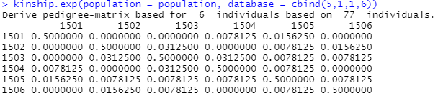

### kinship.emp / kinship.emp.fast

As MoBPS does store all points of recombination it is possible to directly calculate the kinship, by backtracking of chromosome segments and comparing if and what segments of individuals are in IBD. In addition to the standard input of the **population** list and selected **gen**, **database**, **cohorts** it is also possible to provide the lists within the population list ($breeding) for each individual to consider via the **animals** parameter. This calculation is explicitly not limited to just the simulated SNPs but also considers everything in-between. This calculation does only consider the founder of each chromosome segment and explicitly not mutations (even after a mutation in the SNP founder stays the same!).

*kinship.emp()* will calculate this for all pairwise relationships. As this procedure is computationally costly and a kinship matrix can become large, it can oftentimes be sufficient to not evaluate all pairs, but just randomly sample some pairs to evaluate. This can be done in *kinship.emp.fast()* and will evaluate **ibd.obs** pairwise relationships (off-diagonal) and **hbd.obs** relationship with the individual with itself (main-diagonal). Note that the defaults of both **ibd.obs** and **hbd.obs** are chosen very small (200/50) to ensure fast computations and will be unbiased – in particular for large cohorts, increasing will however help to reduce estimation variance!

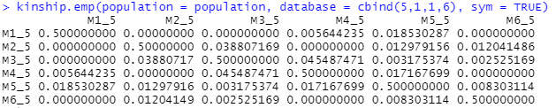



### kinship.development

Function to display the development of kinship over different **gen**, **database**, **cohorts**. Internally *kinship.emp.fast()* is used and the same optional parameters can be used to improve computation time / accuracy.

population **<-** json.simulation**(**total **=** ex_json**)**

kinship.development**(**population, json **= TRUE**, display.cohort.name **=** **TRUE)**

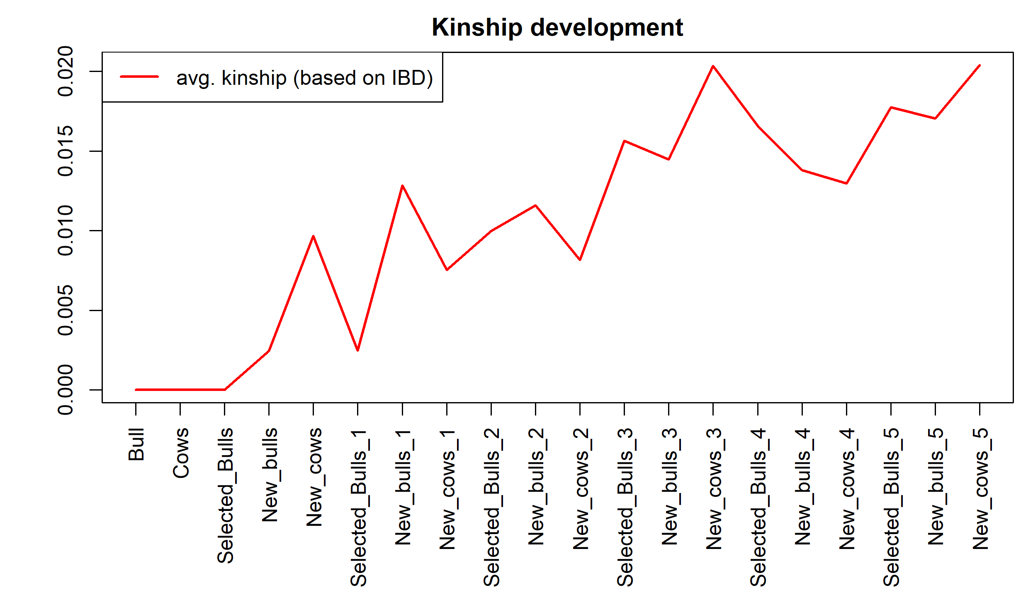

## analyze.population

With this function, one can analyze the allele frequency of a specific marker over time. Select the marker to analyze via parameters **chromosome** & **snp**. To selected with generations to compare use **gen**, **database**, **cohorts**.

population **<-** json.simulation**(**total **=** ex_json**)**

analyze.population**(**population,5,2, gen**=**1**:**8**)**

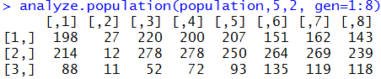

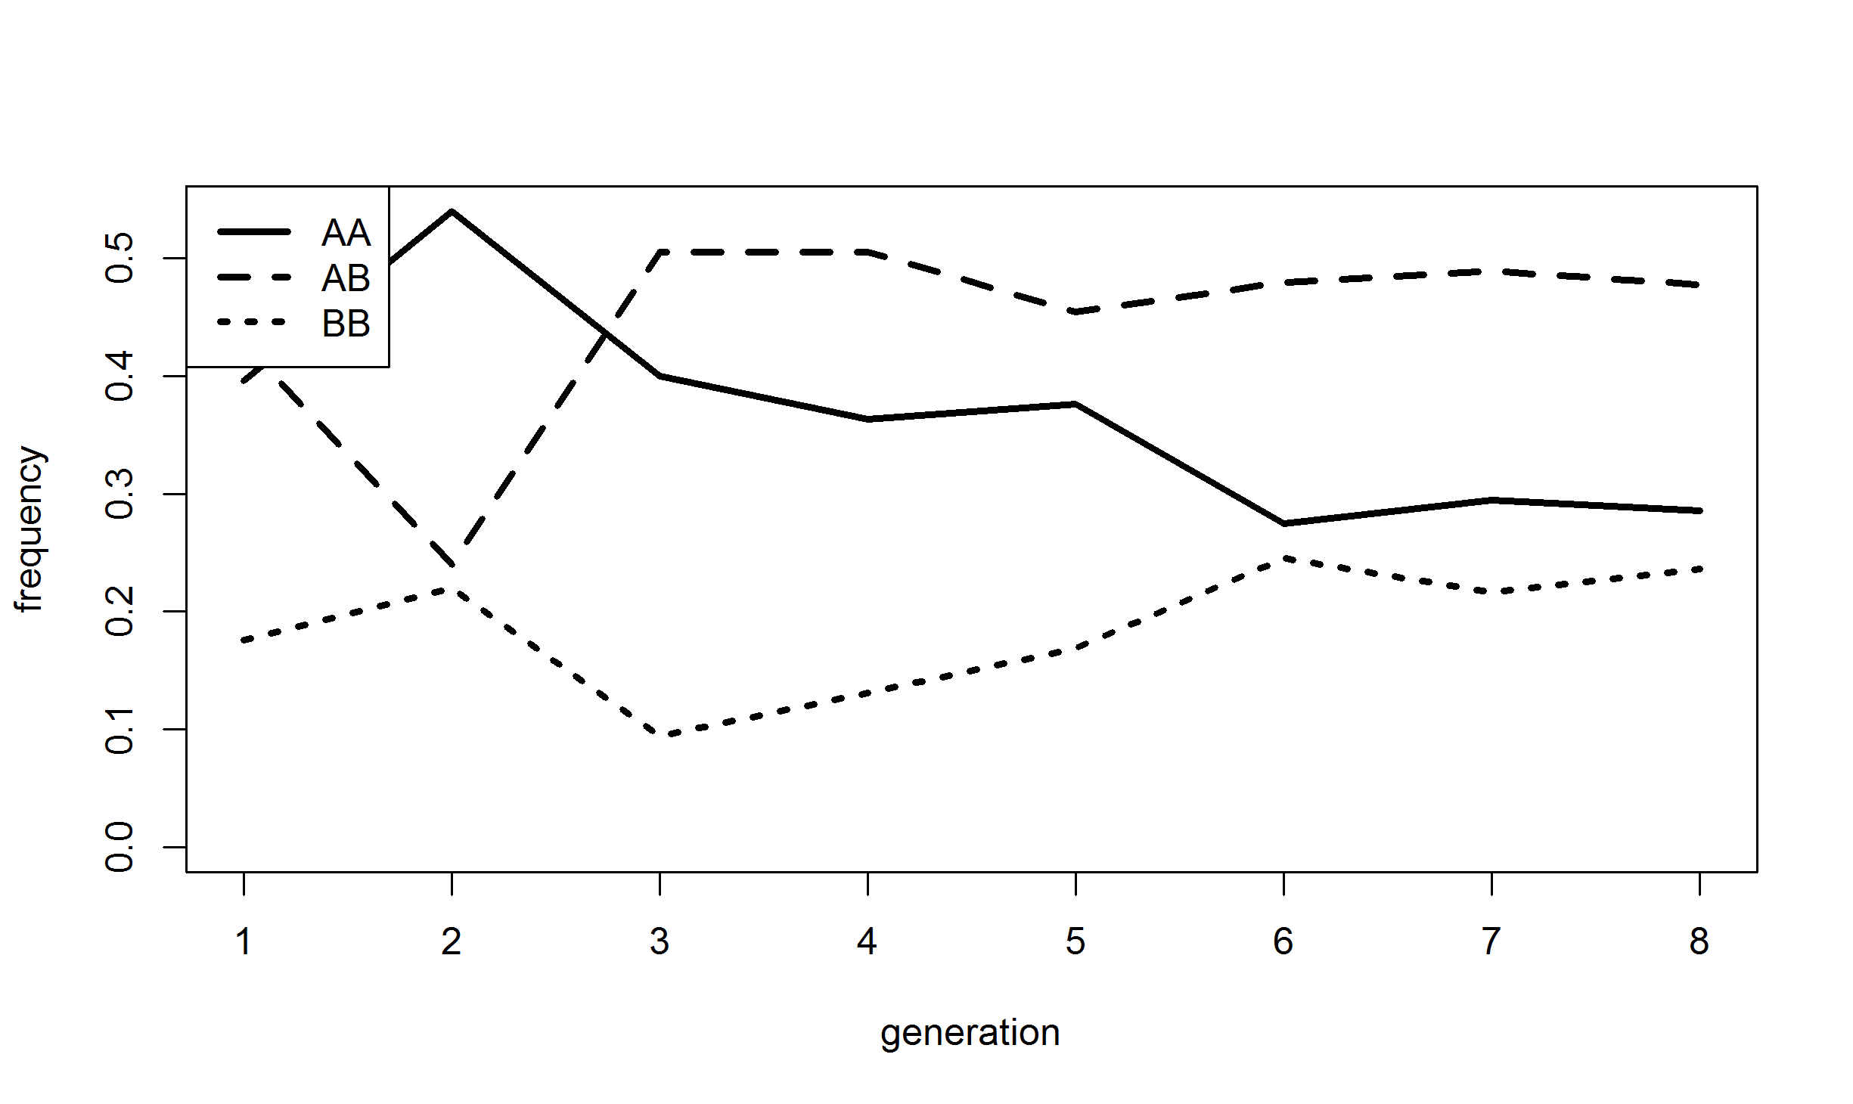

## new.base.generation

With a rising number of generations, the number of points of recombinations to store is increasing. For efficient storing it can make sense to compute and store haplotypes for a later generation and use those individuals as a new founder generation. For this use *new.base.generation()* and select the new base generation via the parameter **base.gen**. To further reduce memory needs and computation time you can additionally delete data of previous generations via **delete.previous.gen**, **delete.breeding.totals** and **delete.bve.data**.

## founder.simulation

This function can be used to simulate a random mating structure for a high number of generations and will lead to an output that can be used as an input for **dataset** in *creating.diploid().* The number of individuals can be controlled via **nindi** and the number of SNPs to consider via **nsnp**. In case the number of individuals in the final dataset is supposed to be higher than in the build-up generations **nfinal** can be used to clarify. The share of female individuals in both **nindi** and **nfinal** is controlled via **sex.quota** / **sex.quota.final**. The total number of generations to simulated in controlled via **n.gen**. Furthermore, all parameters to design a genomic map are given in the same way as in *creating.diploid()*. In case not only the final haplotypes, but the population list itself is of interest set **big.output** to TRUE which will provide you with the genomic map, the population list and a pedigree relationship matrix for the final generation.

Finally, an automatic estimation of the LD-decay and allele frequency spectrum can be generated by setting the parameter **plot** to TRUE.

Note that this is “only” modelling a random mating architecture and in case a population structure with a more complex background is wanted, a manual generation with *creating.diploid()* and *breeding.diploid()* is required.

population **<-** founder.simulation**(**nindi**=**100, nsnp**=**1000, n.gen**=**100**)**

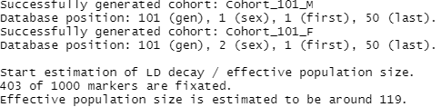

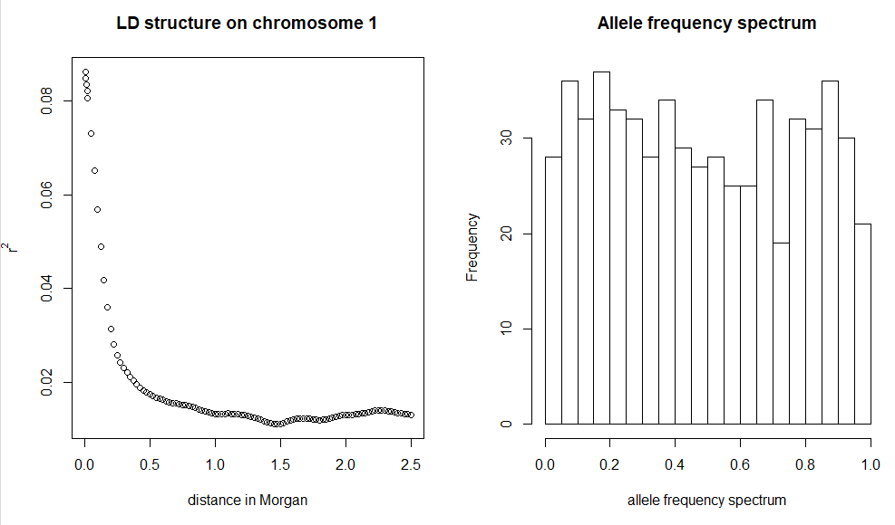

## pedigree.simulation

This function can be used to simulate a given pedigree. In the pedigree the first column contains the ID of the offspring, second/third column the ID of the father / mother. Optionally one can provide the earliest generation of generation in the fourth column and the sex of each individual in the fifth column. If not specified all individuals will be generated at the earliest possible time and in a joined group per generation – default is all individuals are male. We do not perform any pedigree clean-up in this function!

All parameter in creating.diploid() regarding genome structure and traits are also available for pedigree.simulation().

pedigree **<-** matrix**(**c**(**1,0,0,

2,0,0,

3,0,0,

4,1,2,

5,1,3,

6,1,3,

7,1,3,

8,4,6,

9,4,7**)**, ncol**=**3, byrow**=TRUE)**

population **<-** pedigree.simulation**(**pedigree, nsnp**=**1000**)**

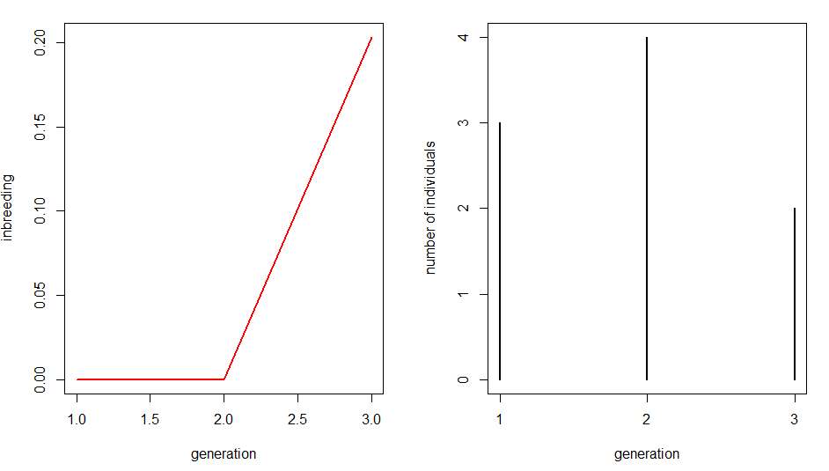

## creating.trait

With this function one can generate additional traits for the base population without the need to add genetic datasets. Functionality is the same as *creating.diploid()* otherwise. For details on the use we refer to section 4.3.

## combine.traits

With this function multiple traits can be linked and will then be handled as observations for the same trait in a breeding value estimation (e.g. for GxE or slightly different genetic backgrounds in different breeds).

## bv.standardization

This function can be used to scale QTL effects to obtain a certain mean (**mean.target**) and genomic variance (**var.target**) in a set of preselected groups (**gen**/**database**/**cohorts**). On default, estimated breeding values and phenotypes are not scaled – to active this set **adapt.bve** and **adapt.pheno** to TRUE.

## creating.phenotypic.transform

This function can be used to generate to automatically apply a transformation function on the generated phenotypes. The transformation function used has to be provided in **phenotypic.transform.function** and the trait to transform is selected via **trait** (default: 1). E.g. to generate a binary trait use:

function(x){y = x>10; return(y)}

To transform all phenotypic observations higher than 10 to 1 and all below to 0. Thresholds to obtain certain probabilities of each phenotype must be manually derived according to the trait mean and variance set via *bv.standardization()* and the entered heritability.

## clean.up

This function can be used to delete recombination points between segments that stem from the same founder strand and therefore are usually uninformative. On default, all individuals will undergo this clean up procedure. To select specific groups for the clean up use **gen**/**database**/**cohorts**.

## ensembl.map

Via this function, genetic maps provided in Ensembl (<https://www.ensembl.org/index.html> & <http://plants.ensembl.org/index.html>) can be imported. Internally the package biomaRt is used – for guidelines on how to install this package we refer to <https://bioconductor.org/packages/release/bioc/html/biomaRt.html>.

The naming of parameters is orientated according to the biomaRt package. Set **dataset** to the dataset you want to access (e.g. for cattle-SNPs: “btaurus_snp”) – for a list of possible datasets run this function with **export.datasets** set to TRUE.

To import a subset of all markers use the parameter filter and **filter.values**. To limit the markers to a specific SNP-chip just set **filter.values** to the name of the chip (e.g. **filter.values**=”Illumina BovineSNP50 BeadChip”). Names of potential filters for a dataset can be exported by setting **export.filters** to TRUE.

For us, the direct export in R via Ensembl was painfully slow and the package did not always do what we intended it to do. Therefore, we are providing exemplary map files for most common species in the associated R-package MoBPSmaps. For a list of maps that are already included in MoBPS and the associated data package MoBPS_maps we refer to section 14.

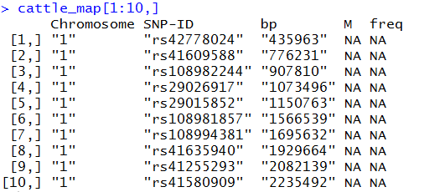

## compute.costs

To calculate the costs of the currently simulated breeding program use the function *compute.costs()*. Currently implemented cost factors include the following:

|  |  |  |
| --- | --- | --- |
| Cost factor | MoBPS -Parameter | Default |
| Phenotyping | phenotyping.costs | 10 |
| Genotyping | genotyping.costs | 100 |
| Housing/Field costs | Housing.costs | 0 |
| Fixed costs | fix.costs | 0 |
| Annual costs | fix.costs.annual | 0 |
| Profit per BV | profit.per.bv | 1 |

Note that all default settings are basically chosen at random and should be modified when analyzing a real breeding program. In case costs/gains between sexes are different, use a vector. To separate between generations use a matrix with each row coding costs/gains per generation.

To only calculate the resulting costs of some generations/cohorts use database/gen.

To model an interest rate set **interest.rate** (default: 1 – meaning i = 0%. We here assume inputs of the form 1 + i) – with costs/gain changed according to a base generation (**base.gen** – default: 1)



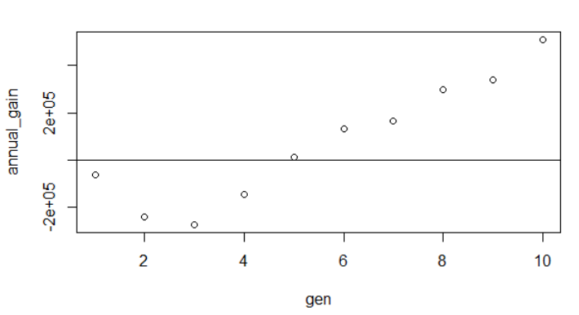

## compute.costs.cohorts

The functionally of *compute.costs.cohorts()* is similar to *compute.costs()* with the added benefit of usability with input parameters provided in our user-interface. Input parameters include **phenotyping.costs**, **genotyping.costs**, **housing.costs**, **fix.costs**, **fix.costs.annual**, **profit.per.bv**, **interest.rate**. In case the user interface is provided considered groups (**gen**, **database**, **cohorts**) are automatically assigned to their time point of creation for discounting.

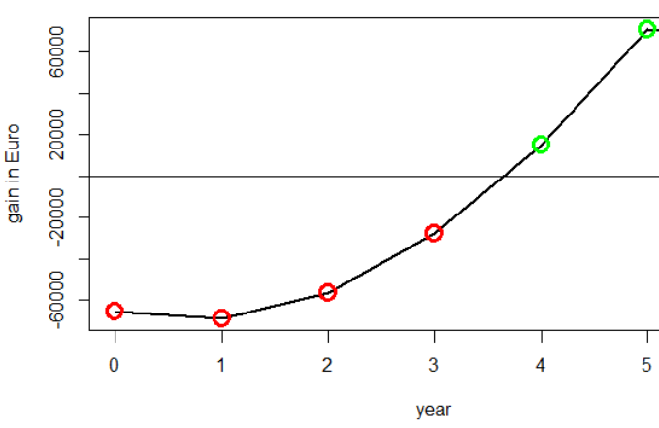

## summary

The population list generated via *creating.diploid()* and *breeding.diploid()* is of class “population”. Application of the generic function summary leads to an overview of the population list including the number of individuals, cohorts, the structure of the genome and traits:

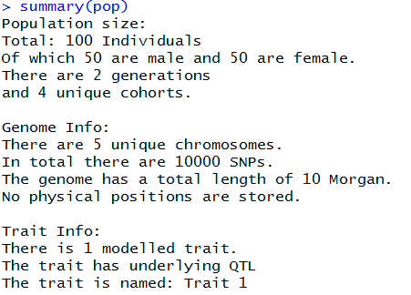

## pedmap.to.phasedbeaglevcf

The standard input for genomic data in MoBPS are haplotypes (not genotypes!). In the case of using your own genomic data, it is highly recommended to perform genomic phased before using the dataset as an input. In this function, a routine pipeline to generate a phased dataset is executed. In this pipeline BEAGLE 5.0 (<https://faculty.washington.edu/browning/beagle/beagle.html>) and PLINK 1.9 (<https://www.cog-genomics.org/plink/1.9/>) are used. Additional file are generated in a selected directory. Path for all three have to be provided in **beagle_jar**, **plink_dir**, **db_dir**. Input can either be a dataset in PLINK format (**ped_path**, **map_path**) or a vcf-file (**vcf_path**). Defaults are all chosen to work on the webserver for our web-interface (Chapter 0). Phasing can also be directly performed in the web-interface.

# Data structure of the population list

All information regarding the breeding program is stored in a population list (R-object: list) which is modified by each run of *breeding.diploid()* and *creating.diploid()*. The population list contains matrices, inside of lists, inside of lists, inside of lists, inside of lists, inside of lists, inside of lists (you get the point!) – when understanding the structure behind it is actually not that bad, luckily you do not have to understand the structure behind for most applications since you can use exporting function discussed in section 0.

The list contains two major parts - $info ((or [[1]])) and $breeding ((or[[2]]):

## $info

$info contains all general information concerning genetic architecture, size of the program and internal information needed to perform the simulations. Each entry is named according to what it is supposed to contain.

|  |  |
| --- | --- |
| schlather.slot1 | Internal variable for miraculix (cre: M. Schlather) |
| chromosome | Number of chromosomes in the population list |
| snp | Number of SNPs per chromosome |
| position | Position (in Morgan) on the chromosome for each marker |
| snp.base | Major/Minor Allele (e.g. characters since internally 0/1 is used) |
| snp.position | Overall position in the genome (ongoing over chromosomes |
| length | Length of each chromosome |
| length.total | Cumulative length of chromosomes |
| func | It’s just FALSE – placeholder for later |
| size | Size of each group (generation/sex) |
| bve | Coding if breeding values are simulated |
| bv.calculated | Coding if breeding values are calculated for the founders (will be after first run of *breeding.diploid()*) |
| breeding.totals | Recap of each run of *breeding.diploid()* (if stored) |
| bve.data | Recap of each breeding value estimation (if stored) |
| bve.nr | Number of traits (with QTLs behind) to consider |
| bv.random | Coding which traits have underlying QTLs behind |
| bv.random.variance | Genetic variance for traits with no QTLs behind |
| snps.equidistant | Are SNPs equidistant on every chromosome (speed up!) |
| origin.gen | List of founding generations (with stored haplotypes) |
| cumsnp | Cumulative sum of SNP number (just to save computational time) |
| bp | Physical position of each marker (bp) |
| snp.name | Name of each marker |
| next.animal | ID of the next individual to generate |
| bve.mult.factor | (bv) * this |
| bve.poly.factor | (bv) ^ this |
| base.bv | This + QTL_effects |
| bv.calc | Number of total traits (including those with no QTL behind) |
| real.bv.length | Traits with (additive/multiplicative/dice-effects) |
| sex | Sex of the founders added in *creation.diploid* |
| real.bv.add | Lists with an overview of all single marker QTLs for each trait |
| real.bv.mult | Lists with an overview of all two marker QTLs for each trait |
| real.bv.dice | Lists with an overview of all three+ marker QTLs for each trait |
| pheno.correlation | Correlation matrix of the environmental variance between traits |
| bv.correlation | Correlation matrix of the genetic variance between traits (only for non-QTL traits) |
| miraculix | Coding if miraculix was used to generate the data – only miraculix users will be able to work with those population lists |
| cohorts | List of all cohorts with name and position in the population list |
| effect.p.add | Markers involved as QTL in the single QTL proportion |
| effect.p.mult1 | Markers involved as QTL in the two-SNP QTL proportion |
| effect.p.mult2 | Markers involved as QTL in the two-SNP QTL proportion |
| effect.p | Markers involved as QTL in any trait |
| store.effect.freq | Frequency of each marker in each generation |
| last.sigma.e.database | Database to derive the last used environmental variance |
| last.sigma.e.value | Last used environmental variance |
| last.sigma.e.heritabilty | Heritability assumed to derive last used environmental variance |
| comp.times | Computation times needed in each use of *breeding.diploid()* (if stored) |
| comp.times.bve | Computation times needed in the breeding value estimation in each use of *breeding.diploid()* (if stored) |
| comp.times.generation | Computation times needed in for the generation of new individuals in each use of *breeding.diploid()* (if stored) |
| culling.stats | Information on the culling reason of each individual (mostly releveant for the web-interface) |
| phenotypic.transform | Indication on with traits undergo a transformation function when generating a phenotype |
| phenotypic.transform.function | Function to apply on the generated phenotype (e.g. for discrete distributions) |
| repeat.mating | Probabilities for the number of offspring per mating (litter size) |
| repeat.mating.copy | Probabilites for the number of copys of an individual generated in all copy/combine actions |
| is.maternal | TRUE/FALSE indication if each respective traits is caused by maternal effects |
| is.paternal | TRUE/FALSE indication if each respective traits is caused by paternal effects |
| is.combi | TRUE/FALSE indication if each respective traits is derived as a combination of other traits |
| combi.weights | Weights of each other traits for combined traits |

## $breeding

$breeding contains all relevant information concerning the individuals of the breeding scheme. For efficiency purposes, a lot of this is internally coded or computed on-the-fly.

Individuals are sorted according to generation, sex and individual number. In case data has to be stored for both male and female (or father/mother) there will be two entries with the first one being the male (Have to talk with the equality commissioner about that!).

$breeding[[generation]][[sex]][[ individual nr.]] (( or [[2]][[generation]][[sex]][[ individual nr.]]))

### Storage per generation

|  |  |
| --- | --- |
| $breeding[[generation]][[3,4]] | Estimated breeding values of males (3) and females (4) |
| $breeding[[generation]][[5,6]] | Class of males (5) and females (6) |
| $breeding[[generation]][[7,8]] | Underlying “true” genetic values of males (7) and females (8) |
| $breeding[[generation]][[9,10]] | Observed phenotypes for males (9) and females (10) |
| $breeding[[generation]][[11,12]] | Time point of generation for male (11) and females (12) – in case of copy.individual != time of birth! |
| $breeding[[generation]][[13,14]] | Creating type of generation for males(13) and females (13)  This is only relevant for the web-based application |
| $breeding[[generation]][[15,16]] | Individual IDs for male (15) and females (16) |
| $breeding[[generation]][[17,18]] | Has been removed – currently not in use |
| $breeding[[generation]][[19,20]] | Reliability estimated for male (19) and females (20) |
| $breeding[[generation]][[21,22]] | Last applied selection index (mostly relevant for complex selection indices like (Miesenberger 1997) |
| $breeding[[generation]][[23,24]] | Time of birth for male(23) and female (24) individuals |
| $breeding[[generation]][[25,26]] | Time of culling for male(25) and female (26) individuals |
| $breeding[[generation]][[27,28]] | Average offspring phenotype for male(27) and female (28) individuals |
| $breeding[[generation]][[29,30]] | Number of offspring phenotypes used in 27/28 for male(29) and female (30) individuals |
| $breeding[[generation]][[31,32]] | Time point of death for male (31) and female (32) individuals |

### Storage per individual

$breeding[[generation]][[sex]][[ individual nr.]]…

|  |  |
| --- | --- |
| [[1,2]] | Points of recombination on the first (1) and second (2) chromosome set |
| [[3,4]] | Points of mutations |
| [[5,6]] | Efficiently stored origins of segments between two points of recombination. Decoding using *decodeOrigins()* (miraculix) / *decodeOriginsR()* (else).  Output in *get.recombi()* is automatically decoded |
| [[7,8]] | Father / Mother |
| [[9,10]] | Efficiently stored haplotypes (if it is a founder – else empty) |
| [[11,12]] | Storage of duplications (long not used!) |
| [[13,14]] | Storage of history of recombinations |
| [[15]] | How often a phenotype was generated for the individual |
| [[16]] | Is the individual genotyped |
| [[17]] | True breeding value before gene editing |
| [[18]] | Generation of death and previous class |
| [[19]] | Share of the genetic material of the grandfather of the father inherited |
| [[20]] | Share of the genetic material of the grandfather of the mother inherited |
| [[21]] | List of all individuals with the same id. |
| [[22]] | Vector of array used for genotyping |
| [[23]] | Permanent residual |
| [[24]] | Temporary (newly samples for each phenotyping) residual |

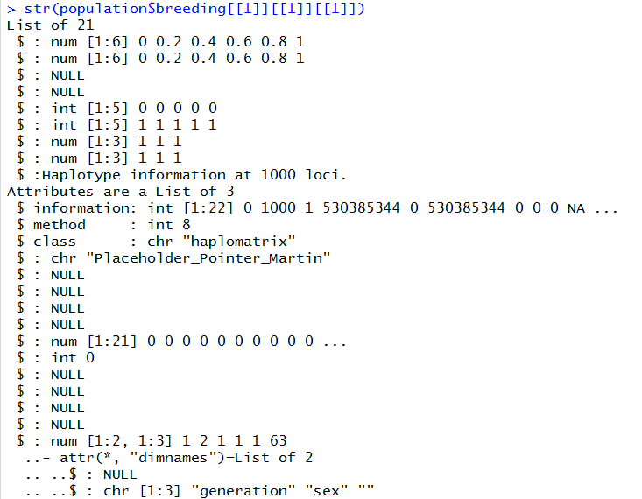

# Memory and computation times

Critical parts of MoBPS concerning memory requirements and computation times can be performed using the associated R-package miraculix. By using SSE2 operations and bit-wise storing computation speed can be massively increased leading to about 10 times faster matrix multiplications than the regular R implementation while needing only 1/16 of the regularly needed memory.

To speed up the computation of the breeding value estimation, one can use multiple cores by the usage of **miraculix.cores** (default: 1) or in case miraculix is not active **ncore**. To parallelize the generation of new individuals set **parallel.generation** to TRUE and set the number of cores used via **ncore.generation**. This will only lead to significant improvement in computation time for the generation of a lot of individuals. Even when using a single core ~1’000 individuals are generated per second. The packages doParallel (Microsoft Corporation and Steve Weston 2018) and doRNG (Renaud Gaujoux 2018) are used for parallelization in R.

Computing time for the whole simulation (population$info$comp.times), the steps of the breeding value estimation (population$info$comp.times.bve) and the generation of new individuals (population$info$comp.times.generation) are stored in the population list. If this is not required you can deactivate this by setting **store.comp.times**, **store.comp.times.bve** and **store.comp.times.generation** to FALSE in *breeding.diploid().* Unless **verbose** is set to FALSE you should automatically receive notifications on the current step of the algorithm and computing times of individual steps. Activation of **Rprof** can provide even more information.

### Efficient BLAS / LAPACK

MoBPS uses various functions and operations that use standard R function like the matrix multiplication and inversion. There are highly efficent solutions provided in the context of Basic Linear Algebra Subprograms (BLAS) and Linear Algebra Package (LAPACK). I personally am using a conda container with libopenblasp-r0.3.12.so. Just for reference to computing speed / benchmarking consider running the following on your system:

n **<-** 5000

T **<-** matrix**(**0, nrow**=**n, ncol**=**n**)**

A <- T %*% T

My garbage windows computer without optimization takes 100 seconds for this code. Our computing cluster with their standard single core BLAS 6 seconds, and an optimized computing cluster with OpenBLAS requires 2 seconds using a single core (or 0.6 seconds with 5 cores). You yourself should judge if your simulation take long enough that you need to take a look into this. Effects will not be 100-fold as in this example as most of the computations have at least a bit more efficiently implemnted version that run if your BLAS is not good expect substantial gain (not only for MoBPS related project!)

### Reducing the size of the population list

Especially when simulating populations with lots of markers, individuals and/or generations, data storage can become a problem. As the internal structure of a population list is complex and manually deleting things is not recommended.

As MoBPS is storing recombination points and not the haplotype itself (on the fly calculation), the amount of storage needed increases with the number of meiosis since the last founder. To negate those issues one can declare individuals as “new” founder. Meaning that the haplotypes for those individuals are calculated and thus recombination points before do not need to be stored. For details on this we refer to section 9.6. In particular when working with large genomes and low number of SNPs, this can massively reduce storage needs.

To delete points of recombination between the same founder strand, the function *clean.up()* can be applied on the population list. For more on that, we refer to section 9.12.

Further reduction of the required memory can be obtained by deleting old information. In contrast to *clean.up()* this will lose information and is only recommended to be used on early generations that are not needed in any later steps or in the following analysis. Use following parameters in *breeding.diploid()*:

**delete.haplotypes**: Vector containing all generations for which haplotypes no longer need to be stored (note that only founder generations are stored anyway – everything else is calculated on-the-fly)

**delete.same.origin**: Merge two adjacent segments with the same founding haplotypes (deletion of a recombination point with no influence)

**delete.individuals**: Vector containing all generations for complete deletion– to only delete one sex use **delete.sex** (vector contain sex to delete – 1 (male), 2 (female). Especially when the number of recombinations stored per individual, becomes bigger this is of relevancy.

### Reducing memory needs in the BVE

To calculate the genomic relationship matrix, one has to perform matrix multiplication of a matrix containing n*p entries (individuals x markers). Note that for every entry only 2 bits are needed when using miraculix. Nevertheless, this can become extremely big – to reduce this, one can perform the calculation of G sequentially and only load a part of Z into memory at any time.

To activate this, set **sequenceZ** to TRUE. The number of markers in memory can be controlled via **maxZ** (default: 5000). Alternatively, one can put **maxZtotal** to control the total number of entries instead. As this is increasing the computation time, we first recommend to activation of miraculix. As long as miraculix is installed this will happen automatically unless the parameter **miraculix** in *creating.diploid()* is set to FALSE.

To speed up commutation one can use multiple cores by the usage of **miraculix.cores** (default: 1) or in case miraculix is not active **ncore**. The backend outside of miraculix is using doParallel and mclapply but doMPI is supported as well – we highly recommend the use of miraculix instead.

Setting **fast.compiler** to TRUE will additionally activate a just-in-time-compiler (enableJIT(3)).

To save computation speed in the GWAS, one can use **approx.residuals** – this does not influence the order of the predicted effect markers but will influence p-values slightly.

### Inverting G using miraculix

The inversion of can take a lot of time, is numerically unstable and might not even be possible at all if the matrix is not invertible at all. Instead of the standard cholesky procedure using *chol2inv(chol())*, the inversion can also be done in RandomFieldsUtils/miraculix by activating **chol.miraculix**. Leading to slightly reduced computing times – but also includes screening for semi definite matrices and an automatically changed algorithm, if needed, and thus proceeding without error.

Note that depending on your Blas, you might automatically fall back on the basic solve() function from the base package. E.g., when using OpenBlas this function is fully parallized and uses computational trips that are just not available to use. If this is needed is automatically checked when loading the RandomFieldsUtils package, so you do not need to worry about this! You should however worry about using an efficient Blas ;)

### Working with a high number of traits

When working with an extremely high number of traits (e.g. due to multiple versions of a traits in GxE) the generation of individuals can take extended time because the genomic value for each trait needs to be calculated. To not evaluate all traits on generation use the parameter **bv.ignore.traits** including a vector of all traits to not evaluate. Whenever phenotypes of a trait are generated this evaluation is automatically done at that time – this is only problematic when you just want to export a trait later without ever needing the calculation of it during the simulation itself.

Similarly, selected traits can be skipped in the breeding value estimation via the parameter **bve.ignore.traits**.

### On-the-fly calculation of haplotypes

To save memory, haplotypes are calculated on-the-fly. For this, the location of each recombination point (between which markers) has to be stored. In case one is working with equidistant markers, it basically takes no time. For other cM-positions it might increase computation speed to provide a function that derives the last marker in front of a certain position in Morgan. This function can be entered via **import.position.calculation**. Only in extreme cases (lots of markers) this should even matter!

# List of input parameters in breeding.diploid()

For a description of each parameter we refer to the use of the help function in R (?*breeding.diploid*) and/or other sections of this Guidelines.

|  |  |  |
| --- | --- | --- |
| **Parameter** | **Default** | **options** |
| population | NULL | A previous population list |
| mutation.rate | 10^-8 | Value between 0 and 1 |
| remutation.rate | 10^-8 | Value between 0 and 1 |
| recombination.rate | 1 | Any positive numeric |
| selection.criteria | NULL | “bve”, “bv”, “pheno”, “offpheno” |
| selection.m | NULL (“random” if selection.criteria = NULL; else “function” | “random”, “function” |
| selection.f | NULL (selection.m) | “random”, “function” |
| new.selection.calculation | TRUE | FALSE |
| selection.function.matrix | NULL | Don’t touch – will be removed |
| selection.size | C(0,0) | Vector with two non-negative values |
| breeding.size | 0 | Positive number // 2 element vector (male/female) |
| breeding.sex | 0.5 | Value between 0 and 1 |
| breeding.sex.random | FALSE | TRUE |
| class.m | 0 | Vector with all classes to consider |
| class.f | NULL (class.m) | Vector with all classes to consider |
| add.gen | 0 (will lead to added generation) | Value between 1 and number of generations |
| recom.f.indicator | NULL | Not necessary (use modified marker position instead!) |
| duplication.rate | 0 |  |
| duplication.length | 0.01 | Duplication modelling needs changes! |
| duplication.recombination | 1 |  |
| same.sex.active | FALSE | TRUE |
| new.class | 0 | Numeric value (ideally positive integer; -1 is reserved for dead individuals) |
| bve | FALSE | TRUE |
| bve.solve | “exact” | “pcg”, function to replace solve() in the BVE. |
| bve.array | NULL (which will use 1) | Numeric value above 0 |
| bve.direct.est | TRUE | FALSE |
| bve.gen | NULL | 1:3 |
| bve.database | NULL |  |
| bve.cohorts | NULL | c(“Founder_M“, “F1“) |
| bve.avoid.duplicates | TRUE | FALSE |
| Bve.exclude.fixed.effects | NULL |  |
| Bve.beta.hat.approx | TRUE | FALSE |
| report.accuracy | TRUE | FALSE |
| sigma.e | NULL | Numeric value above 0 |
| sigma.s | 100 | Numeric value above 0 |
| bve.per.sample.sigma.e | TRUE | FALSE |
| share.phenotyped | 1 | Value between 0 and 1 |
| phenotyping | NULL | “all“ for all individuals  “non_obs” for all previously not observed  “non_obs_m” for all previously not observed male individuals  “non_obs_f” for all previously not observed female individuals |
| phenotyping.gen | NULL | 1:3 |
| phenotyping.database | NULL |  |
| phenotyping.cohorts | NULL | c(“Founder_M“, “F1“) |
| phenotyping.child | NULL | „zero“, „mean“, „obs“ |
| Relationship.matrix | “vanRaden” | “kinship”, “CE”, “CM”, “non_stand” |
| depth.pedigree | 7 | Positive Integer |
| delete.haplotypes | NULL | Vector of all generations to delete (natural number) |
| delete.individuals | NULL | Vector of all generations to delete (natural number) |
| fixed.breeding | NULL | matrix with each row containing (gen1,sex1,nr1, gen2,sex2,nr2, probability.female) with gen/sex/nr1 information on the first parent / father, gen/sex/nr2 information on the second parent / mother) |
| fixed.breeding.best | NULL | matrix with each row containing  (sex1, nr1, sex2, nr2, sex.probability) chosen from the group of selected individuals |
| max.offspring | C(Inf,Inf) | vector with two natural numbers (first male, second female) |
| max.litter | C(Inf,Inf) | Vector with two natural numbers (first male, second female) |
| max.mating.pair | Inf | Numeric value (1-Inf) |
| store.breeding.totals | FALSE | TRUE |
| forecast.sigma.s | TRUE | FALSE |
| multiple.bve | “add” | “ranking” |
| multiple.bve.weights.m | 1 | Any weights – use a vector with length equal to number of traits |
| multiple.bve.weights.f | NULL (multiple.bve.weights.m) | Any weights – use a vector with length equal to number of traits |
| store.bve.data | FALSE | TRUE |
| fixed.assignment | FALSE | “bestworst”, “worstbest” |
| reduce.group | NULL | Per row: Generation, Sex, Individuals to survive, class of individuals |
| reduce.group.selection | “random” | “function” |
| selection.highest | c(TRUE,TRUE) | C(FALSE/TRUE,FALSE/TRUE) |
| same.sex.sex | 0.5 | Numeric value between 0 and 1 |
| same.sex.selfing | TRUE | FALSE |
| selfing.mating | FALSE | TRUE |
| selfing.sex | 0.5 | Numeric value between 0 and 1 |
| praeimplantation | NULL | No use currently recommended |
| sigma.e.gen | NULL | 1:3 |
| sigma.e.database | NULL |  |
| sigma.e.cohorts | NULL | c(“Founder_M“, “F1“) |
| heritability | NULL | Numeric value between 0 and 1 |
| multiple.bve.scale.m | FALSE | TRUE |
| multiple.bve.scale.f | NULL (multiple.bve.scale.m) | TRUE |
| save.recombination.history | FALSE | TRUE |
| martini.selection | FALSE | TRUE |
| BGLR.bve | FALSE | TRUE |
| BGLR.model | “RKHS” | “BRR”, “BL”, “BayesA”, “BayesB”, “BayesC” |
| BGLR.burnin | 500 | natural number |
| BGLR.iteration | 5000 | natural number |
| BGLR.save | “RKHS” | any path you want |
| BGLR.save.random | FALSE | TRUE |
| BGLR.print | FALSE | TRUE |
| mas.bve | FALSE | TRUE |
| mas.markers | NULL | Vector with SNP-positons |
| mas.number | 5 | Any natural number |
| mas.effects | NULL | Vector with numeric values |
| threshold.selection | NULL | Numeric value |
| threshold.sign | “>” | “<“,“=“,“<=“,“>=“ |
| copy.individual | FALSE | TRUE |
| copy.individual.m | FALSE | TRUE |
| copy.individual.f | FALSE | TRUE |
| copy.individual.keep.bve | TRUE | FALSE |
| dh.mating | FALSE | TRUE |
| dh.sex | 0.5 | Numeric value between 0 and 1 |
| offpheno.parents.gen | NULL | 1:3 |
| offpheno.parents.database | NULL |  |
| offpheno.parents.cohorts | NULL | c(“Founder_M“, “F1“) |
| offpheno.offspring.gen | NULL | 1:3 |
| offpheno.offspring.database | NULL |  |
| offpheno.offspring.cohorts | NULL | c(“Founder_M“, “F1“) |
| bve.parent.mean | FALSE | TRUE |
| bve.grandparent.mean | FALSE | TRUE |
| bve.mean.between | “bvepheno” | „bve“, „pheno“, „bv“ |
| n.observation | 1 | Natural number |
| share.genotyped | 1 | Numeric value between 0 and 1 |
| added.genotyped | 0 | Numeric value between 0 and 1 |
| genotyped.gen | NULL | c(“Founder_M“, “F1“) |
| genotyped.database | NULL | c(“Founder_M“, “F1“) |
| genotyped.cohorts | NULL | c(“Founder_M“, “F1“) |
| genotyped.share | 1 | Numeric value 0-1 |
| genotyped.array | 1 | Natural number |
| genotyped.remove.gen | NULL | c(“Founder_M“, “F1“) |
| genotyped.remove.database | NULL | c(“Founder_M“, “F1“) |
| genotyped.remove.cohorts | NULL | c(“Founder_M“, “F1“) |
| genotyped.remove.all.copy | TRUE | FALSE |
| remove.non.genotyped | TRUE | FALSE |
| Singlestep.active | FALSE | TRUE |
| bve.0isNA | TRUE | FALSE |
| phenotype.bv | FALSE | TRUE |
| standardize.bv | FALSE | TRUE |
| standardize.bv.level | 100 | Numeric value |
| standardize.bv.gen | 1 | Natural number <= generation number |
| bve.input.phenotype | “own” | “off“, “mean“, “weighted“ |
| delete.same.origin | FALSE | TRUE |
| remove.effect.position | FALSE | TRUE |
| estimate.u | FALSE | TRUE |
| fast.uhat | TRUE | FALSE |
| new.residual.correlation | NULL | Positive definite matrix |
| new.breeding.correlation | NULL | Positive definite matrix |
| recalculate.bv.var.correlation | FALSE | TRUE |
| new.bv.random.correlated | TRUE | FALSE |
| estimate.add.gen.var | FALSE | TRUE |
| estimate.pheno.var | FALSE | TRUE |
| selection.m.gen | NULL | 1:3 |
| selection.f.gen | NULL | 1:3 |
| selection.m.database | NULL |  |
| selection.f.database | NULL |  |
| selection.m.cohorts | NULL | c(“Founder_M“, “F1“) |
| selection.f.cohorts | NULL | c(“Founder_M“, “F1“) |
| reduced.selection.panel.m | NULL | Vector containing numeric values |
| reduced.selection.panel.f | NULL | Vector containing numeric values |
| store.comp.times | TRUE | FALSE |
| store.comp.times.bve | TRUE | FALSE |
| fixed.effects.p | NULL |  |
| fixed.effects.freq | NULL |  |
| ogc | FALSE | TRUE |
| ogc.target | “min.sKin” | “max.BV”, “min.BV” |
| ogc.uniform | NULL | “male”, “female” |
| ogc.ub | NULL | Numeric value |
| ogc.lb | NULL | Numeric value |
| ogc.ub.sKin | NULL | Numeric value |
| ogc.lb.BV | NULL | Numeric value |
| ogc.ub.BV | NULL | Numeric value |
| ogc.eq.BV | NULL | Numeric value |
| Ogc.ub.sKin.increase | NULL | Numeric value |
| Ogc.lb.BV.increase | NULLL | Numeric value |
| Relationship.matrix.ogc | “kinship” | “vanRaden” (see relationship.matrix) |
| depth.pedigree.ogc | 7 | Positive Integer |
| avoid.mating.fullsib | FALSE | TRUE |
| avoid.mating.halfsib | FALSE | TRUE |
| emmreml.bve | FALSE | TRUE |
| nr.edits | 0 | any natural number |
| gene.editing | FALSE | TRUE |
| gene.editing.offspring | FALSE | TRUE |
| gene.editing.best | FALSE | TRUE |
| gene.editing.offspring.sex | c(TRUE,TRUE) | Vector with two boole variables |
| gene.editing.best.sex | c(TRUE,TRUE) | vector with two boole variables |
| gwas.u | FALSE | TRUE |
| approx.residuals | TRUE | FALSE |
| sequenceZ | FALSE | TRUE |
| maxZ | 5000 | Any natural number |
| maxZtotal | 0 | Any natural number |
| gwas.gen | NULL | 1:3 |
| gwas.database | NULL |  |
| gwas.cohorts | NULL | c(“Founder_M“, “F1“) |
| delete.sex | c(1,2) | 1 (male), 2 (female) |
| gwas.group.standard | FALSE | TRUE |
| y.gwas.used | “pheno” | “bv“, “bve“ |
| culling.cohort | NULL | Any cohort name |
| culling.time | Inf | Numeric value |
| culling.name | “Not_named” | Any character string |
| culling.bv1 | 100 | numeric value |
| culling.share1 | 0 | Probability between 0 and 1 |
| culling.bv2 | 110 | numeric value |
| culling.share2 | 0 | Probability between 0 and 1 |
| culling.index | 0 | Any weights – use a vector with length equal to number of traits, “lastindex” |
| culling.all.copy | TRUE | FALSE |
| gen.architecture.m | 0 | Natural number (select one of the previously stored architectures) |
| gen.architecture.f | NULL (gen.architecture.m) | Natural number (select one of the previously stored architectures) |
| ncore | 1 | Natural number |
| Z.integer | FALSE | TRUE |
| store.effect.freq | TRUE | FALSE |
| backend | “doParallel” | „doMPI“ |
| randomSeed | NULL | natural number |
| randomSeed.generation | NULL | Natural number |
| Rprof | FALSE | TRUE |
| miraculix | FALSE | TRUE (automatically activated when miraculix is used is *creating.diploid()*) |
| miraculix.mult | NULL (leading to FALSE) | TRUE / FALSE |
| fast.compiler | 0 | 3 (For R >= 3.4 this is default in R) |
| miraculix.cores | 1 | natrual number |
| store.bve.parameter | FALSE | TRUE |
| print.error.sources | FALSE | TRUE |
| chol.miraculix | FALSE | TRUE |
| bve.insert.gen | NULL | 1:3 |
| bve.insert.database | NULL |  |
| bve.insert.cohorts | NULL | c(“Founder_M“, “F1“) |
| best.selection.ratio.m | 1 | positive numeric value |
| best.selection.ratio.f | NULL (best.selection.ratio.m) | positive numeric value |
| best.selection.criteria.m | “bv” | “bve“, “pheno“ |
| best.selection.criteria.f | NULL (best.selection.criteria.m) | “bve“, “pheno“ |
| best.selection.manual.ratio.m | NULL | positive numeric value |
| best.selection.manual.ratio.f | NULL (best.selection.manual.ratio.m) | positive numeric value |
| best.selection.manual.reorder | TRUE | FALSE |
| bve.class | NULL (take all!) | vector containing numeric values |
| parallel.generation | FALSE | TRUE |
| ncore.generation | 1 | Positive numeric value |
| name.cohort | NULL | “Founders” or any other character string |
| add.class.cohorts | TRUE | FALSE |
| display.progress | TRUE | FALSE |
| ignore.best | C(0,0) | Any two element vector (first male, second female) |
| combine | FALSE | TRUE |
| repeat.mating | 1 | Positive numeric value OR matrix with two colums (litter size; probability of that litter size) |
| repeat.mating.copy | 1 | Positive numeric value OR matrix with two colums (litter size; probability of that litter size) |
| repeat.mating.overwrite | TRUE | FALSE |
| time.point | 0 | Positive numeric value (this will be automatically processed in the web-based-application) |
| creating.type | 0 | This is automatically stored in the web-based-application  # 0 – Founder  # 1 – Selection  # 2 – Reproduction  # 3 – Recombination  # 4 – Selfing  # 5 – DH-Production  # 6 – Cloning  # 7 – Combine  # 8 – Aging  # 9 – Split |
| genotyped.gen | NULL | 1:3 |
| genotyped.database | NULL |  |
| genotyped.cohorts | NULL | c(“Founder_M“, “F1“) |
| genotyped.share | 1 |  |
| genotyped.array | 1 (everything) |  |
| bve.imputation | TRUE | FALSE |
| bve.imputation.errorrate | 0 | Value between 0 and 1 |
| sex.s | NULL | Vector with same length as number of new individuals |
| new.phenotype.correlation | NULL | Positive definite matrix |
| bve.ignore.traits | NULL | Vector containing integers |
| bv.ignore.traits | NULL | Vector containing integers |
| **OLD PARAMETERS THAT ARE STILL THERE HAVE NEWER VERSION** | | |
| new.bv.observation | phenotyping | “all“ for all individuals  “non_obs” for all previously not observed  “non_obs_m” for all previously not observed male individuals  “non_obs_f” for all previously not observed female individuals |
| new.bv.observation.gen | phenotyping.gen | 1:3 |
| new.bv.observation.database | phenotyping.database |  |
| new.bv.observation.cohorts | phenotyping.cohorts | c(“Founder_M“, “F1“) |
| new.bv.child | phenotyping.child | “zero”, “mean”, “obs” |
| best1.from.group | NULL | Matrix with one group per row |
| best2.from.group | NULL | Matrix with one group per row |
| best1.from.cohort | NULL | Vector containing names of cohorts |
| best2.from.cohort | NULL | Vector containing names of cohorts |
| computation.A | “vanRaden” | “kinship”, “CE”, “CM”, “non_stand” |
| relationship.matrix.ogc | “kinship” | “vanRaden” (see computation.A) |
| export.selected | FALSE | TRUE |
| export.relationship.matrix | FALSE | TRUE |

# List of input parameters in creating.diploid()

For a description of each parameter we refer to the use of the help function in R (?*creating.diploid*) and/or other sections of this Guidelines.

|  |  |  |
| --- | --- | --- |
| **Parameter** | **Default** | **options** |
| population | NULL (will lead to “random”) | A previous population list |
| dataset | “random” | SNP-dataset (One haplotype per colum), “random”, “all0”, “homorandom”, “allhetero” |
| nsnp | 0 | Positive integer value |
| nindi | 0 | Positive integer value |
| vcf | NULL | Path to a vcf-file |
| vcf.maxsnp | Inf | Any integer value |
| vcf.chromosomes | NULL (all chromosomes) | vector with character values |
| vcf.VA | TRUE | FALSE |
| map | NULL | Matrix with up to 5 colums containing (chr.nr, snp.name, bp, position in Morgan, allele freq). Rest will be set to NULL/NA.  For more see section 14 |
| chr.nr | NULL (all markers on the same chromosome) | Vector containing the chromosome for each generated marker, or natural number with the number of chromosomes |
| bp | NULL | Vector containing the base-pair for each generated marker |
| snp.name | NULL | Vector containing the snp-name for each generated marker |
| bpcm.conversion | 0 | Recommendations:  For human: 1.000.000  For chicken: 300.000 |
| chromosome.length | NULL (will lead to 5M) | Positive numeric value |
| freq | “beta” | Numeric value or vector for each marker |
| beta.shape1 | 1 | Positive numeric value |
| beta.shape2 | 1 | Positive numeric value |
| sex.s | “fixed” | “random”, vector containing the sex of each newly added individual. |
| share.genotyped | 1 | Numeric value between 0 and 1 |
| genotyped.s | NULL | vector containing the sex of each newly added individual. |
| add.chromosome | FALSE | TRUE |
| generation | 1 | Positive integer value (no empty generations inbetween!) |
| class | 0 | Numeric value (positive integer recommended) |
| sex.quota | 0.5 | Numeric value between 0 and 1 |
| snps.equidistant | NULL (will be TRUE if no other way to derive Morgan-position is provided) | FALSE/TRUE |
| position.scaling | FALSE | TRUE |
| length.before | 5 | Positive numeric value |
| length.behind | 5 | Positive numeric value |
| hom0 | NULL (automatically derived) | Vector containing major allele for each generated marker. |
| hom1 | NULL (automatically derived) | Vector containing minor allele for each generated marker. |
| miraculix | TRUE | FALSE |
| bit.storing | FALSE | TRUE (this is less efficient than miraculix but does not rely on C-code) |
| nbits | 30 | Integer value between 1 and 30 |
| bv.total | 0 (automatically set according to traits provided) | Integer value. If higher than the number of traits simulate traits based on pedigree/inbreeding rates |
| trait.name | NULL | Vector containing the names of the traits (e.g. “milk”) |
| real.bv.add | NULL | List with each element containing effect matrices |
| real.bv.mult | NULL | List with each element containing effect matrices |
| real.bv.dice | NULL | List with each element containing effect lists |
| n.additive | 0 | Positive integer value |
| n.equal.additive | 0 | Positive integer value |
| n.dominant | 0 | Positive integer value |
| n.equal.dominant | 0 | Positive integer value |
| dominant.only.positive | FALSE | TRUE |
| n.qualitative | 0 | Positive integer value |
| n.quantitative | 0 | Positive integer value |
| var.additive.l | NULL | List containing a single numeric value or vector with variances for each trait |
| var.dominant.l | NULL | List containing a single numeric value or vector with variances for each trait |
| var.qualitative.l | NULL | List containing a single numeric value or vector with variances for each trait |
| var.quantitative.l | NULL | List containing a single numeric value or vector with variances for each trait |
| effect.size.equal.add | 1 | Positive numeric value |
| effect.size.equal.dom | 1 | Positive numeric value |
| exclude.snps | NULL | Vector containing marker positions with no simulated random effects |
| shuffle.traits | NULL | TRUE |
| shuffle.cor | NULL | Correlation matrix for the traits to shuffle |
| replace.real.bv | FALSE | TRUE |
| name.cohort | NULL | Character string |
| skip.rest | FALSE | TRUE (INTERNAL PARAMETER!) |
| randomSeed | NULL | Integer value |
| template.chip | NULL | “cattle”, “chicken”, “pig”, “sheep”, “maize” |
| time.point | 0 | Positive numeric value (this will be automatically processed in the web-based-application) |
| creating.type | 0 | This is automatically stored in the web-based-application  # 0 – Founder  # 1 – Selection  # 2 – Reproduction  # 3 – Recombination  # 4 – Selfing  # 5 – DH-Production  # 6 – Cloning  # 7 – Combine  # 8 – Aging  # 9 – Split |
| remove.invalid.qtl | TRUE | FALSE |

# List of datasets included in the package

MoBPS does contain a variety of maps that are pre-imported from Ensembl since the actual import takes quite long for bigger map files. In case you feel a certain map is missing feel free to contact us so we can add it to the tool. Maps are available in the associated R-package MoBPSmaps. Only map_chicken1, map_cattle1 and map_maize1 are included in MoBPS itself. To use a specific map use it as an input for the parameter **map** in *creating.diploid()*.

In addition to all those maps an exemplary Json-file (**ex_json**) generated by a recent version of our interface is included for text use in *json.simulation()* and other function that utilize datasets generated by *json.simulation()*. Note that this file is automatically generated via the user interface and you do not have to worry about its structure.

|  |  |  |  |  |  |
| --- | --- | --- | --- | --- | --- |
| Dataset name | Corresponding Chip | Number of Markers | Contains:   1. Physical position 2. Morgan position 3. allele frequency | | |
| map_pig1 | Axiom Genotyping Array | 590‘318 |  |  |  |
| map_pig2 | GGP Porcine HD | 63’113 |  |  |  |
| map_pig3 | GGP Porcine LD | 8’624 |  |  |  |
| map_pig4 | Illumina_PorcineSNP60 | 55‘684 |  |  |  |
| map_chicken1 | Affymetrix Chicken600K Array | 547’024 |  |  |  |
| map_chicken2 | Affymetrix Chicken600K Array (diversity subset) | 293’251 |  |  |  |
| map_chicken3 | Affymetrix Chicken600K Array (50k subset) | 50’000 |  |  |  |
| map_cattle1 | Illumina BovineSNP50 BeadChip | 45’613 |  |  |  |
| map_cattle2 | Illumina BovineHD BeadChip | 727‘605 |  |  |  |
| map_cattle3 | Illumina BovineLD BeadChip | 6’600 |  |  |  |
| map_cattle4 | Genotyping chip variations | 732‘645 |  |  |  |
| map_horse1 | Illumina EquineSNP50 BeadChip | 51’105 |  |  |  |
| map_sheep1 | IlluminaOvineHDSNP | 575‘256 |  |  |  |
| map_sheep2 | IlluminaOvineSNP50 | 46‘545 |  |  |  |
| map_sheep3 | Genotyping chip variants | 580‘661 |  |  |  |
| map_goat1 | Illumina_GoatSNP50 | 55‘050 |  |  |  |
| map_human1 | Affy GeneChip500K | 483‘418 |  |  |  |
| map_human2 | Illumina_1M-duo | 1‘122‘013 |  |  |  |
| map_human3 | Illumina_HumanHap550 | 545‘902 |  |  |  |
| map_maize1 | Affymetrix Axiom Maize Genotyping Array | 501’124 |  |  |  |
| map_wheat1 | Subset of a 55k chip from (Liu et al. 2018) | 12’109 |  |  |  |
| map_wheat2 | Subset of a 90K chip from (Wen et al. 2017) | 29’692 |  |  |  |
| map_sorghum1 | Subset of a 90k chip from (Bekele et al. 2013) | 3’000 |  |  |  |
| map_soybean1 | Song et al. 2016 | 60’701 |  |  |  |
| map_rice1 | Morales et al. 2020 | 7’098 |  |  |  |
| map_barley1 | Bayer et al. 2017 | 50’826 |  |  |  |
| map_oilseed1 | Mason et al 2017 | 16’858 |  |  |  |
| map_salmon1 | Tsai et al 2013 (male recombination rates) | 96’396 |  |  |  |
| map_salmon2 | Tsai et al 2013 (female recombination rates) | 96’396 |  |  |  |
| map_tilapia1 | Penaloza et al. 2020 | 68’910 |  |  |  |
| map_seabream1 | Palaiokostas et al. 2016 | 12’085 |  |  |  |

Ex_json – the first few rows. Do not bother trying to understand it from just the JSON-file and look at it via our interface or let j*son.simulation()* just do the job for you:

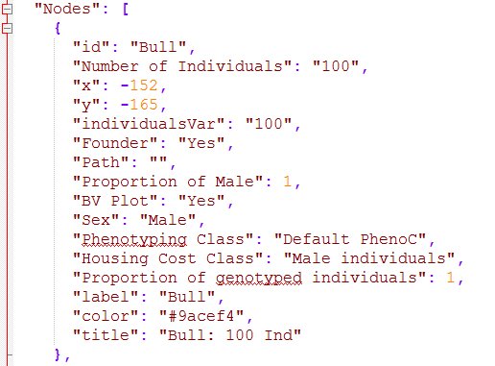

# On the generation of traits

In this section, we provide additional background on how traits and phenotypes are generated to obtain provided architectures that were selected in section 4.3.

## General

To obtain correlated traits with underlying QTL the Cholesky decomposition of the matrix provided in **shuffle.cor** is calculated. Next, QTL effect sizes are scaled to ensure the same genetic variance for all traits and existing traits are then combined into new traits by use of the entries of the upper triangular matrix resulting from *chol()*. Note that the number of underlying QTL is for each trait will therefore change! An added benefit of this way of generating traits is that any positive semi-definite matrix is a valid input for this approach and trait correlations are consist over time.

In case non-QTL based traits (X1) are simulated the genetic variance of those traits is sampled of a multivariate Gaussian distribution with the QTL-based traits (X2):

Residual effects are generated by generation independent *N(0,1)* random variables and subsequent scaling with the Cholesky decomposition of the residual correlation matrix (**new.residual.correlation**). Note that the first observation of one trait will always be correlated to the first observation of the other traits, but not to other observations! In case a repeatability w2 is provided the residual variance will be separated in a permanent part that will be used for all observations and the temporary part that will be re-sampled for each observation with:

,

,

.

The resulting residuals for the phenotypes are then generated via:

with and A being the target residual correlation matrix (**new.residual.correlation**).

## Genotype – by – environment

To model GxE, we recommend the generation of multiple different traits. Usually, one should make sure that those traits have high correlation (e.g. via shuffle.cor or a specific real.bv.add) and similar scaling (mean.target / var.target / bv.standardization() ). These separate traits can be linked via the function combine.traits(), which will lead to multiple traits being viewed as the same trait in a breeding value estimation. An example on the use can be found in section XXX.

# User-interface

## MoBPSweb

In addition to the R-package itself, we also developed a web-based interface that can be used an relatively easy way to get started with the framework. This have also been published as MoBPSweb (Pook et al. 2021). Nonetheless, the user-interface is still in active development and available at [www.mobps.de](http://www.mobps.de). Extended documentation on the use of the web-interface can be found on the webpage directly.

When looking through the openly available code you will find code snippets that are only relevant for the interface (*json.simulation()*).

The main goal of the user interface is the usage of the R-package without the need for programming skills in R or knowledge of the details of the package to set up your simulation. Note that the interface will not be able to grasp the full functionality/efficiency of the R-package but the goal is to get close. Input parameters can be entered in a web-based application (java-script) – especially the breeding scheme can be entered in an intuitive way via nodes (cohorts of individuals) and edges (breeding & selection processes).

Simulations can be directly started via the web interface with a VM server hosted from Goettingen. At the current state we can provide computational resources for smaller breeding programs (20 CPU, 64 GB Memory), but it is also possible to download the JSON-file containing all information of the user interface and run the simulation via *json.simulation()* in R. When running simulation directly in R, additional parameter settings are provided to export the population at a give time point (**export.population** via **export.gen/timepoint**), scale the size of the cohorts (**size.scaling**) and similar in accordance to *breeding.diploid()*.

Student users are allowed to use 5 cores & 20 GB memory with a maximum run-time of 4 hours.

Professional users are allowed to use 5 cores & 30 GB memory with a maximum run-time of 48 hours.

If you feel you need more computational ressources or are interested in setting up your own MoBPS webserver contact use directly ([Torsten.pook@uni-goettingen.de](mailto:Torsten.pook@uni-goettingen.de)).

A schematic overview of the structure of the MoBPSweb interface:

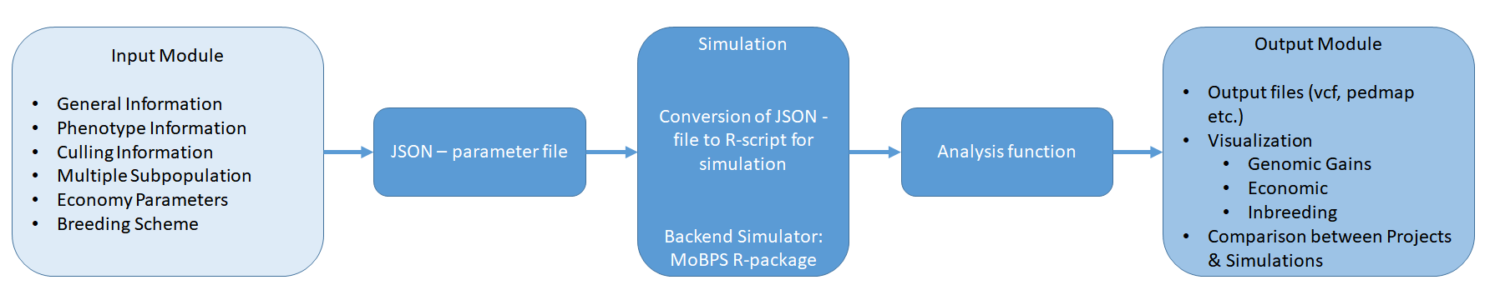

For most inputs, we provide implemented help buttons to briefly explain what kind of input is expected. The exemplary JSON-script provided in the R-package would look like this (note that all advanced parameter options are deactivated to not further complicate things):



## Input modules

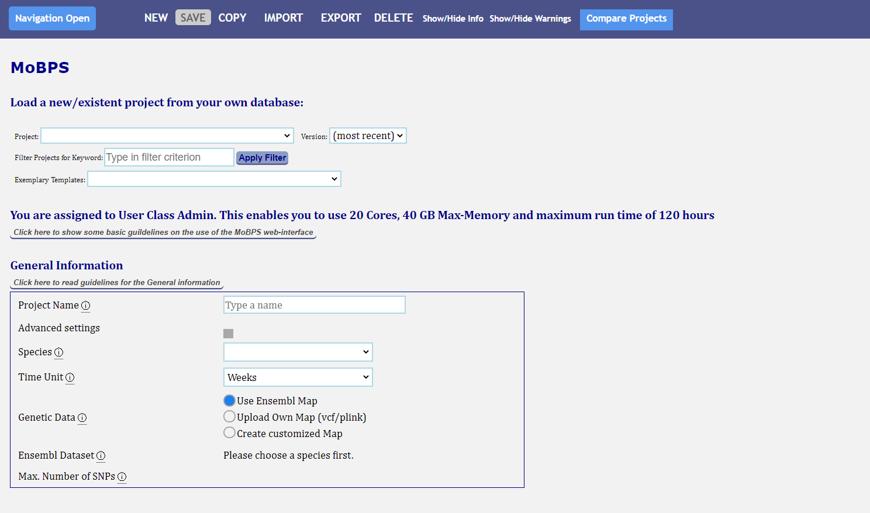

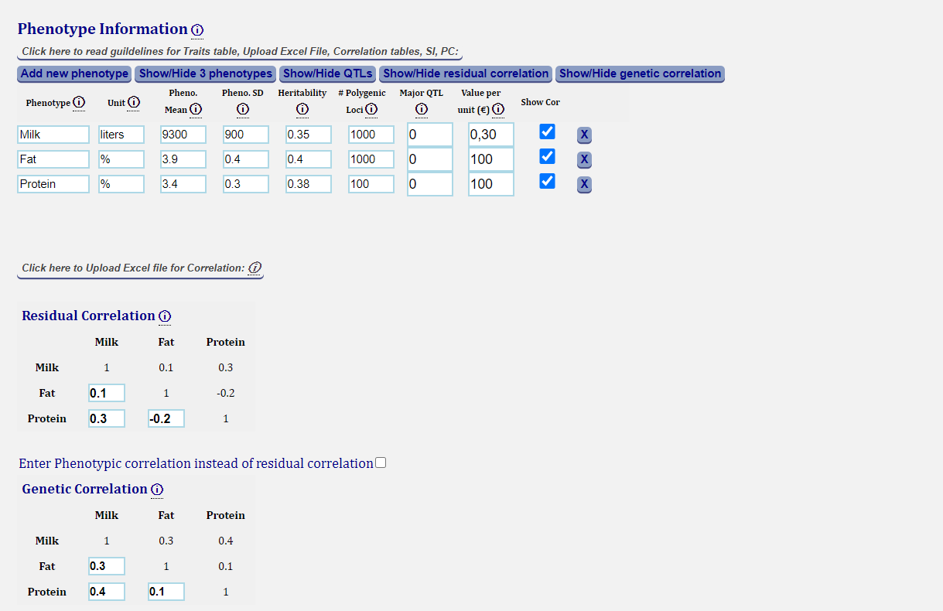

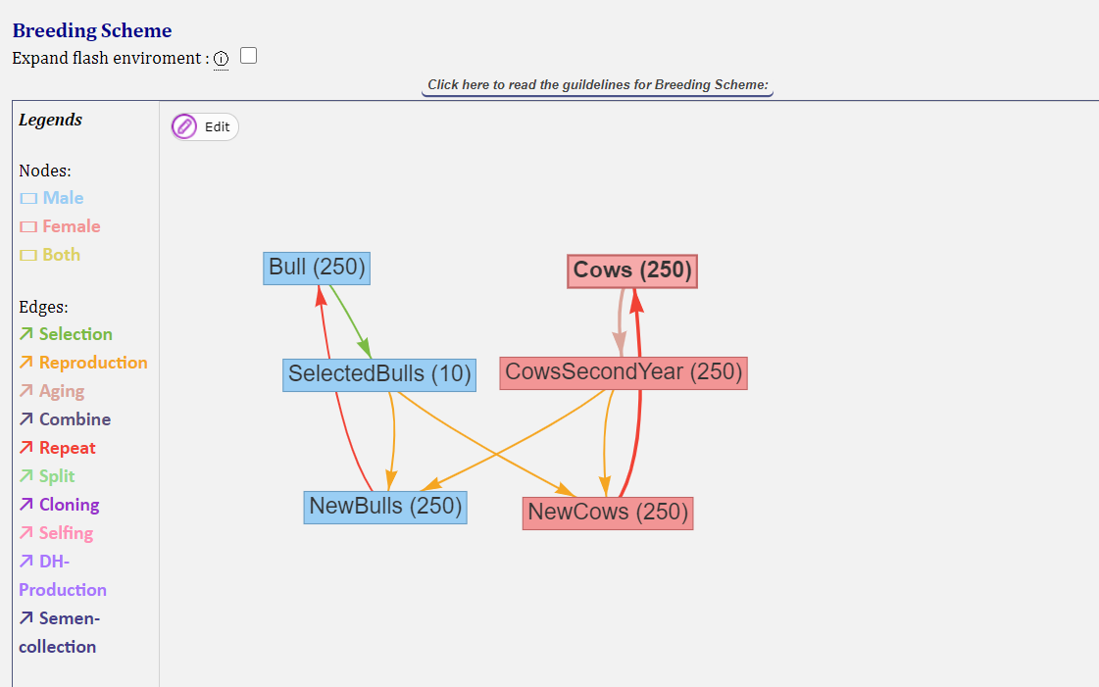

## Output modules

After the simulations are executed, the resulting population-list can be download in R and then be manually analyzed. Alternatively, we also provide some basic evaluation functions. In case multiple simulations are performed it is also possible to analyze the average between multiple runs of the simulation:

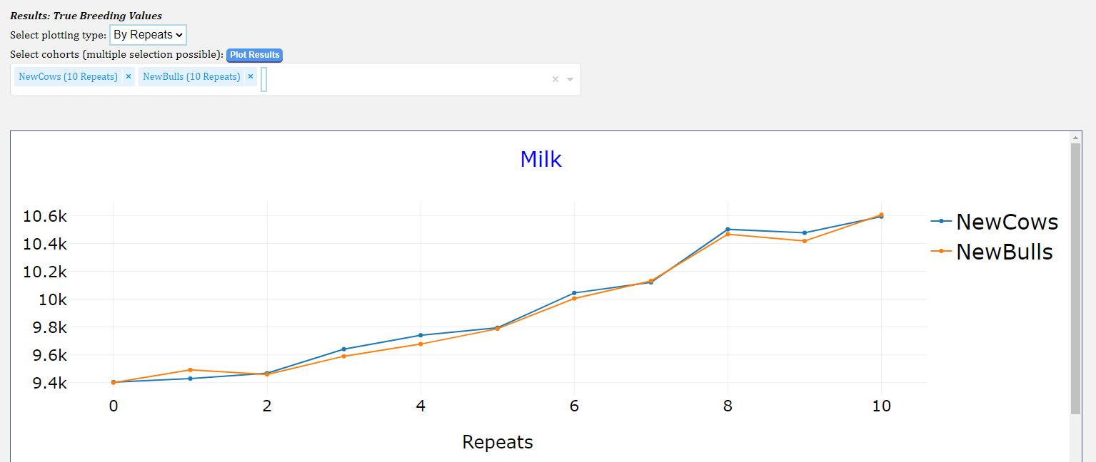

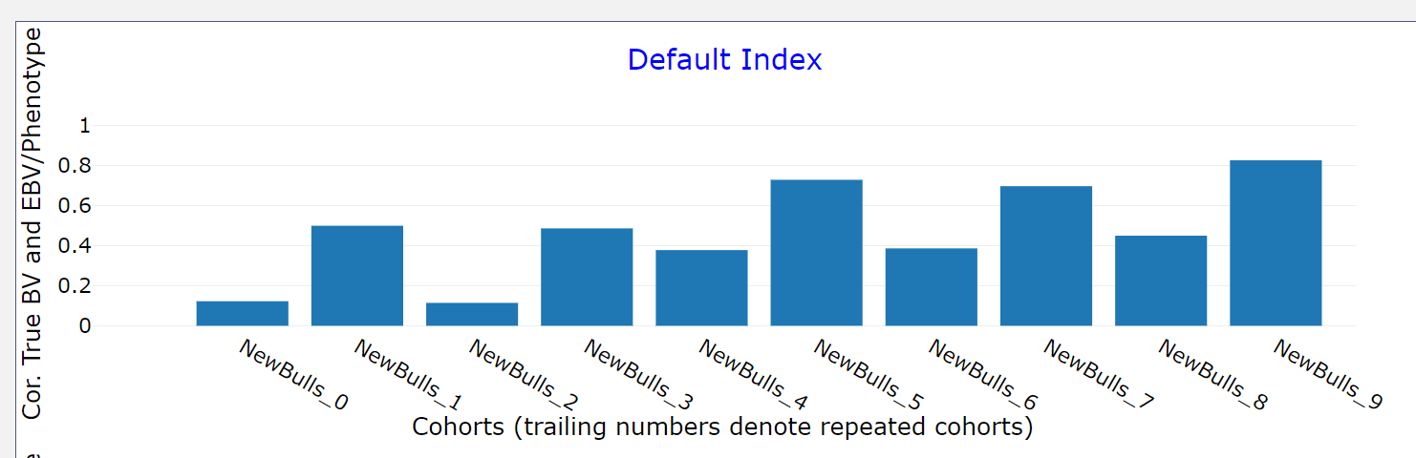

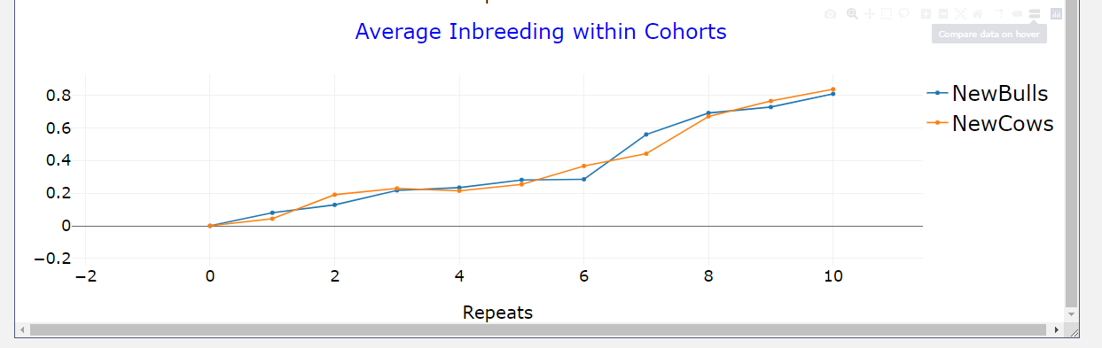

## Compare Projects

The CompareProjects – module can be used to plot multiple different projects in a joint graph. All output modules available for single projects are also available for CompareProjects.

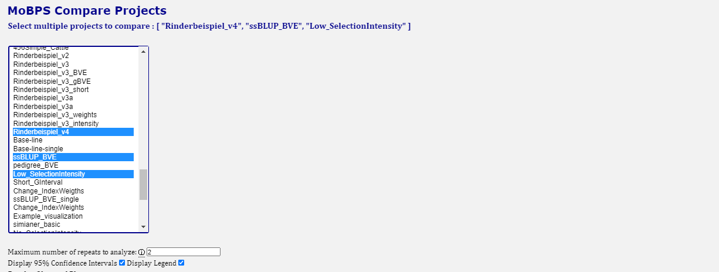

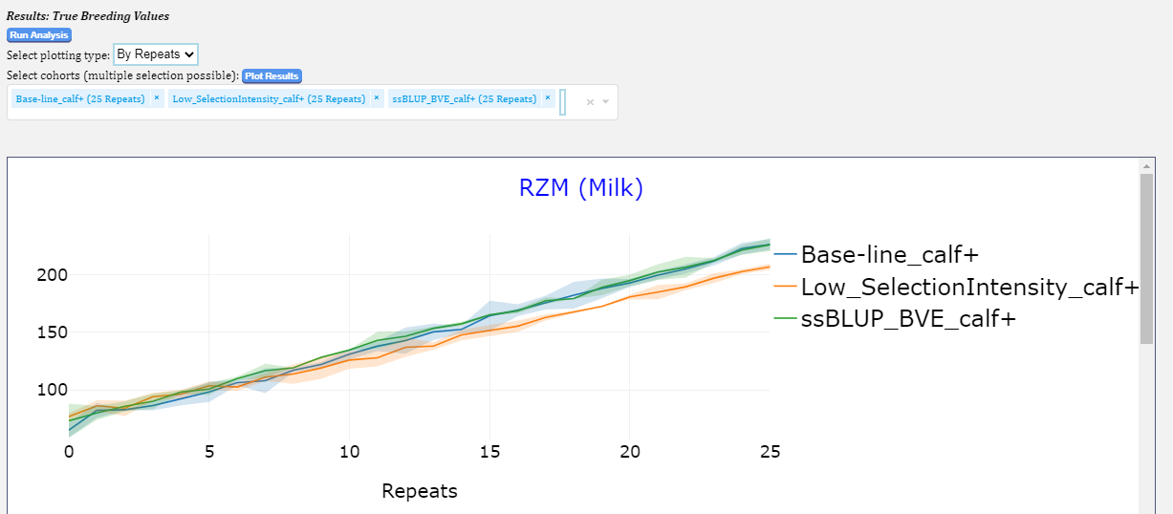

# References

Akdemir, Deniz; Okeke, U. G. (2015): EMMREML. Fitting mixed models with known covariance structures. In: *R package version* 3 (1).

Bekele, Wubishet A.; Wieckhorst, Silke; Friedt, Wolfgang; Snowdon, Rod J. (2013): High‐throughput genomics in sorghum. From whole‐genome resequencing to a SNP screening array. In: *Plant biotechnology journal* 11 (9), S. 1112–1125.

Browning, Brian L.; Zhou, Ying; Browning, Sharon R. (2018): A One-Penny Imputed Genome from Next-Generation Reference Panels. In: *The American Journal of Human Genetics* 103 (3), S. 338–348.

Covarrubias-Pazaran, Giovanny (2016): Genome-assisted prediction of quantitative traits using the R package sommer. In: *PLOS ONE* 11 (6), e0156744.

Endelman, Jeffrey B. (2011): Ridge regression and other kernels for genomic selection with R package rrBLUP. In: *The Plant Genome* 4 (3), S. 250–255.

Groenen, Martien A.; Wahlberg, Per; Foglio, Mario; Cheng, Hans H.; Megens, Hendrik-Jan; Crooijmans, Richard PMA et al. (2009): A high-density SNP-based linkage map of the chicken genome reveals sequence features correlated with recombination rate. In: *Genome Research* 19 (3), S. 510–519.

Hill, William G. (1974): Prediction and evaluation of response to selection with overlapping generations. In: *Animal Science* 18 (2), S. 117–139.

Jenko, Janez; Gorjanc, Gregor; Cleveland, Matthew A.; Varshney, Rajeev K.; Whitelaw, C. Bruce A.; Woolliams, John A.; Hickey, John M. (2015): Potential of promotion of alleles by genome editing to improve quantitative traits in livestock breeding programs. In: *Genetics Selection Evolution* 47 (1), S. 55.

Lee, Michael; Sharopova, Natalya; Beavis, William D.; Grant, David; Katt, Maria; Blair, Deborah; Hallauer, Arnel (2002): Expanding the genetic map of maize with the intermated B73× Mo17 (IBM) population. In: *Plant Molecular Biology* 48 (5-6), S. 453–461.

Legarra, Andres; Christensen, Ole F.; Aguilar, Ignacio; Misztal, Ignacy (2014): Single Step, a general approach for genomic selection. In: *Livestock Science* 166, S. 54–65.

Liu, Jiajun; Luo, Wei; Qin, Nana; Ding, Puyang; Zhang, Han; Yang, Congcong et al. (2018): A 55 K SNP array-based genetic map and its utilization in QTL mapping for productive tiller number in common wheat. In: *Theoretical and Applied Genetics* 131 (11), S. 2439–2450.

Ma, Li; O'Connell, Jeffrey R.; VanRaden, Paul M.; Shen, Botong; Padhi, Abinash; Sun, Chuanyu et al. (2015): Cattle sex-specific recombination and genetic control from a large pedigree analysis. In: *PLoS genetics* 11 (11), e1005387.

Martini, Johannes W. R.; Gao, Ning; Cardoso, Diercles F.; Wimmer, Valentin; Erbe, Malena; Cantet, Rodolfo J. C.; Simianer, Henner (2017): Genomic prediction with epistasis models: on the marker-coding-dependent performance of the extended GBLUP and properties of the categorical epistasis model (CE). In: *BMC bioinformatics* 18 (1), S. 3.

Meuwissen, T. H. E. (1997): Maximizing the response of selection with a predefined rate of inbreeding. In: *Journal of animal science* 75 (4), S. 934–940.

Microsoft Corporation and Steve Weston (2018): doParallel: Foreach Parallel Adaptor for the 'parallel' Package. Online verfügbar unter https://CRAN.R-project.org/package=doParallel.

Miesenberger, Josef (1997): Zuchtzieldefinition und Indexselektion für die österreichische Rinderzucht: na.

Pérez, Paulino; de los Campos, Gustavo (2014): Genome-wide regression & prediction with the BGLR statistical package. In: *Genetics*, 483-495.

Pook, T.; Büttgen, L.; Ganesan, A.; Ha, N. T.; Simianer, H. (2020): MoBPSweb. A web-based framework to simulate and compare breeding programs. In: *bioRxiv*, 2020.07.08.193227. DOI: 10.1101/2020.07.08.193227.

Pook, Torsten; Weigend, Steffen; Simianer, Henner (2017): A generalized approach to calculate expectation and variance of kinship in complex breeding schemes. #26908. In: *Annual Meeting of EAAP*.

Prieur, Vincent; Clarke, Shannon M.; Brito, Luiz F.; McEwan, John C.; Lee, Michael A.; Brauning, Rudiger et al. (2017): Estimation of linkage disequilibrium and effective population size in New Zealand sheep using three different methods to create genetic maps. In: *BMC Genetics* 18 (1), S. 68.

Purcell, Shaun; Neale, Benjamin; Todd-Brown, Kathe; Thomas, Lori; Ferreira, Manuel A. R.; Bender, David et al. (2007): PLINK. A tool set for whole-genome association and population-based linkage analyses. In: *The American Journal of Human Genetics* 81 (3), S. 559–575.

Renaud Gaujoux (2018): doRNG: Generic Reproducible Parallel Backend for 'foreach' Loops. Online verfügbar unter https://CRAN.R-project.org/package=doRNG.

Rohrer, Gary A.; Alexander, Leeson J.; Keele, John W.; Smith, Tim P.; Beattie, Craig W. (1994): A microsatellite linkage map of the porcine genome. In: *Genetics* 136 (1), S. 231–245.

Schlather, Martin (2020): Efficient Calculation of the Genomic Relationship Matrix. In: *bioRxiv*, 2020.01.12.903146. DOI: 10.1101/2020.01.12.903146.

Simianer, Henner; Pook, Torsten; Schlather, Martin (2018): Turning the PAGE - the potential of genome editing in breeding for complex traits revisited. In: *World Congress on Genetics Applied to Livestock*, S. 190.

VanRaden, Paul M. (2008): Efficient methods to compute genomic predictions. In: *Journal of Dairy Science* 91 (11), S. 4414–4423.

Wen, Weie; He, Zhonghu; Gao, Fengmei; Liu, Jindong; Jin, Hui; Zhai, Shengnan et al. (2017): A high-density consensus map of common wheat integrating four mapping populations scanned by the 90K SNP array. In: *Frontiers in plant science* 8, S. 1389.

Zerbino, Daniel R.; Achuthan, Premanand; Akanni, Wasiu; Amode, M. Ridwan; Barrell, Daniel; Bhai, Jyothish et al. (2018): Ensembl 2018. In: *Nucleic acids research* 46 (D1), D754-D761.

Zheng, Chaozhi; Boer, Martin P.; van Eeuwijk, Fred A. (2015): Reconstruction of genome ancestry blocks in multiparental populations. In: *Genetics* 200 (4), 1073-1087.

# Citation

The R-package MoBPS is published in G3 Genes, Genomes, Genetics.

For miraculix we recommend to cite our preprint at biorvix miraculix (Schlather 2020):

@article{Pook.2020,

author = {Pook, Torsten and Schlather, Martin and Simianer, Henner},

year = {2020},

title = {MoBPS - Modular Breeding Program Simulator},

pages = {g3.401193.2020},

issn = {2160-1836},

journal = {G3: Genes, Genomes, Genetics},

doi = {10.1534/g3.120.401193}

}

@article {Schlather.2020,

author = {Schlather, Martin},

title = {Efficient Calculation of the Genomic Relationship Matrix},

elocation-id = {2020.01.12.903146},

year = {2020},

doi = {10.1101/2020.01.12.903146},

publisher = {Cold Spring Harbor Laboratory},

URL = {https://www.biorxiv.org/content/early/2020/01/14/2020.01.12.903146},

eprint = {https://www.biorxiv.org/content/early/2020/01/14/2020.01.12.903146.full.pdf},

journal = {bioRxiv}

}

# Acknowledgements

This package was initially (2017-01/2020) developed in the context of the European Union’s Horizon 2020 Research and Innovation Program under grant agreement n°677353 IMAGE. Subsequently development was continued (since 02/2020) in the context the project “MAZE – Accessing the genomic and functional diversity of maize to improve quantitative traits” (Grant ID 031B0882) that is funded by the German Federal Ministry of Education and Research (BMBF).

Additional thanks goes to the Research Training Group 1644 “Scaling Problems in Statistics” for financing travelling and all members of the Animal Breeding and Genetics Group at the University of Goettingen for all the helpful advice to people with less genetic background and ideas of things to implement.

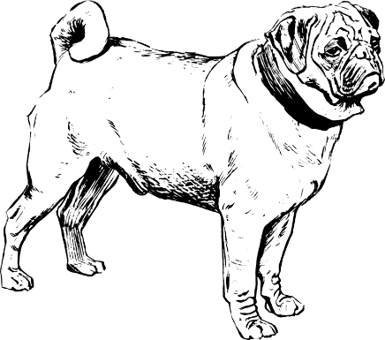



References

Fletcher, Reeves; Reeves, Colin M. (1964): Function minimization by conjugate gradients. In: *The computer journal* 7 (2), S. 149–154.

Malécot, Gustave (1948): Mathématiques de l’Hérédité. Paris: Masson et Cie.

Meuwissen, T. H. E. (1997): Maximizing the response of selection with a predefined rate of inbreeding. In: *Journal of animal science* 75 (4), S. 934–940.

Pook, Torsten; Büttgen, Lisa; Ganesan, Amudha; Ha, Ngoc-Thuy; Simianer, Henner (2021): MoBPSweb: A web-based framework to simulate and compare breeding programs. In: *G3: Genes, Genomes, Genetics* 11 (2). DOI: 10.1093/g3journal/jkab023.

Pook, Torsten; Schlather, Martin; Simianer, Henner (2020): MoBPS - Modular Breeding Program Simulator. In: *G3: Genes, Genomes, Genetics* 10 (6), 1915-1918. DOI: 10.1534/g3.120.401193.

Wellmann, Robin (2017): optiSel: optimum contribution selection and population genetics. In: *R Package. version 0.9.1*.

Wellmann, Robin (2019): Optimum contribution selection for animal breeding and conservation: the R package optiSel. In: *BMC Bioinformatics* 20 (1), S. 1–13.

Zhuang, Yongwen (2019): cPCG: Efficient and Customized Preconditioned Conjugate Gradient Method for Solving System of Linear Equations 2019. Online verfügbar unter https://github.com/styvon/cPCG.